**TEMPERATURE AND HEAT**

**Exercises**

**Section 16.1 Heat, Temperature, and Thermodynamic Equilibrium**

**14.** **Interpret** This problem involves converting temperature from the Celsius scale to the Fahrenheit scale.

**Develop** We assume that the U.S. meteorologist predicts the same temperature, but expresses it on the Fahrenheit scale. Therefore, apply Equation 16.2

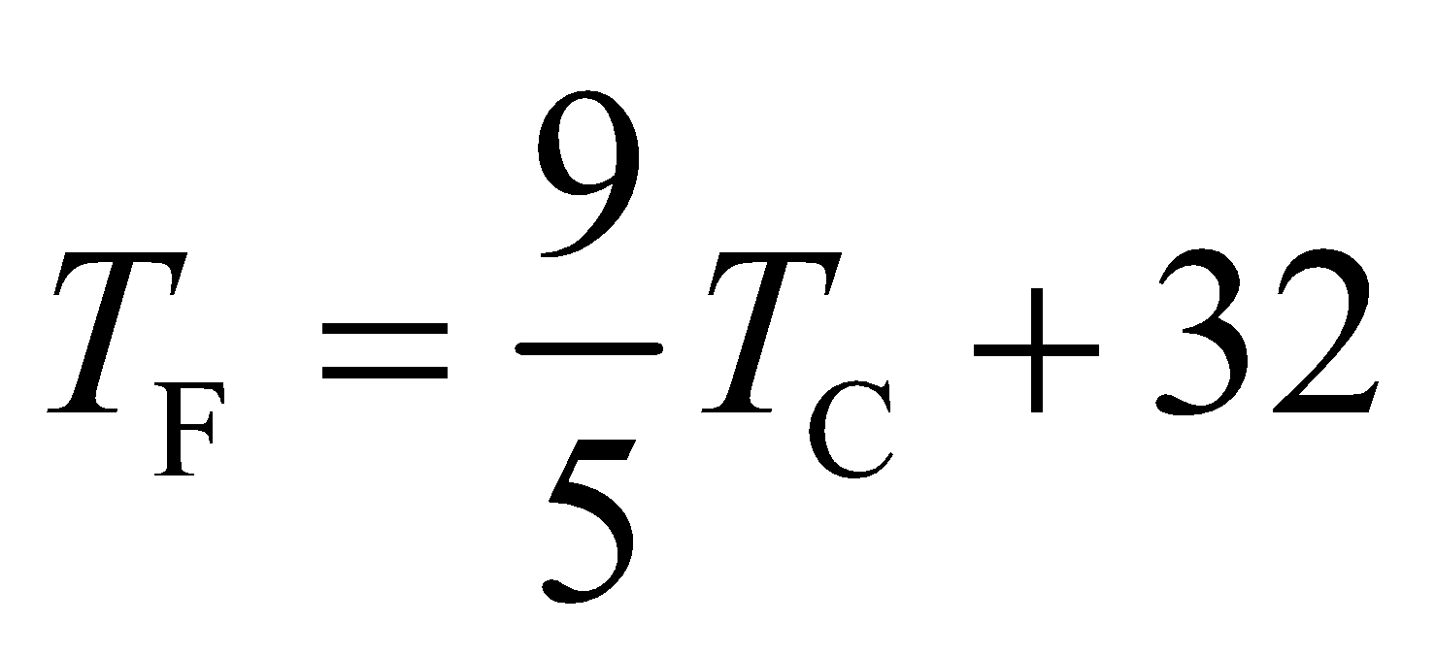

to find the temperature *T*F in Fahrenheit.

**Evaluate** Inserting *T*C = −15°C gives

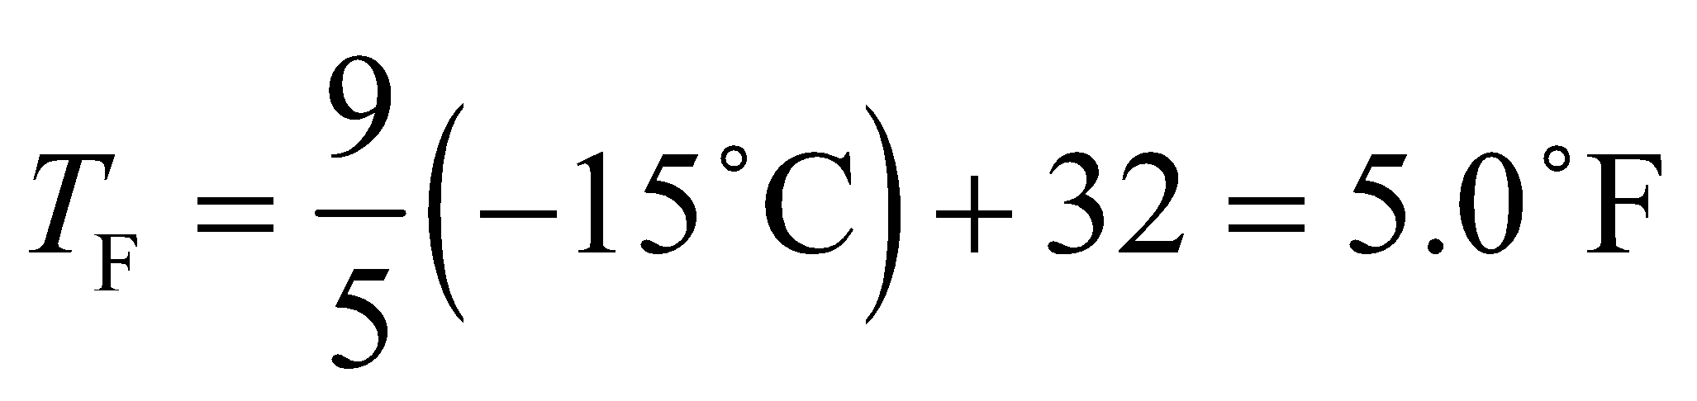

**Assess** This is a reasonable temperature for a cold winter day in the Midwest.

**15. Interpret** This problem involves converting temperature from the Fahrenheit scale to the Celsius scale.

**Develop** The two temperature scales are related by Equation 16.2:



**Evaluate** Inserting *T*F = 68°F and solving the above equation for the Celsius temperature, we obtain

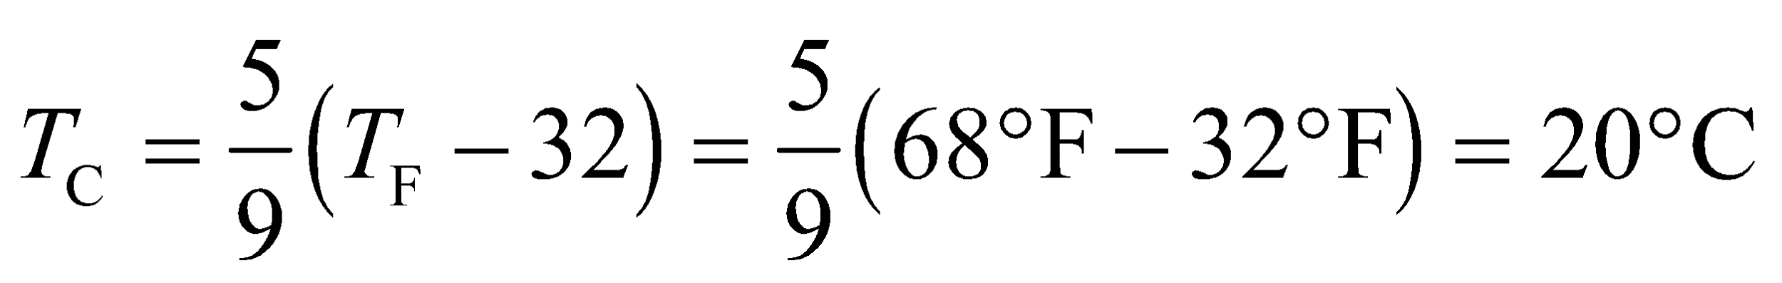

**Assess** This is a useful result to remember since 20°C or 68°F is a typical room temperature.

**16.** **Interpret** This problem involves converting a temperature difference from the Celsius scale to the Fahrenheit scale.

**Develop** Apply Equation 16.2 at the two different (and arbitrary) temperatures, then take the difference:

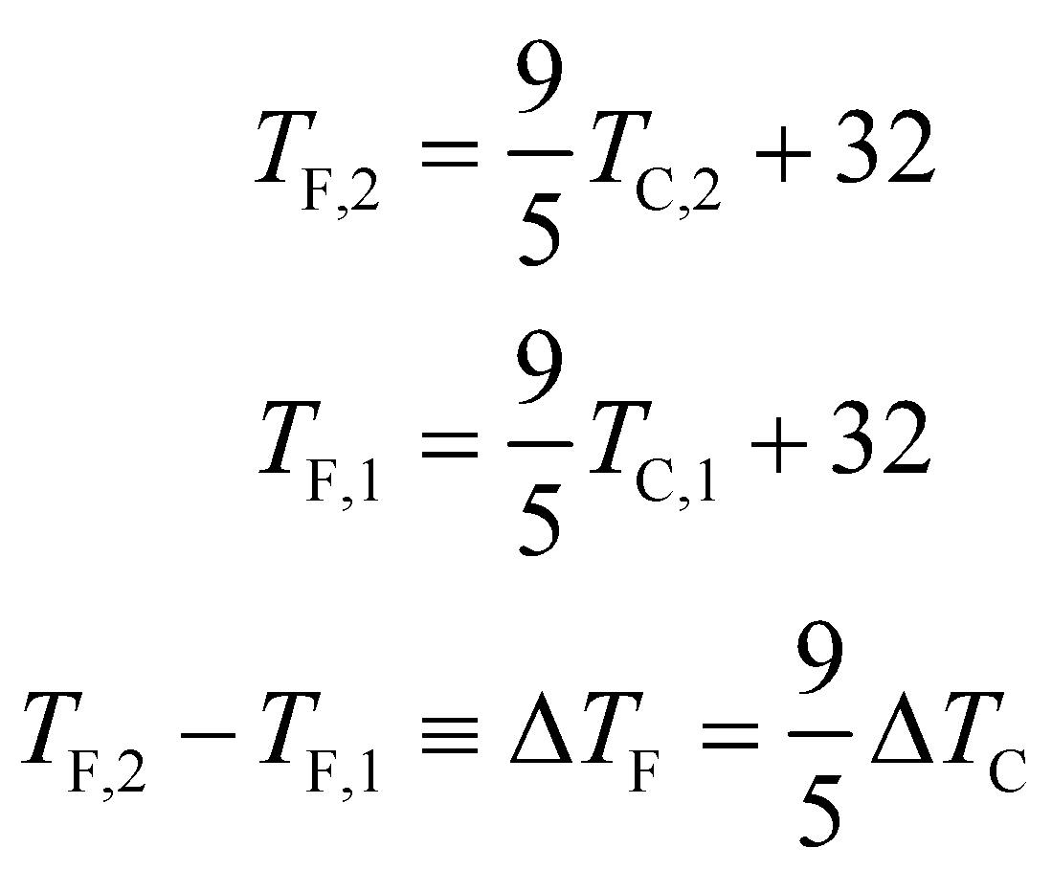

**Evaluate** *ΔT*C = 10°C gives 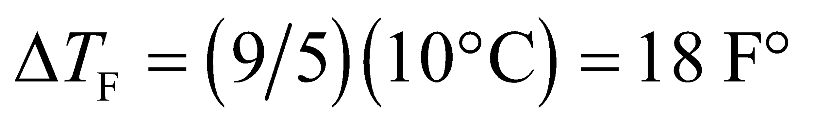.

**Assess** Note that a temperature difference and a temperature reading are not the same, even though both are specified in the same units. The notation F° versus °F is an attempt to clarify this distinction, but is not universally accepted or consistently applied.

**17. Interpret** Given both Fahrenheit and Celsius scales, we want to know when *T*F and *T*C are numerically equivalent.

**Develop** The two temperature scales are related by Equation 16.2:



The condition that the readings are numerically equivalent is

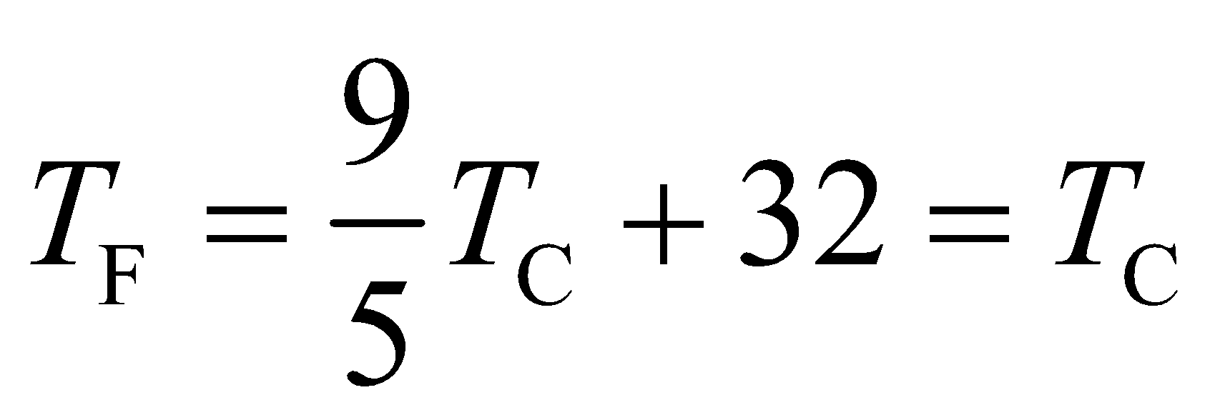

**Evaluate** The above equation can be solved to give

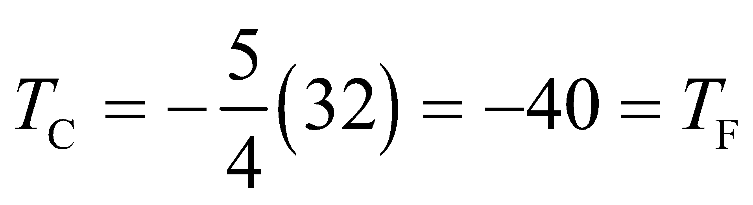

**Assess** This is the only temperature in which both scales yield the same reading: 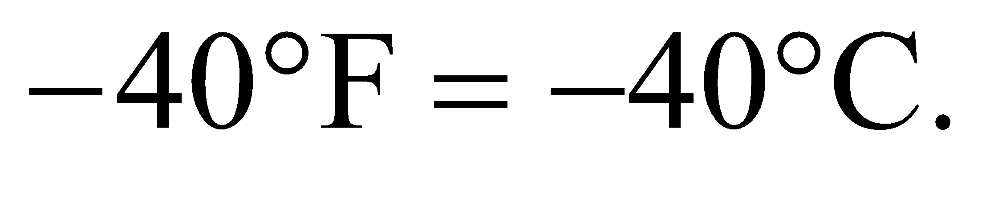

**18.** **Interpret** This problem involves converting temperature from Kelvin to Celsius, and then converting from Celsius to Fahrenheit.

**Develop** To convert from Kelvin to Celsius, apply Equation 16.1 *T*C = *T* −273.15. To convert Celsius to Fahrenheit, use Equation 16.2, 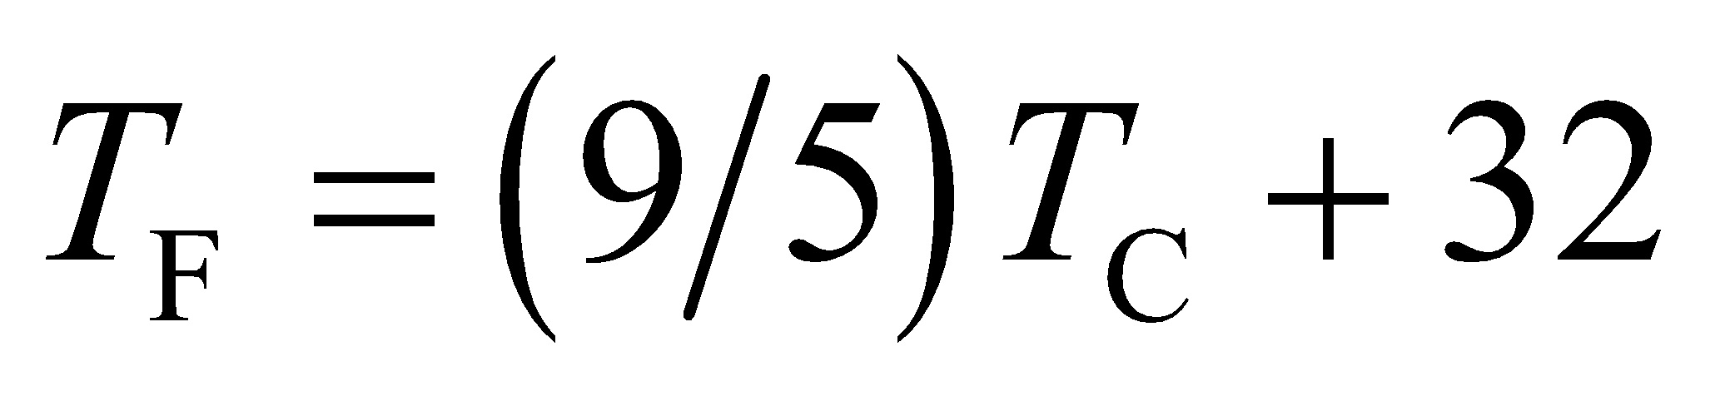.

**Evaluate** The temperature 77.3 K in degrees Celsius is 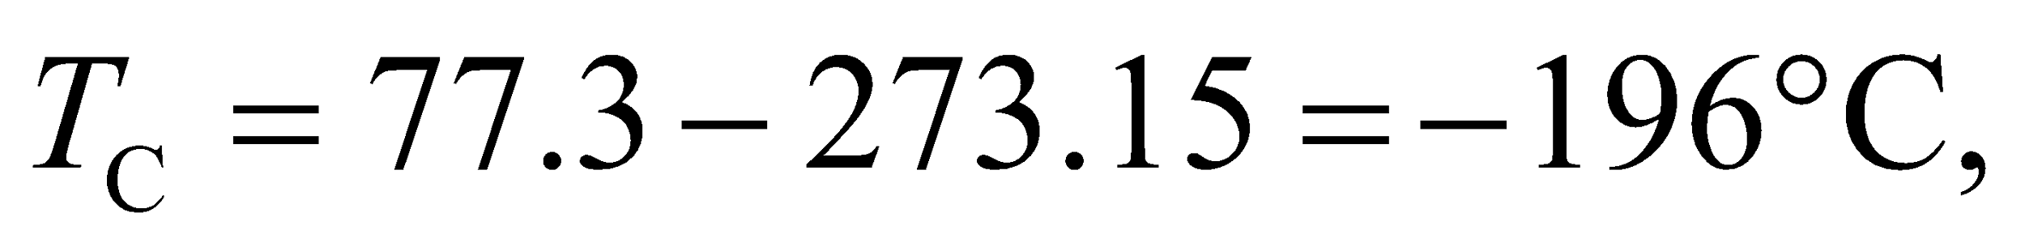which in Fahrenheit is 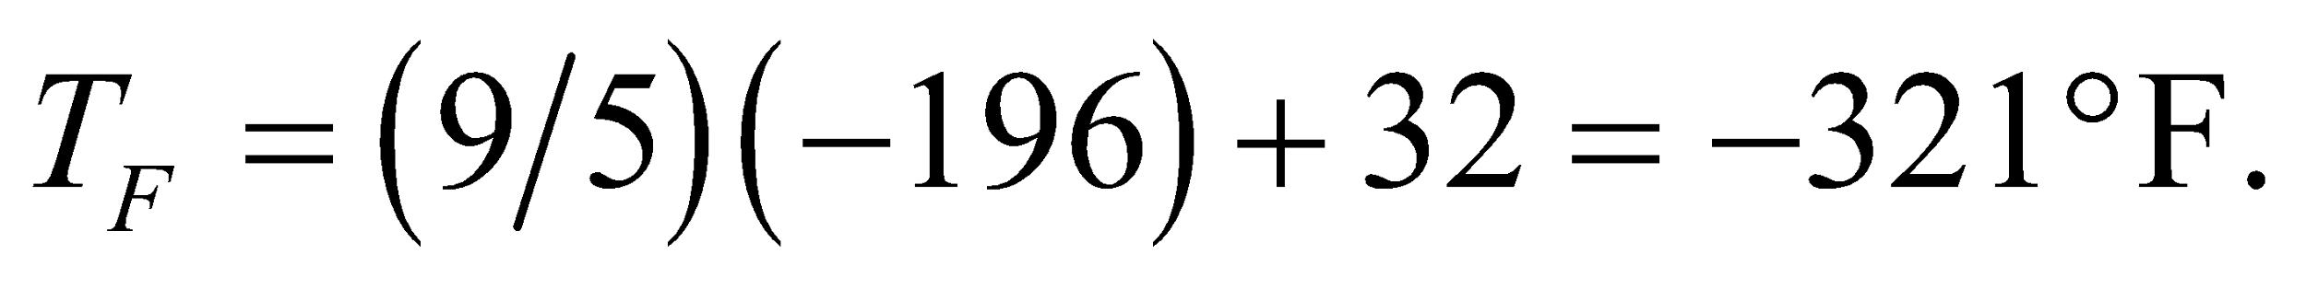

**Assess** As a benchmark, it can be useful to know that liquid nitrogen is at approximately −200°C.

**19. Interpret** This problem is about converting temperature from the Celsius scale to the Fahrenheit scale.

**Develop** The two temperature scales are related by Equation 16.2:

**Evaluate** Solving the above equation for the Fahrenheit temperature, we obtain

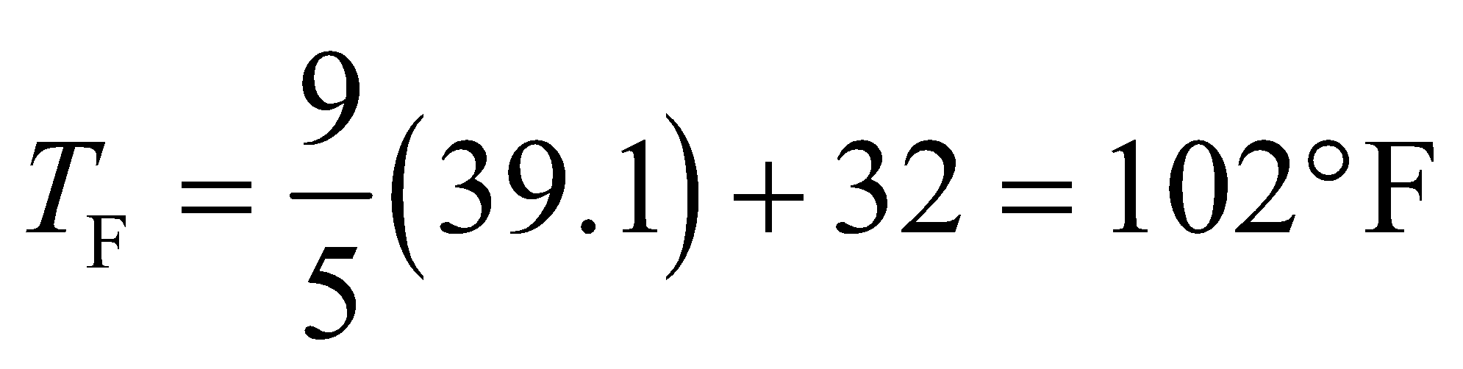

**Assess** The temperature is way above the normal body temperature of 98.6°F (or 37°C). Call the doctor immediately!

**Section 16.2 Heat Capacity and Specific Heat**

**20. Interpret** We find the heat capacity of a large concrete block. We know the mass of the block and its specific heat.

**Develop**  The specific heat of concrete is given in Table 16.1 as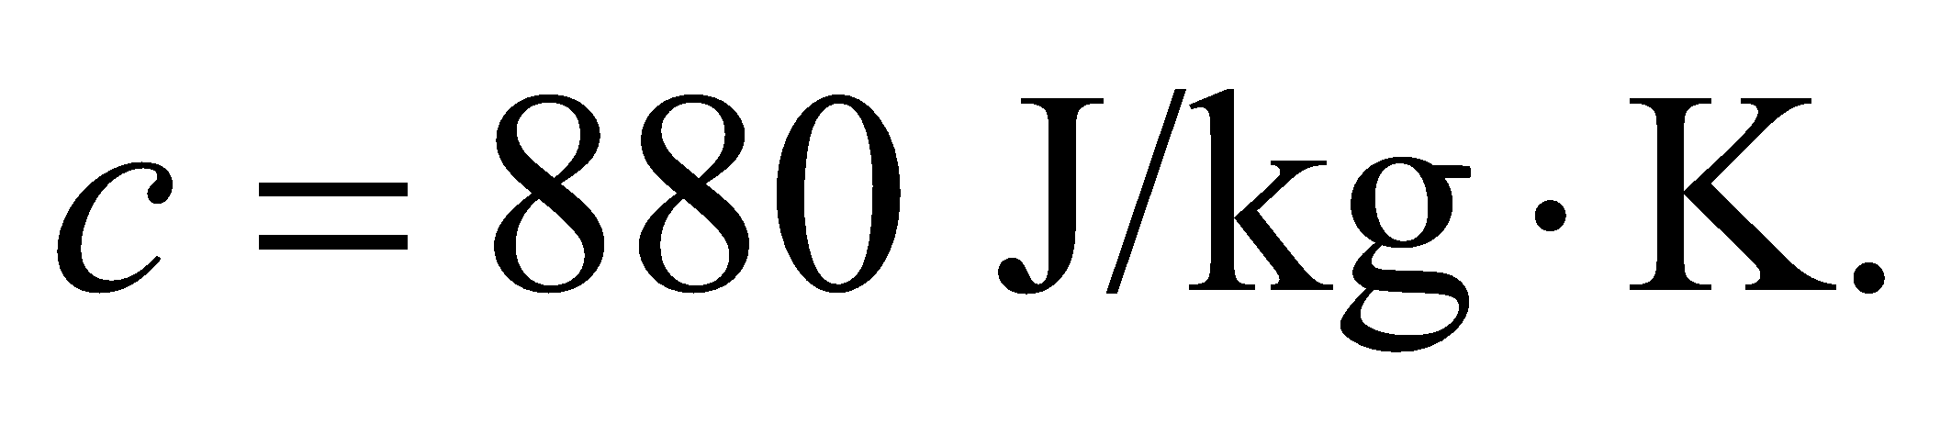 To find the heat capacity, we multiply this specific heat by the mass (recalling that 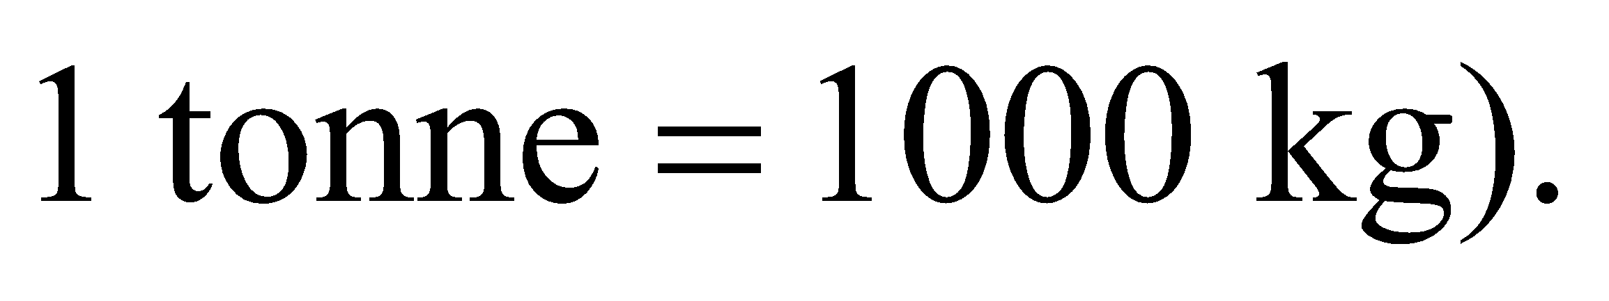

**Evaluate** The heat capacity of the block is



**Assess** This is a large value, but then it takes a large amount of heat to change the temperature of a 55-tonne block of concrete.

**21. Interpret** We are to find the energy necessary to change the temperature of an object by a given amount. This involves the heat capacity of the object and the temperature change.

**Develop**Apply Equation 16.3 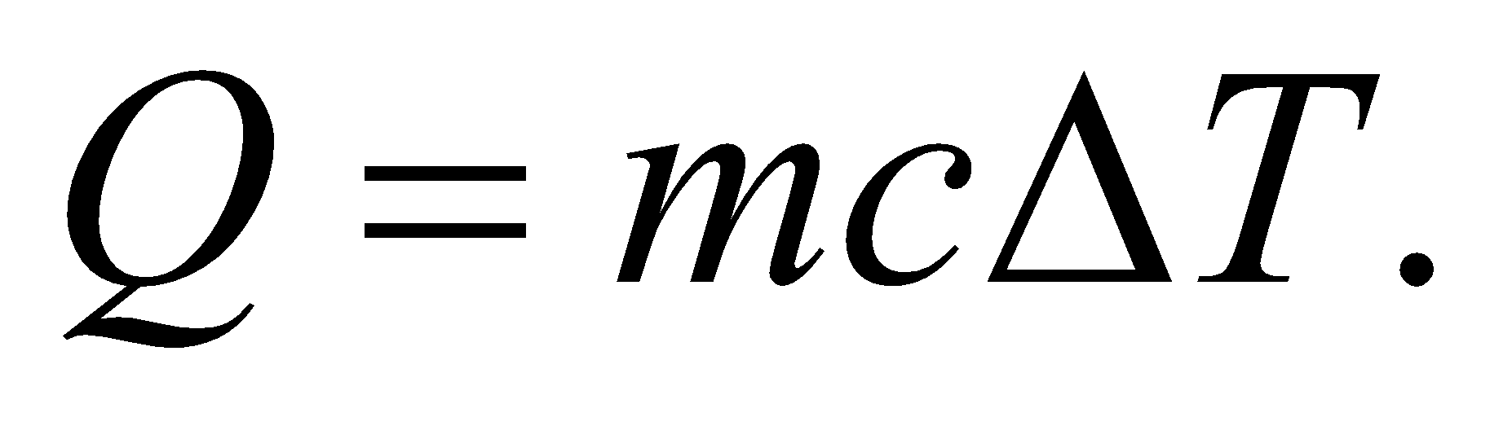 The mass of the aluminum block is *m* =2.0 kg, the specific heat (from Table 16.1) is *c* = 900 J/(kg·K), and the temperature change is *ΔT* = 18 C° = 18 K (see Equation 16.1).

**Evaluate** Inserting the given quantities gives



**Assess** The same value would be the heat released by the aluminum if it cooled 18 C°.

**22. Interpret** Given information about heat, mass, and temperature change of a material, we are asked to find the specific heat of the material.

**Develop**Apply Equation 16.3 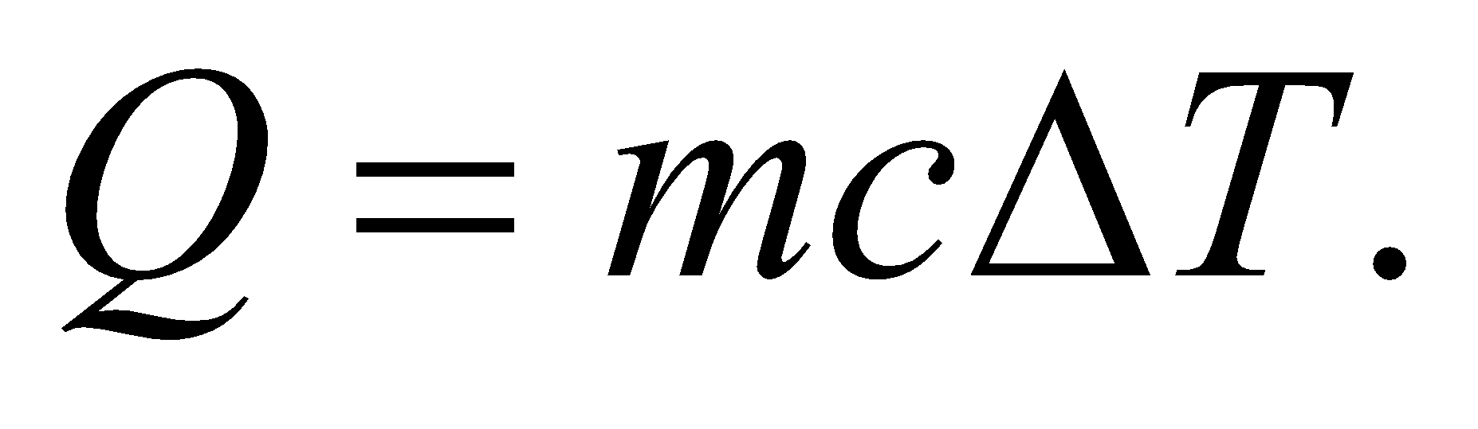 The mass of the object is *m* = 1.0 kg, the heat required is *Q* =7500 J, and the temperature change is *ΔT* =3.0 C° = 3.0 K (see Equation 16.1), so we can solve for the specific heat *c*.

**Evaluate**Inserting the given quantities gives

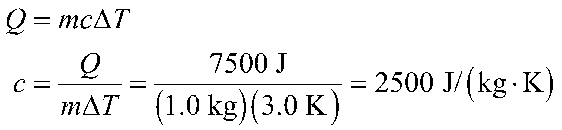

**Assess**This is a very large value for *c*; higher than for most solids.

**23. Interpret** The problem involves calculating the average power output of the human body, given the information about the energy acquired in a day from an average diet. Recall that power is energy per unit time.

**Develop** In a single day, the energy gained from the diet is

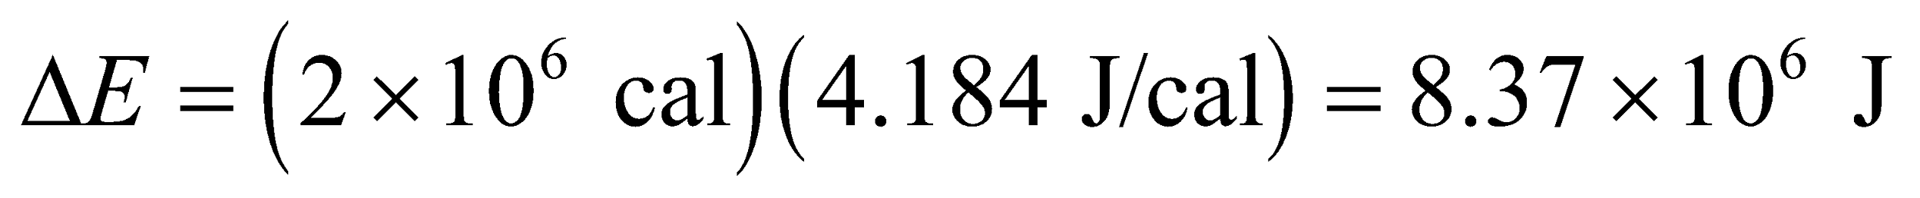

where we have used the conversion factor 1 cal = 4.184 J (see Appendix C). If the body expends all this energy (and does not store any of it), then the energy expended must be this same value (by conservation of energy). Therefore, the average power output of the body is 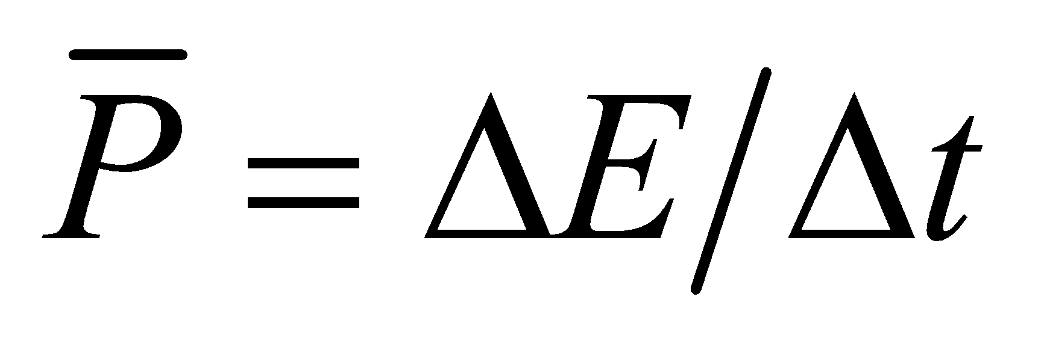, where *Δt* = (1 day)(86,400 s/day) = 86,400 s.

**Evaluate** The average power output is

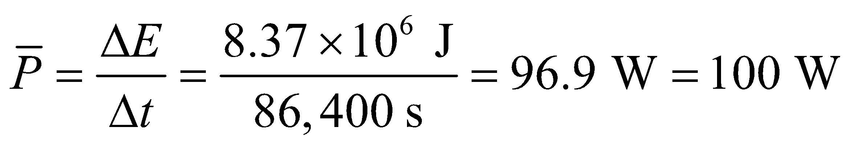

to a single significant figure.

**Assess** The average power output by the human body at rest is about 80 W, the same as a bright light bulb, so this result seems reasonable.

**24. Interpret**  We want to know how far one has to walk to expend the energy contained in a hamburger.

**Develop**  energy expended is the power times the time, while the time required is the distance divided by the speed. Therefore, 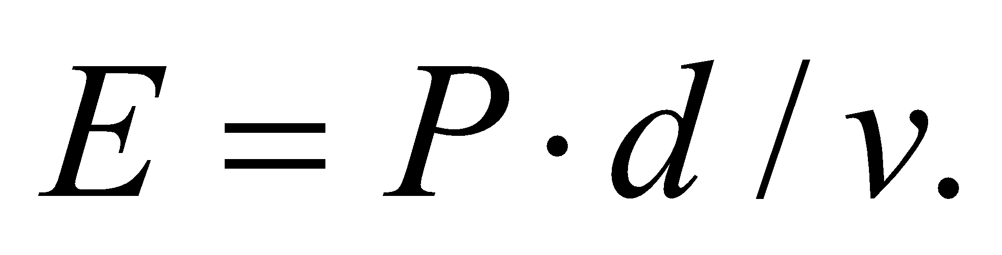 Recall that 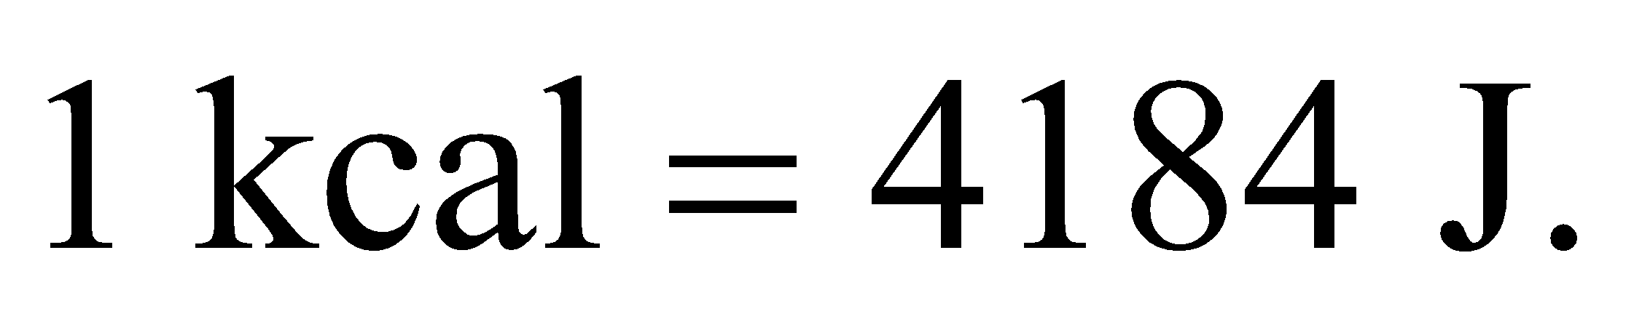

**Evaluate** The distance required to burn off 420 kcal is

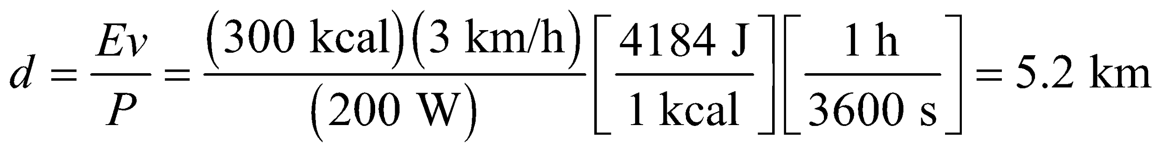

**Assess** This seems like a reasonable amount of exercise for burning off a hamburger.

**25. Interpret** Given the energy it takes to warm the wrench by the given temperature difference, we want to find its heat capacity, as well as the specific heat of the metal from which it is made.

**Develop**The heat capacity of an object is given by 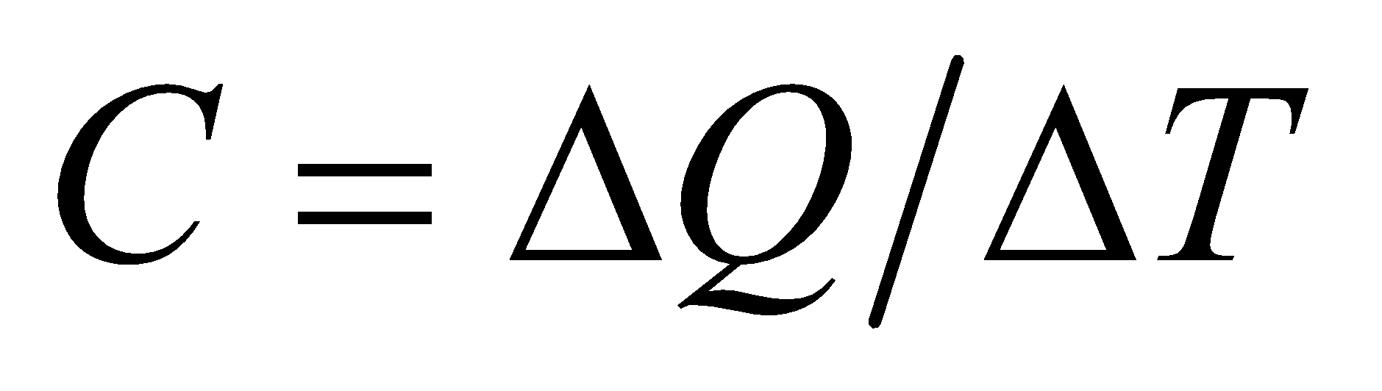, where *ΔQ* is the amount of heat transfer that results in a temperature change *ΔT* = 15 C° = 15 K. Comparing this expression with Equation 16.3, we see that the specific heat of a material is *c* = *C*/*m* (i.e., the heat capacity per unit mass).

**Evaluate** **(a)** Inserting the given quantities gives the average heat capacity as

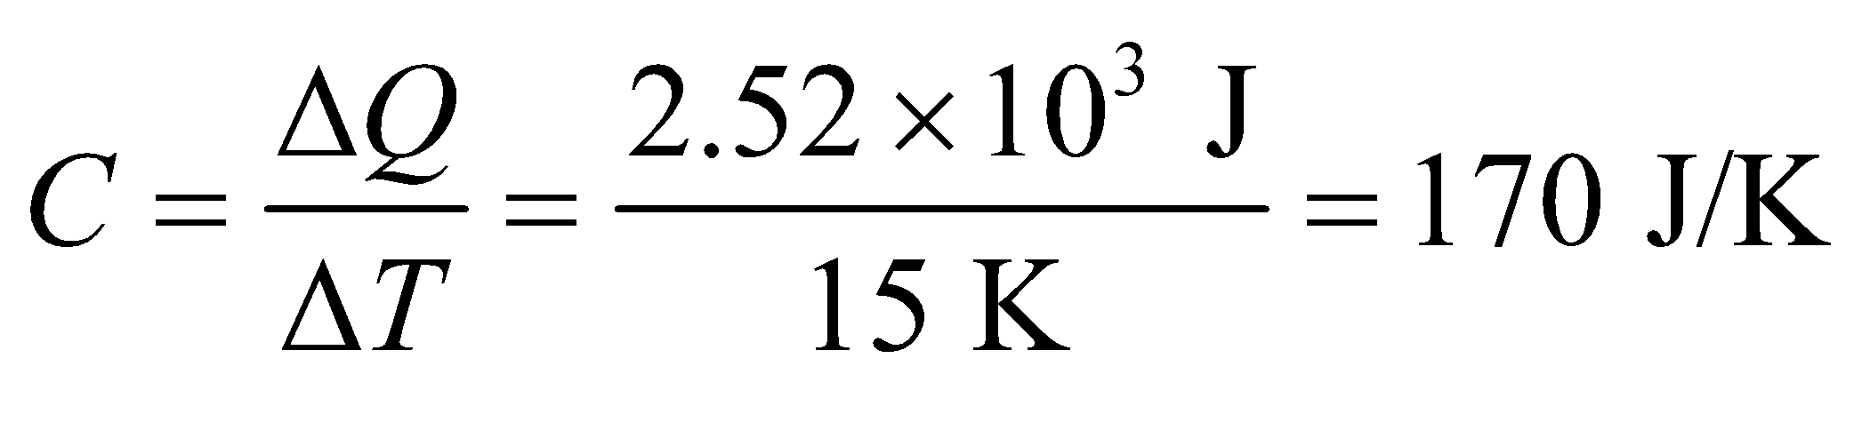

to two significant figures.

**(b)** The average specific heat of the material is

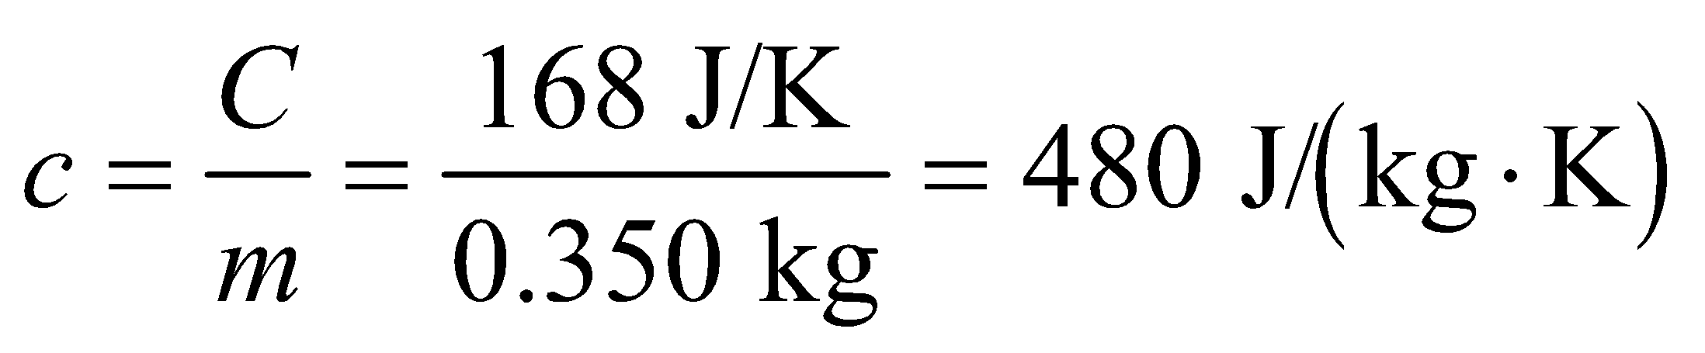

**Assess** The wrench is probably made of iron which has a specific heat of 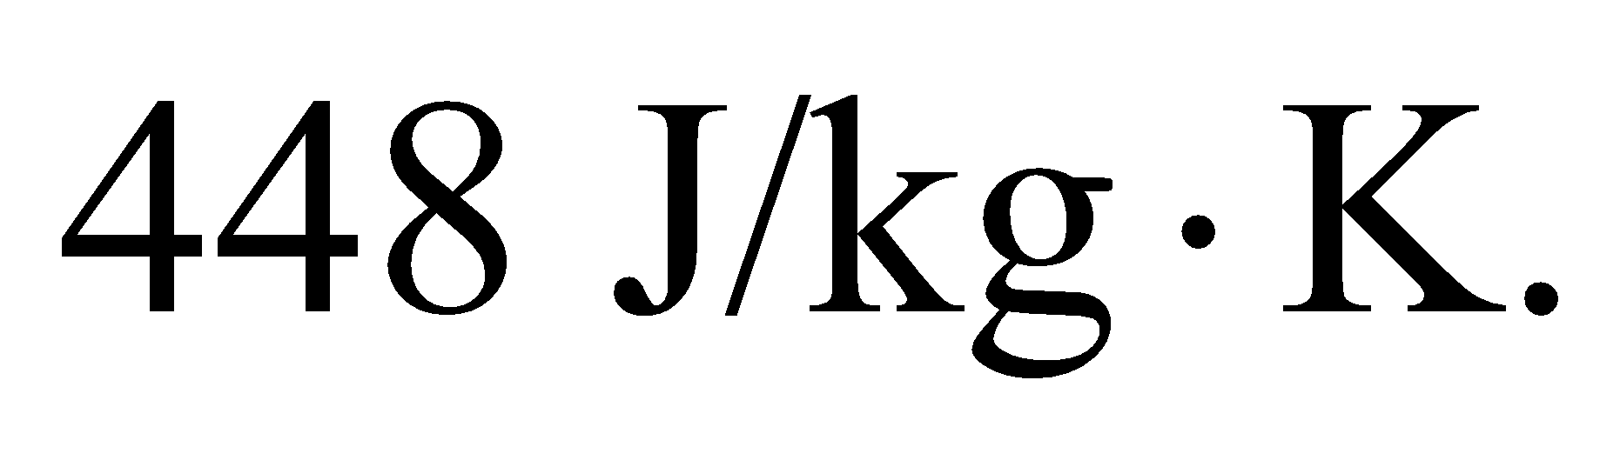

**26.** **Interpret** We are asked to find the heat (i.e., thermal energy) required to change the temperature of an object, which we can solve using the specific heat and the mass of the object. We are also to find the time takes to heat this object with the given power input.

**Develop**The heat required to change the temperature of the skillet by the *ΔT* = 110 C° = 110 K is  The mass of the skillet is *m* = 3.4 kg and the specific heat of iron is given in Table 16.1 as 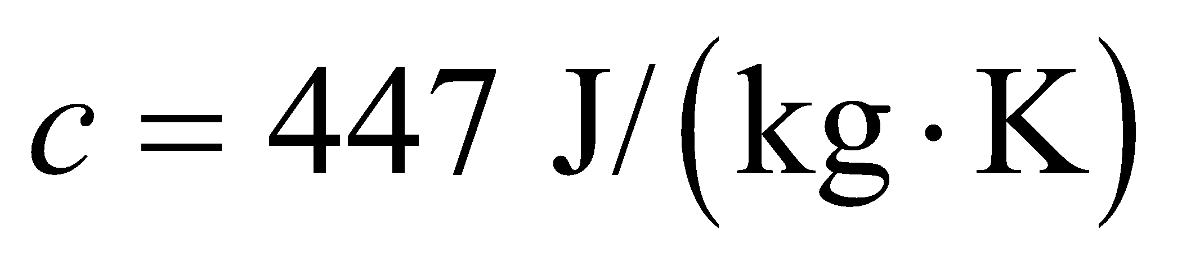. To find the time to heat the pan for part **(b)**, recall that average power is the energy per unit time, or 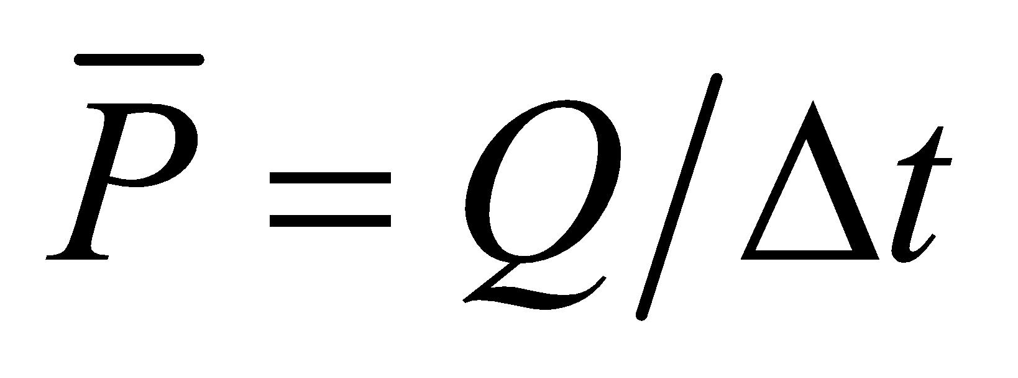, which we can solve given *Q* and 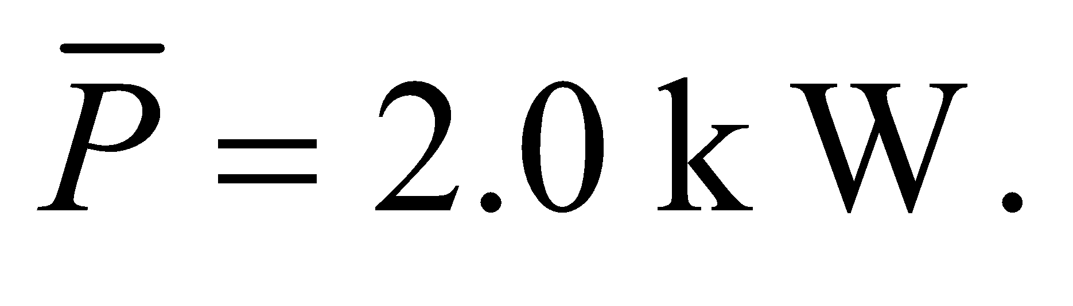

**Evaluate** (**a**) Inserting the given quantities into Equation 16.3 gives



**(b)** The time interval *Δt* required to deliver this amount of thermal energy is

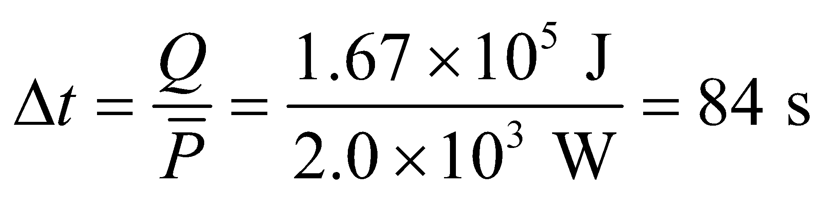

**Assess** This is a reasonable time to heat a small skillet.

**Section 16.3 Heat Transfer**

**27. Interpret** This problem is about converting heat loss expressed in Btu/h to SI units.

**Develop** One Btu (British thermal unit) is equal to 1054 J (see Appendix C), which is the amount of heat that is needed to raise the temperature of 1 lb of water from 63°F to 64°F.

**Evaluate** The conversion to SI units is

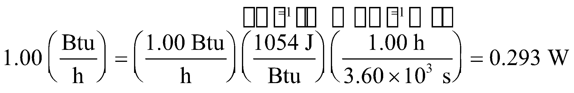

**Assess** Our result shows that 1 W is about 3.4 Btu/h. The power output of air conditioners is commonly given in terms of Btu/h.

**28. Interpret** We’re asked to compare the heat loss rate through equal slabs of wood and Styrofoam.

**Develop** The rate of heat-loss from conduction is given by Equation 16.5,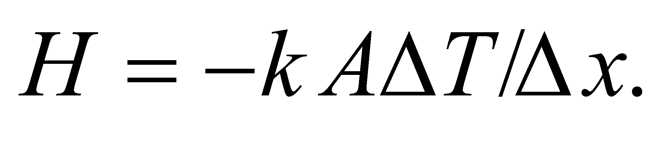 The values of thermal conductivity, *k*, come from Table 16.2: pine wood 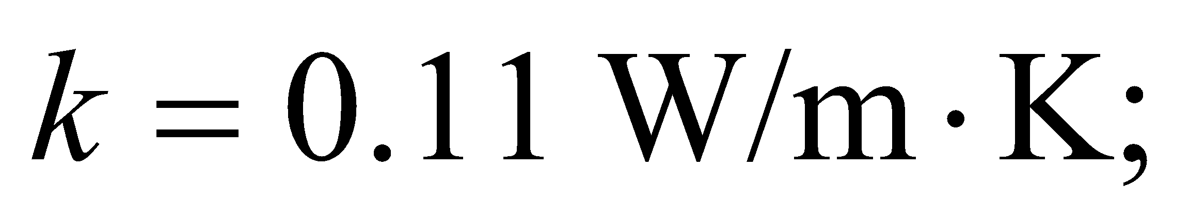Styrofoam 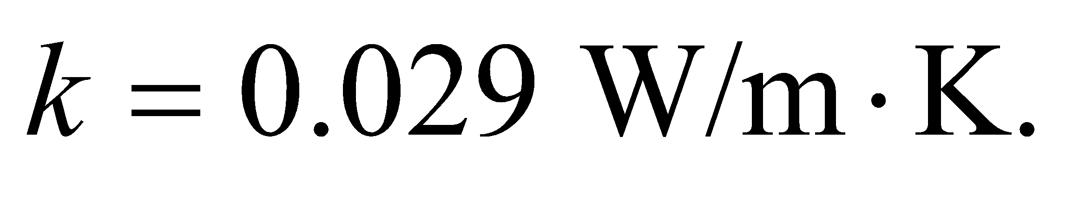 The temperature difference is 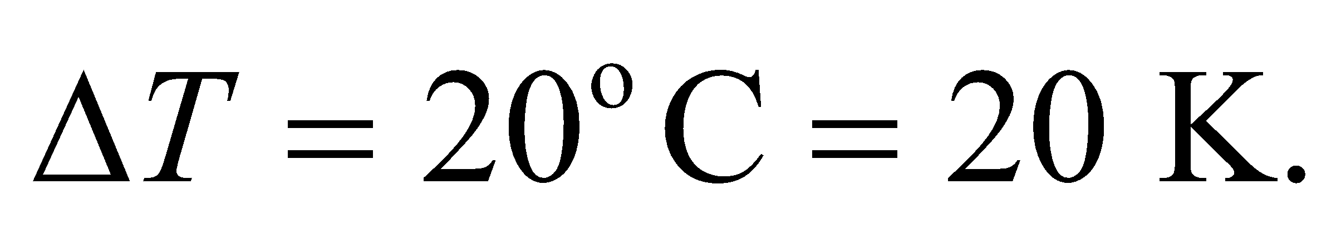 Since we're not given the area of the slabs, we'll write the answers as heat loss per unit area.

**Evaluate** (a) The heat loss through the wood slab is

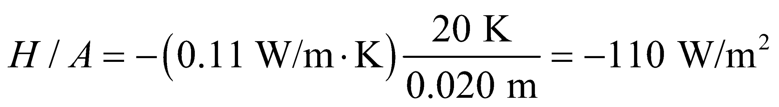

(b) The heat loss through the Styrofoam slab is

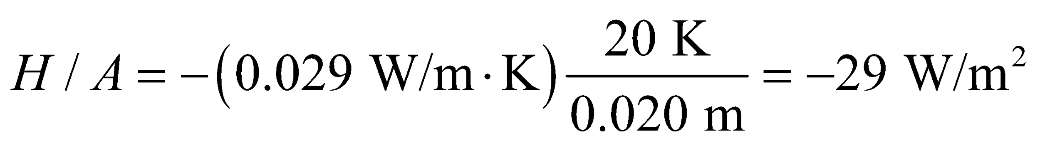

**Assess** The Styrofoam is a better insulator, since it lets less heat escape.

**29. Interpret** This involves calculating the rate of heat conduction through the stove top, given the stove’s dimensions and the inside and outside temperatures.

**Develop** Take the positive-*x* direction to be upward. We assume a steady flow of heat through the an area 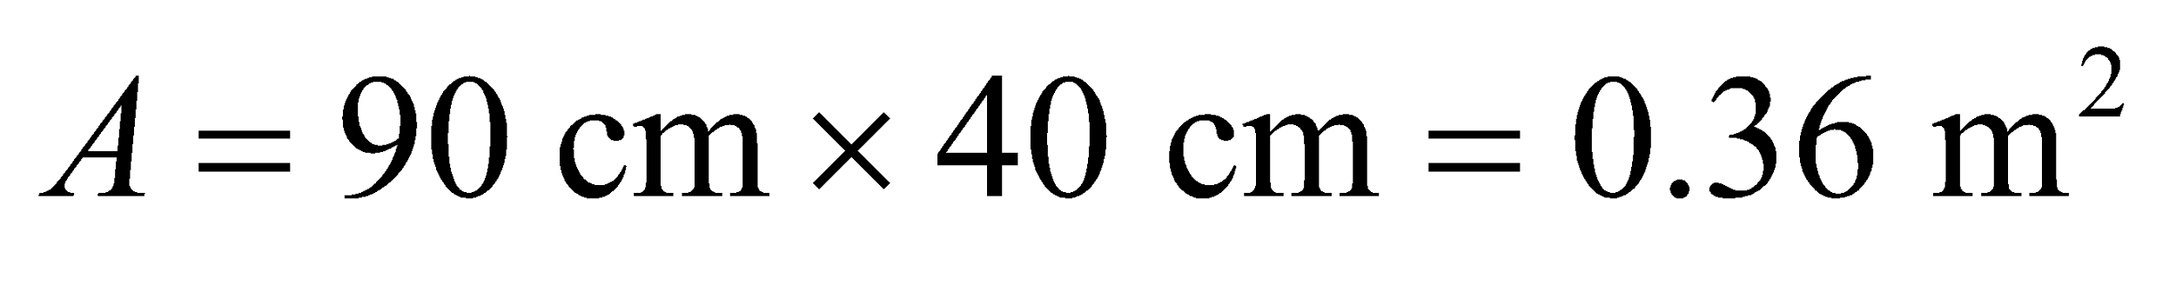, with no flow through the edges. The rate of heat flow is given by Equation 16.5:

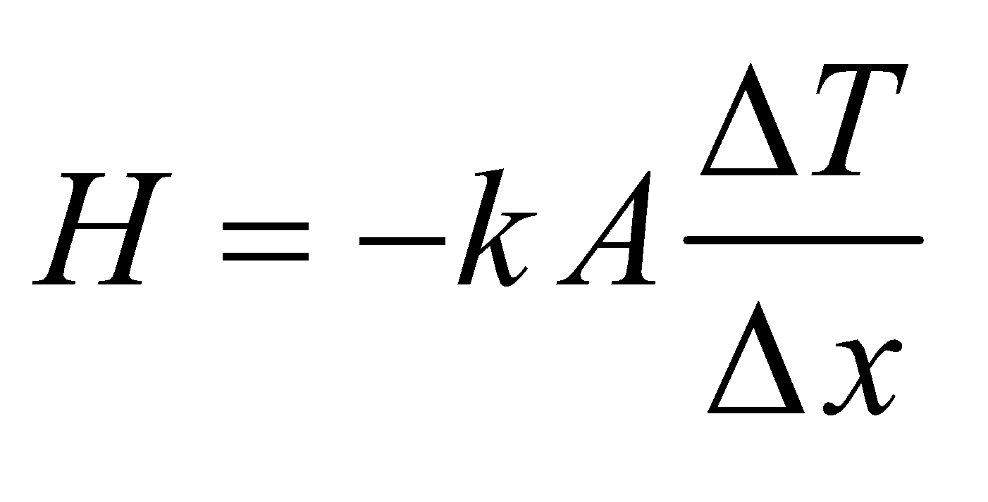

The temperature difference is *ΔT* = *T*outside − *T*inside = 295°C − 310°C = 15°C = −15 K (see Equation 16.1) and *Δx* = *x*outside − *x*inside = 0.0045 m.

**Evaluate** From Table 16.2, we find the thermal conductivity of steel to be *k* = 46 W/(m·K). Thus, the rate of heat conduction is

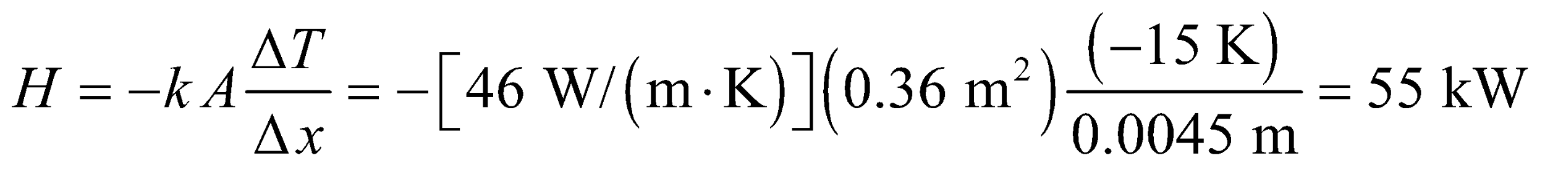

**Assess** The heat flow is positive, for *x* going from the inside of the stove to the outside, because the temperature gradient, 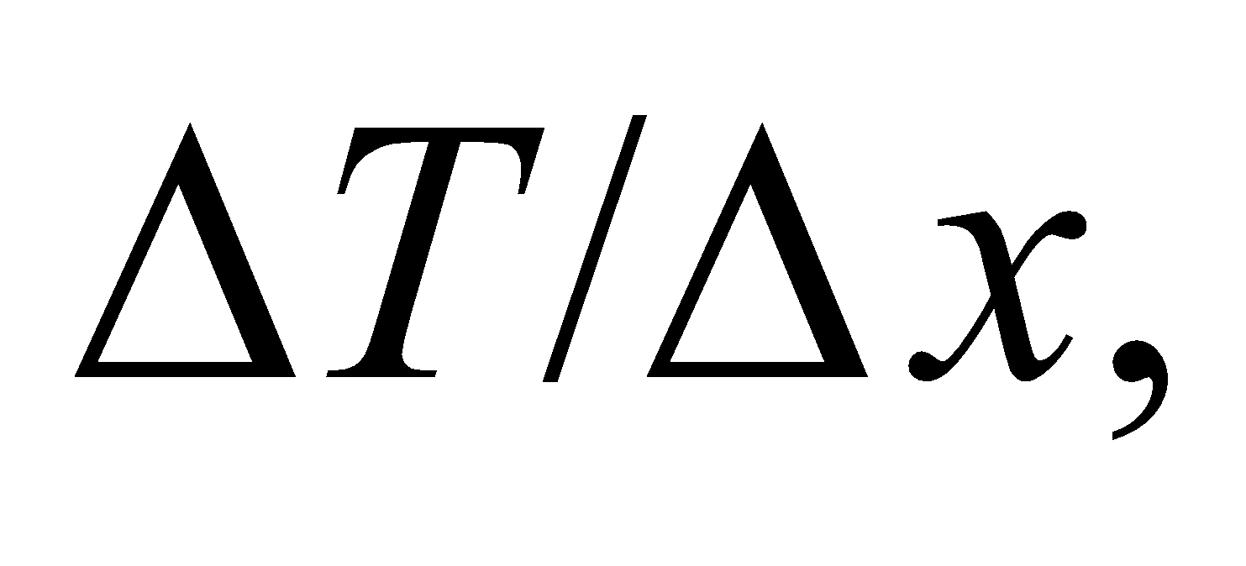 is negative. This means that the thermal energy is flowing from the inside of the stove to the outside of the stove.

**30. Interpret**  want to convince a client that Styrofoam is a very effective insulator.

**Develop** You decide to compare the insulation of 2-inch Styrofoam to that of a concrete wall. Since the area and temperature difference will be the same in both cases, you only need to consider the thermal resistance per unit area, or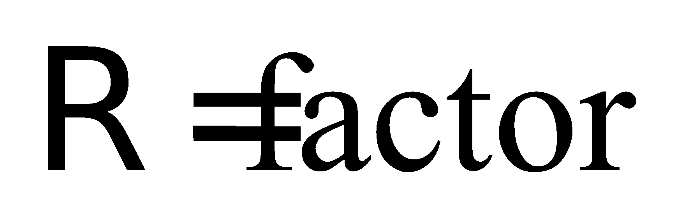of each wall, as defined in Equation 16.8: 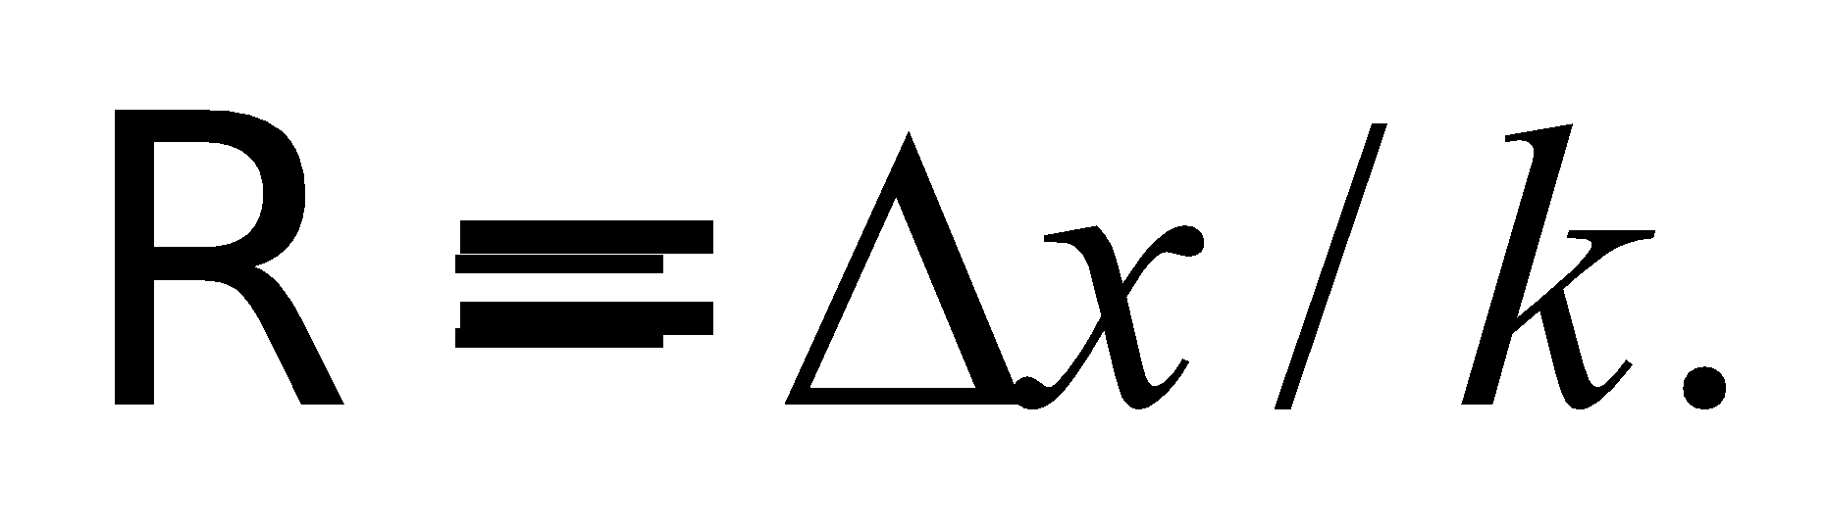 From Table 16.2 the thermal conductivity of Styrofoam and concrete are, respectively, 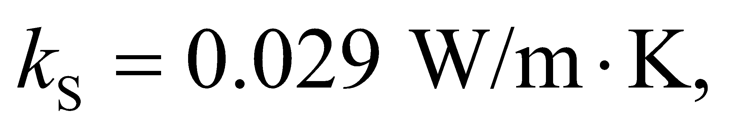 and 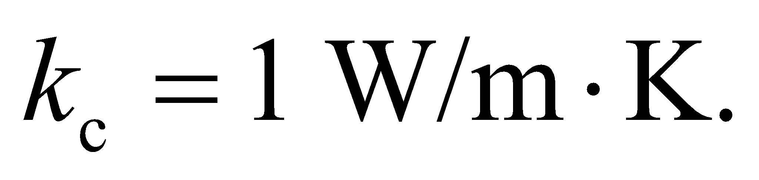

**Evaluate** In order for a concrete wall to have the same as 2-inch Styrofoam, its thickness must be:

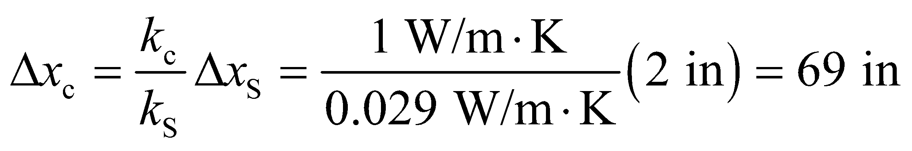

**Assess** One of the reasons Styrofoam is such a good insulator is that it is full of little air pockets, which have a very low heat conductivity: 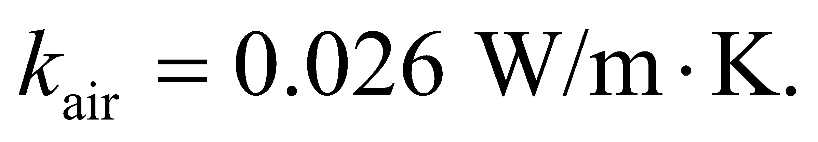

**31. Interpret** This problem involves calculating the rate of heat conduction through the concrete slab, given the temperature difference between the two sides of the slab and the dimensions of the slab.

**Develop** Take the downward direction as the positive-*x* direction. We assume a steady flow of heat through the area 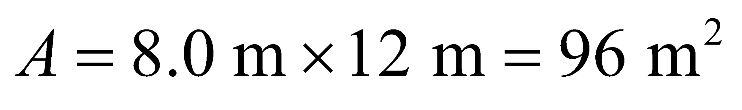, with no flow through the edges. The rate of heat flow is given by Equation 16.5:



The temperature difference is *ΔT* = *T*outside − *T*inside = 10°C − 20°C = −10°C = −10 K (see Equation 16.1) and *Δx* = *x*outside − *x*inside = 0.23 m.

**Evaluate** From Table 16.2, we find the thermal conductivity of concrete to be *k* = 1 W/(m·K). Thus, the rate of heat conduction is

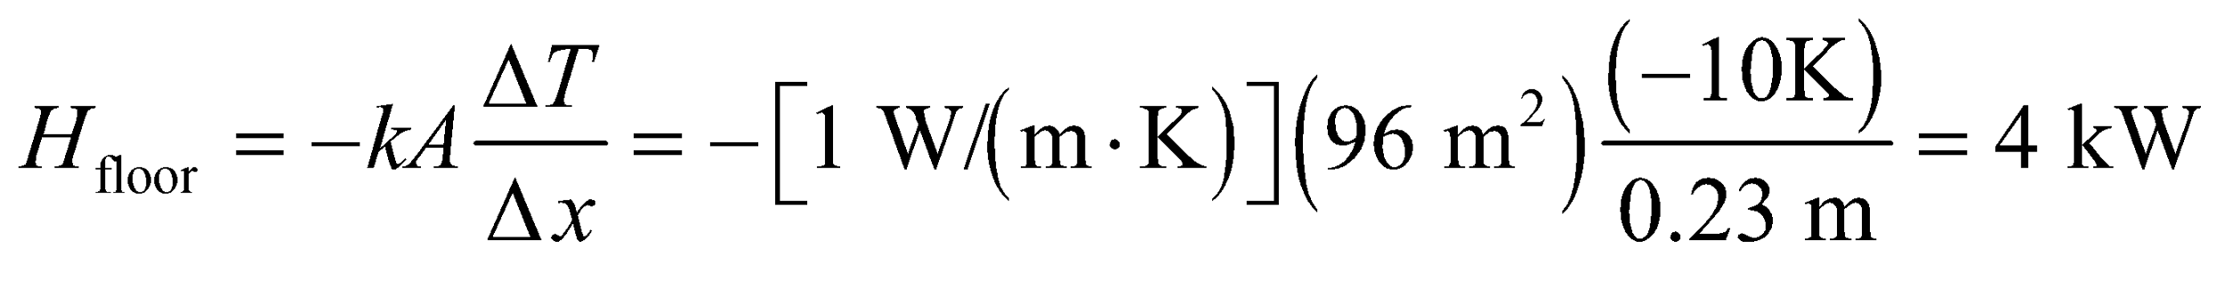

which is reported to a single significant figure because the thermal conductivity of concrete is given to one significant figure.

**Assess** The energy loss through the floor by conduction is substantial. That’s why carpeting can prevent heat loss and keeps the house warm during winter season.

**32.** **Interpret** For this problem, we are to find the thermal resistance per unit area (the factor) of a wall given the temperature difference and the rate of heat flow.

**Develop** Equation 16.5 for the rate of heat-flow per square foot through a slab, written in terms of the thermal resistance of the slab (Equation 16.6), is 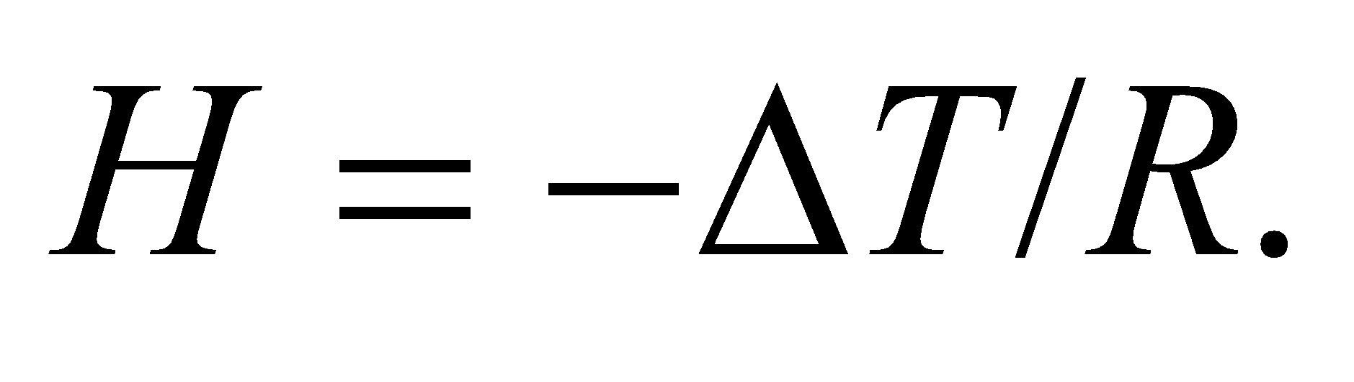 Dividing each side by the area A and using Equation 16.8 ( = *RA*) gives

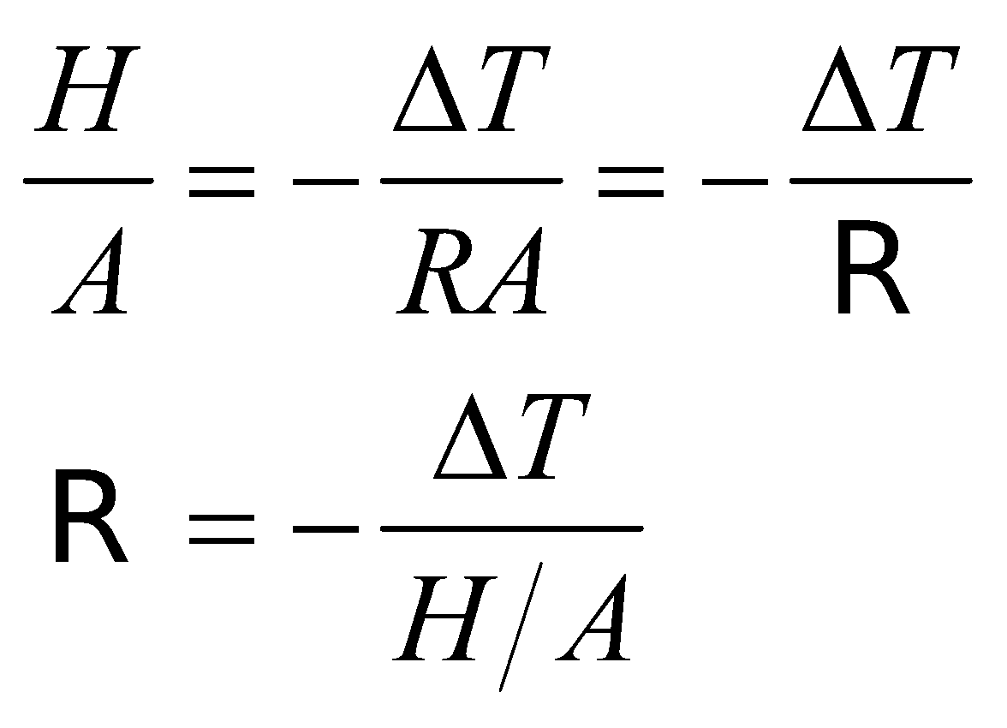

Given that the heat flow per square meter is

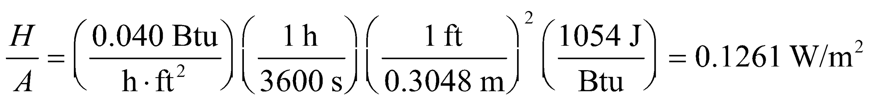

and

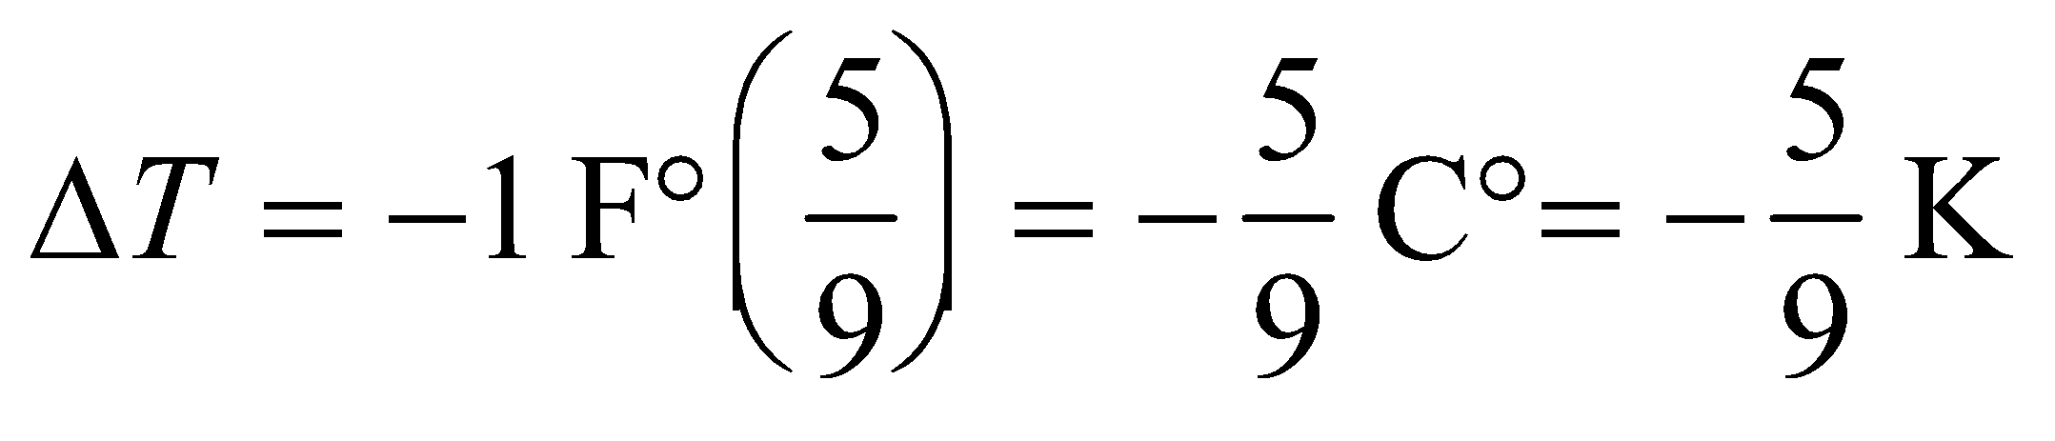

where we have used *ΔT*F = 5*ΔT*C/9 (see Problem 16.16), we can calculate.

**Evaluate** The  factor is

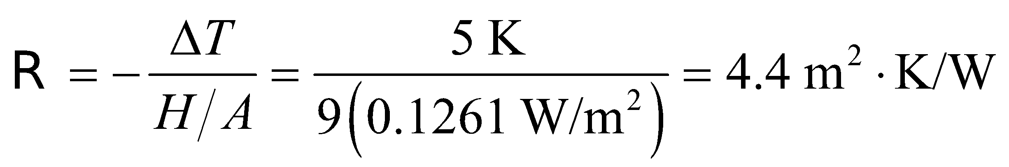

**Assess** There temperature difference is negative because the heat flow is in the direction of decreasing temperature.

**33. Interpret** This problem is an exercise in calculating the  factors for various materials of 1-inch thickness.

**Develop** The -factor of a material is given by Equation 16.8:

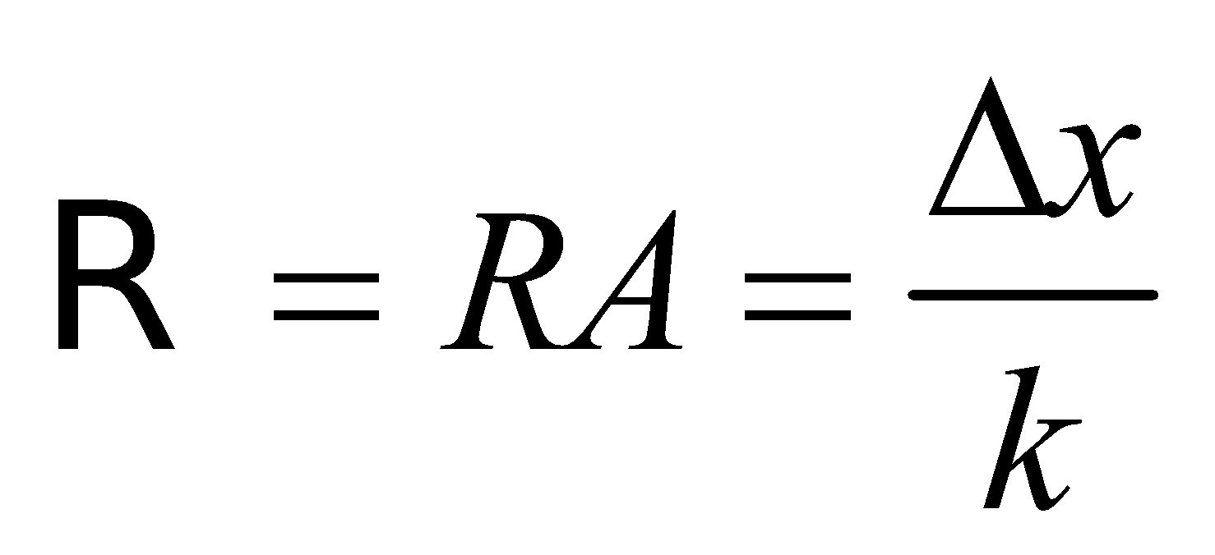

where *R* is the thermal resistance and *k* is the thermal conductivity of a material having a thickness *Δx*. We will calculate the  factors in SI units, using *Δx* = 1 in = 25.4 mm = 0.0254 m.

**Evaluate** Using Table 16.2, with 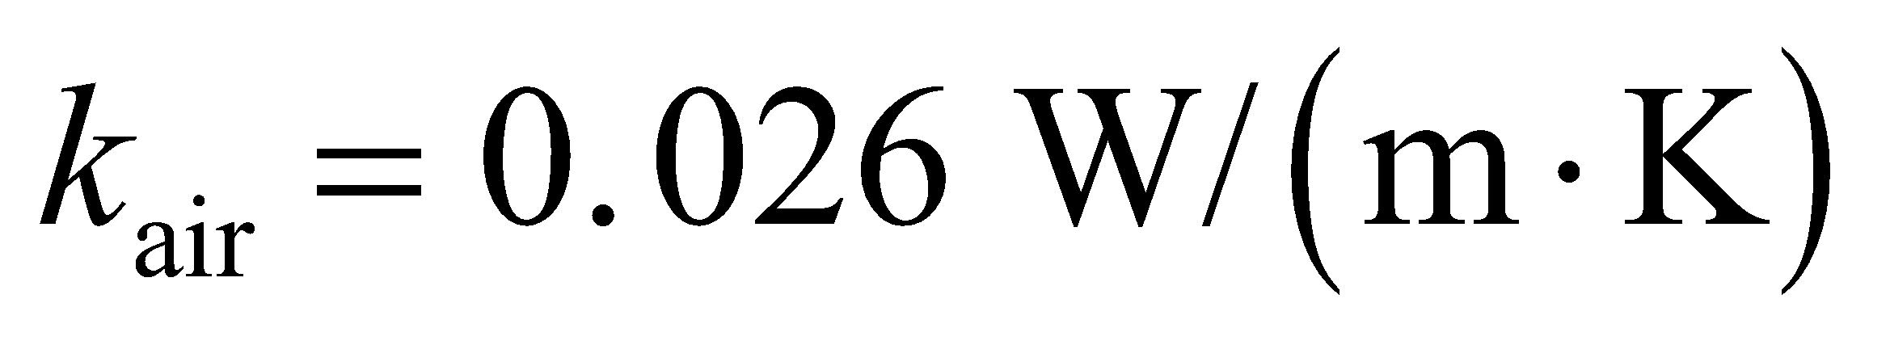 for air, we have

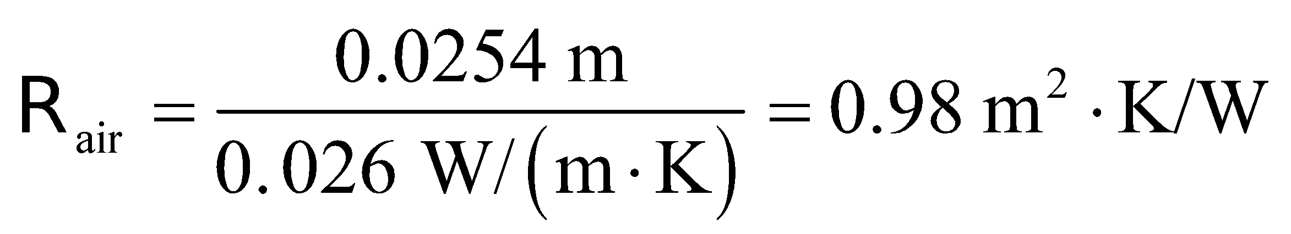

Similarly, with 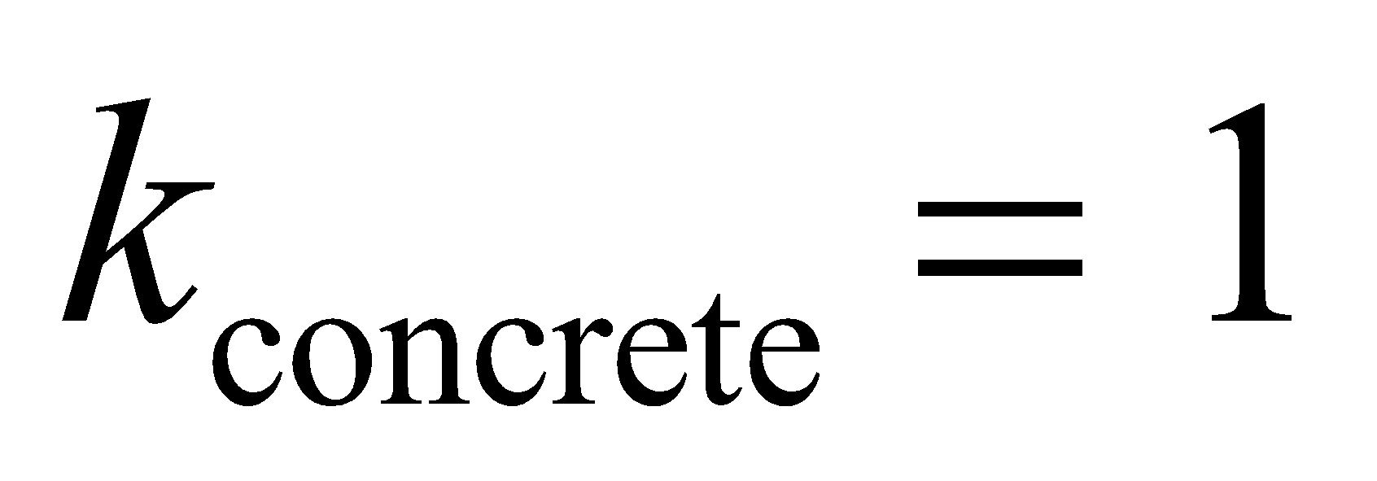, 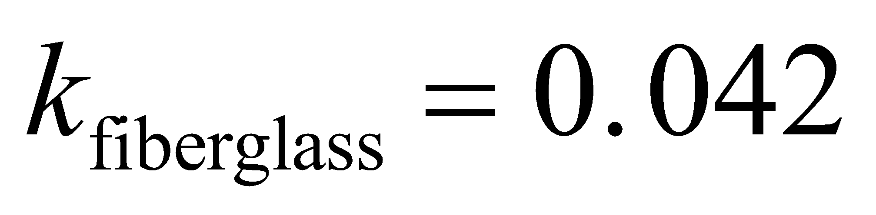 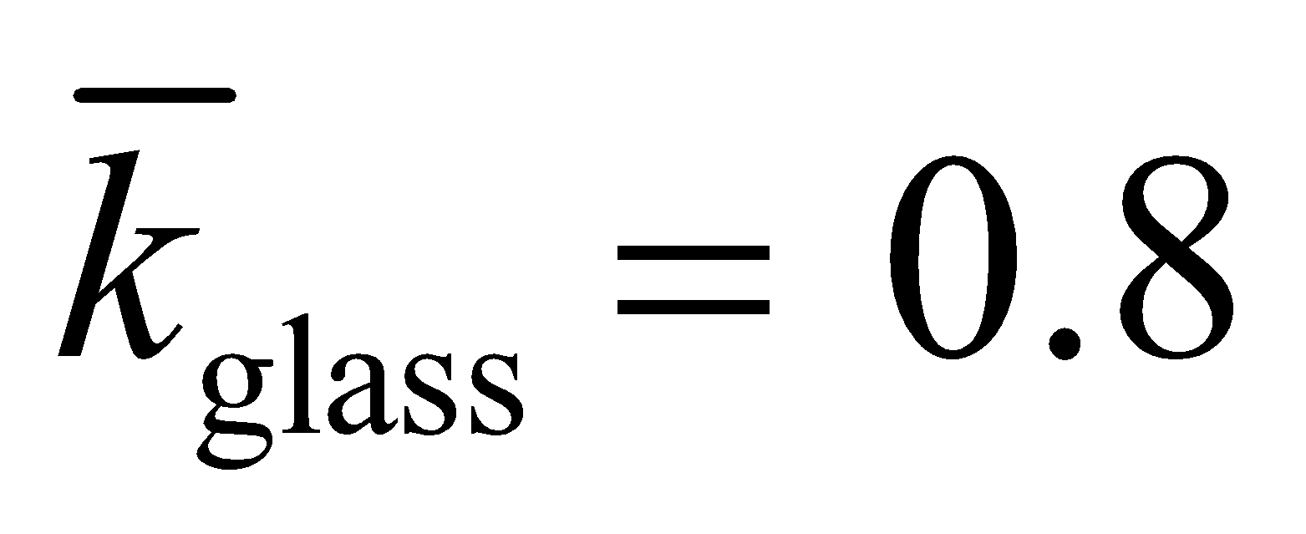, 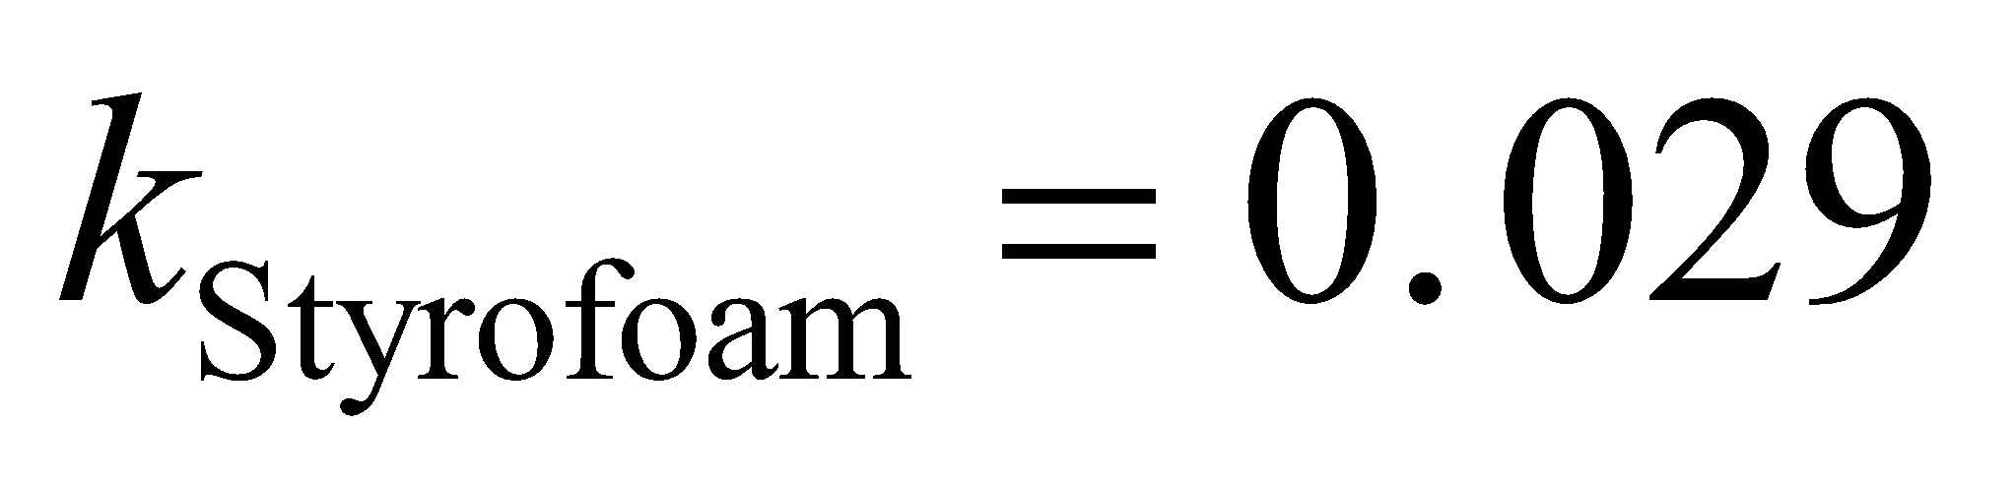 and 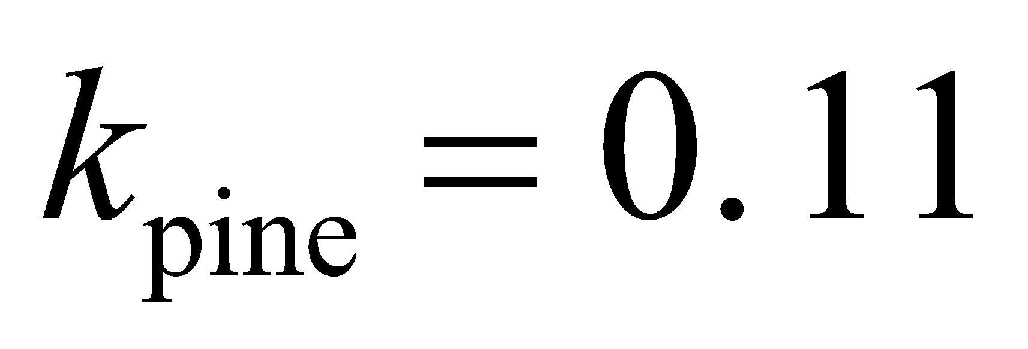 [all in units of W/(m·K)], the -factors are

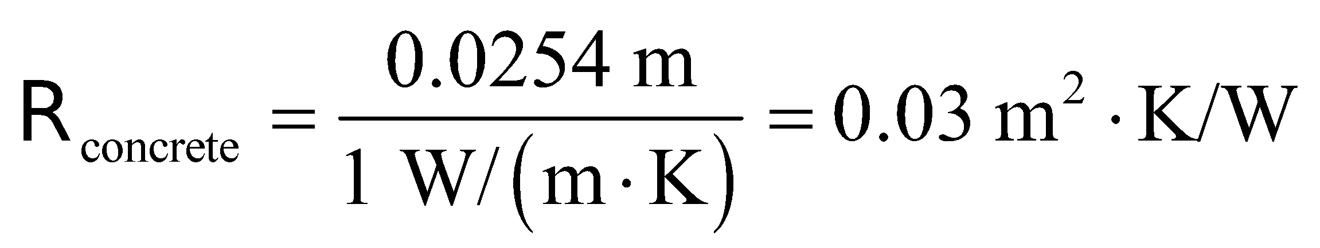

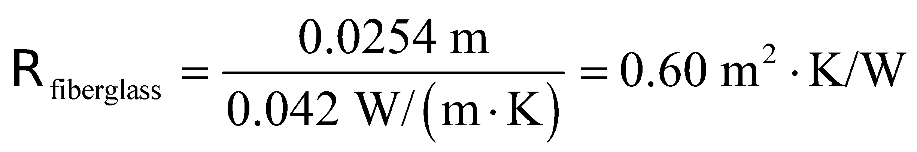

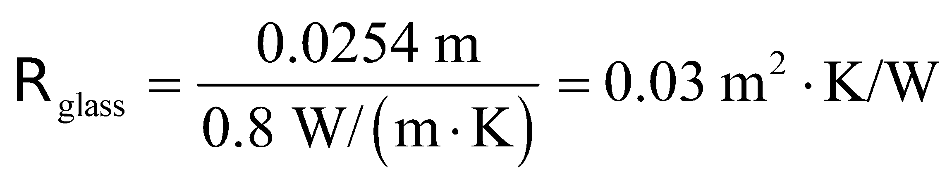

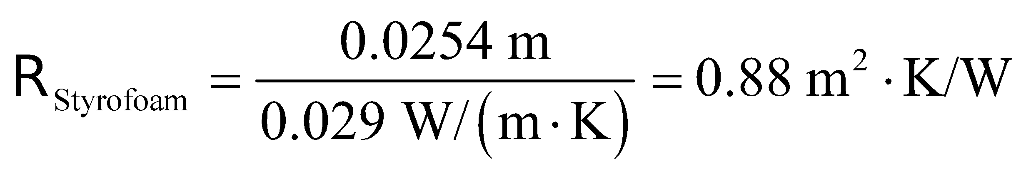

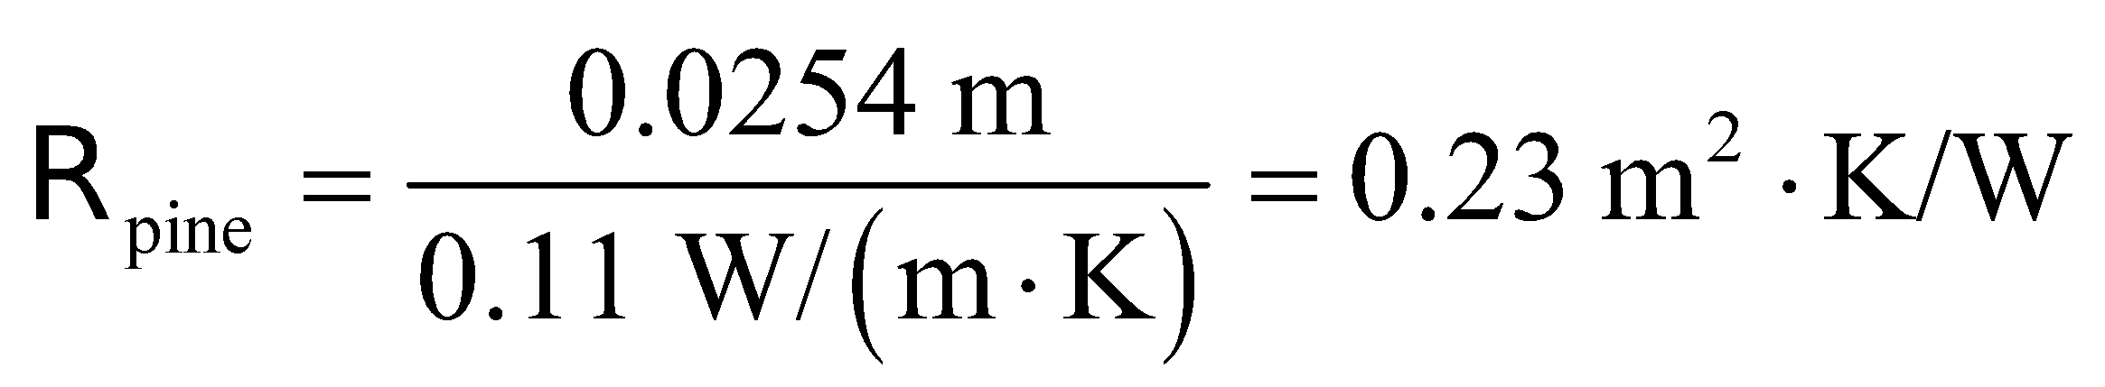

**Assess** The -factor of a material is inversely proportional to the thermal conductivity. Good thermal insulators such as Styrofoam or wood have large -factors.

**34. Interpret**Given an object’s surface area and temperature, we are to find the rate of radiative heat loss. We will use the Stefan-Boltzmann law.

**Develop** The Stefan-Boltzmann law (Equation 16.9) for radiative power is 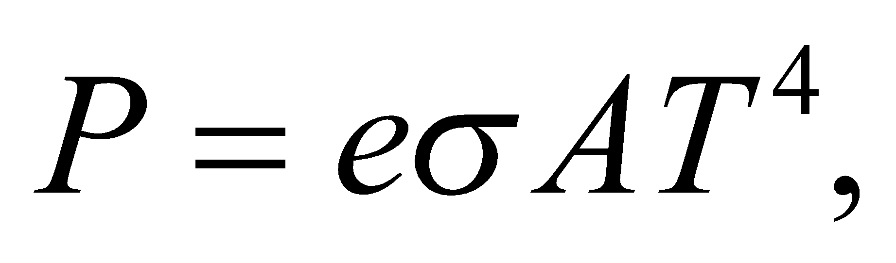 where the Stefan-Boltzmann constant is 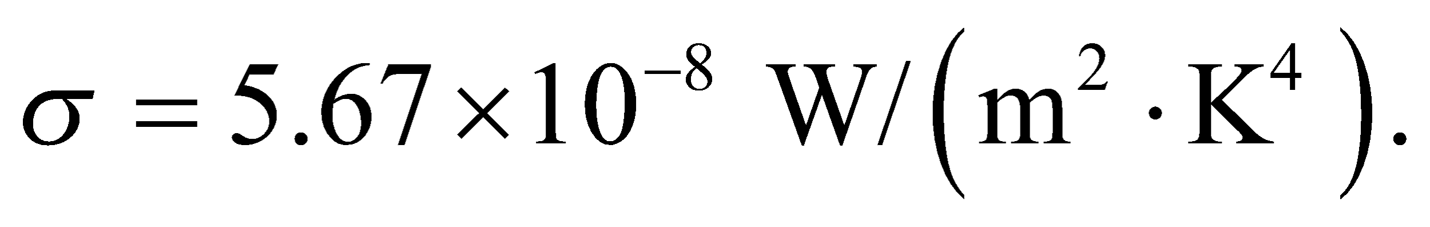 The temperature of the horseshoe is T = 810°C = 1083 K (see Equation 16.1) and the area is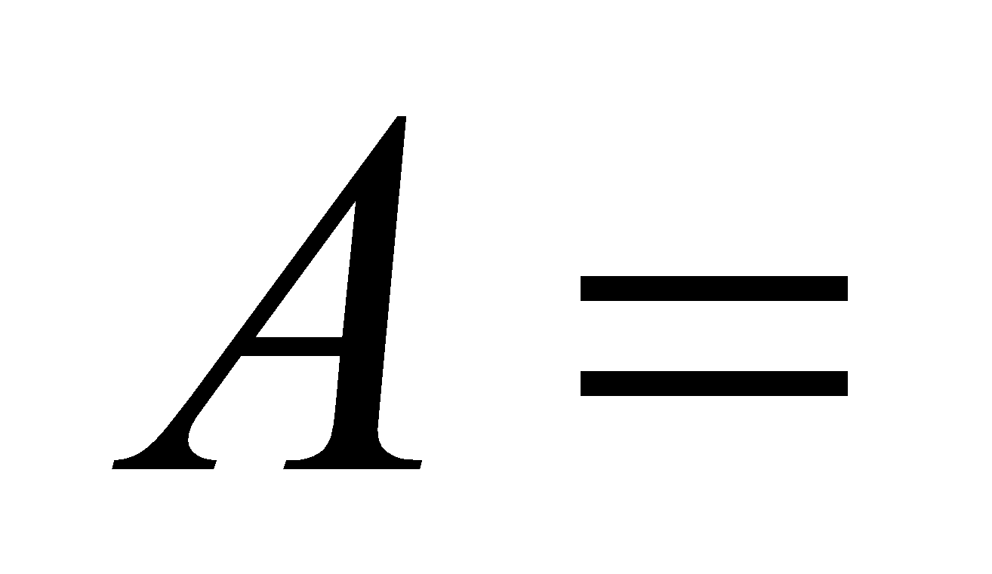 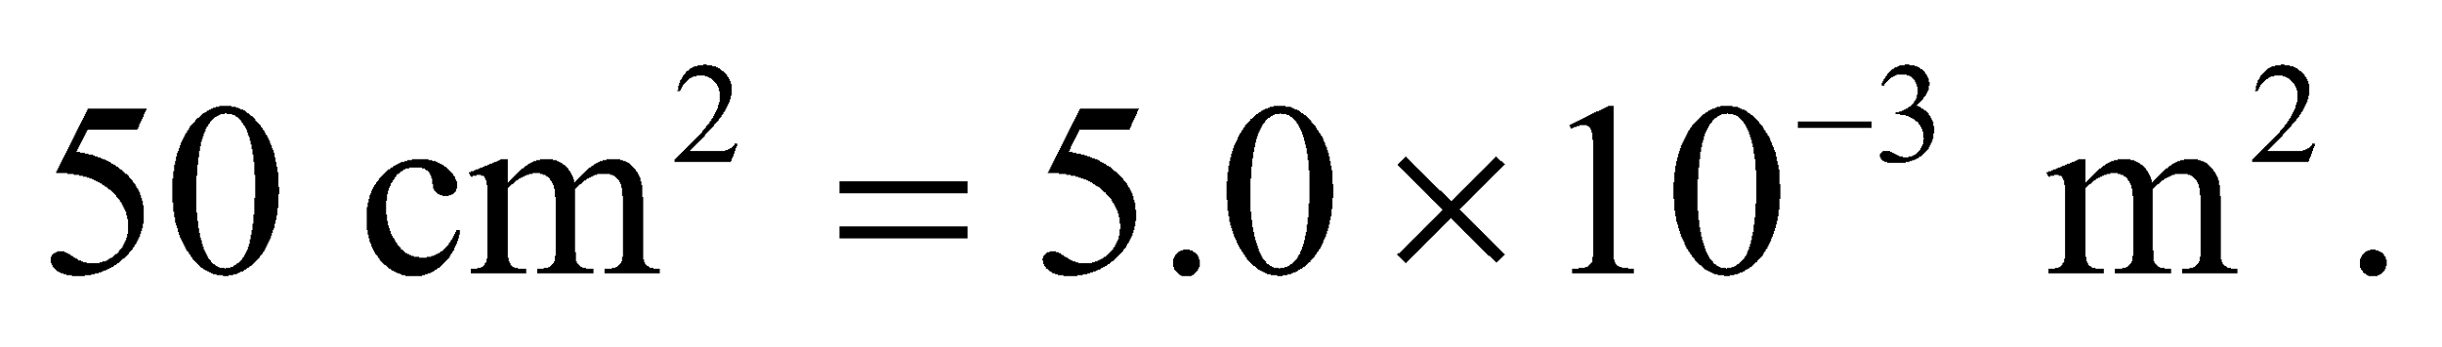We do not know the emissivity *e*, so we will approximate it by *e* = 1.0.

**Evaluate** Inserting the given quantities into the Stefan-Boltzmann law gives



**Assess**This is a bit more than a large indoor lamp. The radiative heat must be less than this because *e* ≤ 1, and the heat loss would decrease linearly with *e*.

**Section 16.4 Thermal-Energy Balance**

**35. Interpret** This is an energy-balance problem involving a stove. We are given the energy loss per unit time per degree temperature difference, and the temperature difference. Note that we are not given the heat-loss mechanism(s), although we can assume it is primarily convection and radiation. We wish to find the rate of energy loss, which by energy balance must be the power required to maintain the temperature.

**Develop**The thermal energy leaving the oven is *H*T*ΔT*, which must be balanced by the power *P* supplied to the oven in order to maintain thermal-energy balance. We multiply the energy loss rate per degree by the temperature difference in degrees. We can therefore write

*P* = *H*T*ΔT*

**Evaluate**Inserting *H*T = 14 W/C° and *ΔT* = (180°C − 20°C) = 160 C° gives

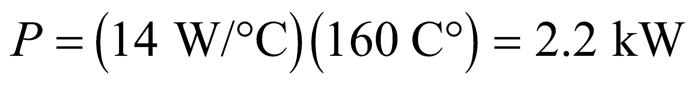

**Assess**2 kW is a reasonable power requirement for an oven.

**36. Interpret** This is an energy-balance problem. You know the rate of energy loss per degree of temperature difference between the inside and the outside of your house. You just need to calculate what the maximum loss would be for the coldest winter days, and compare that to the power supplied by the heating system.

**Develop** The coldest temperature difference will be 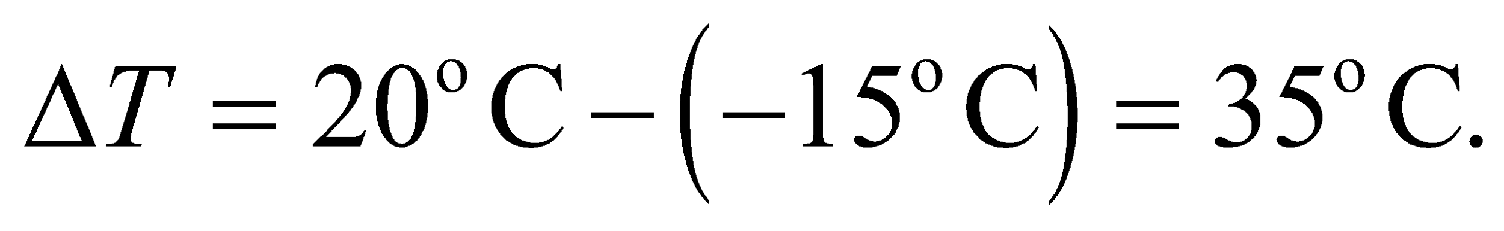

**Evaluate** The heat loss rate in your house on the coldest days is

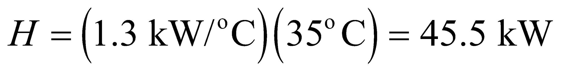

No, you should not buy the 40kW heating system, since you need 5.5 kW more power.

**Assess** Instead of buying a more powerful heating system, it is often cost-effective to add more insulation to reduce the heat-loss rate.

**37. Interpret** This problem involves radiative heat loss and the Stefan-Boltzmann law.

**Develop**Apply the Stefan-Boltzmann law, Equation 16.9, which is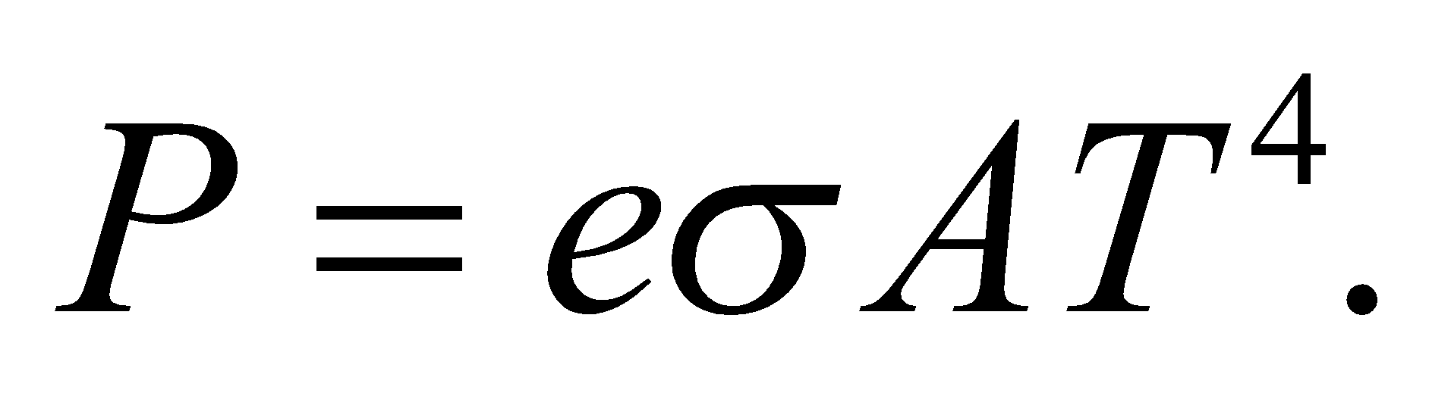 The power is P = 100 W, the temperature is T = 3000 K, and s = 5.67 × 10−8 W/(m2·K4), so we can solve for the area *A.* We will assume that the emissivity is 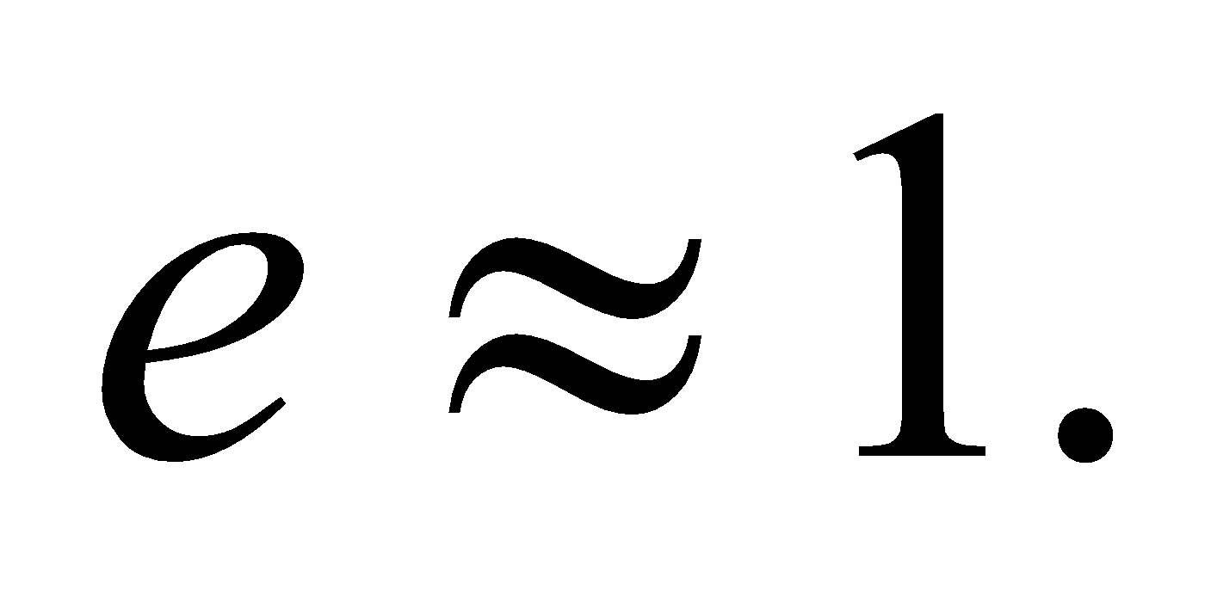

**Evaluate** Inserting the given quantities into the Stefan-Boltzmann law gives

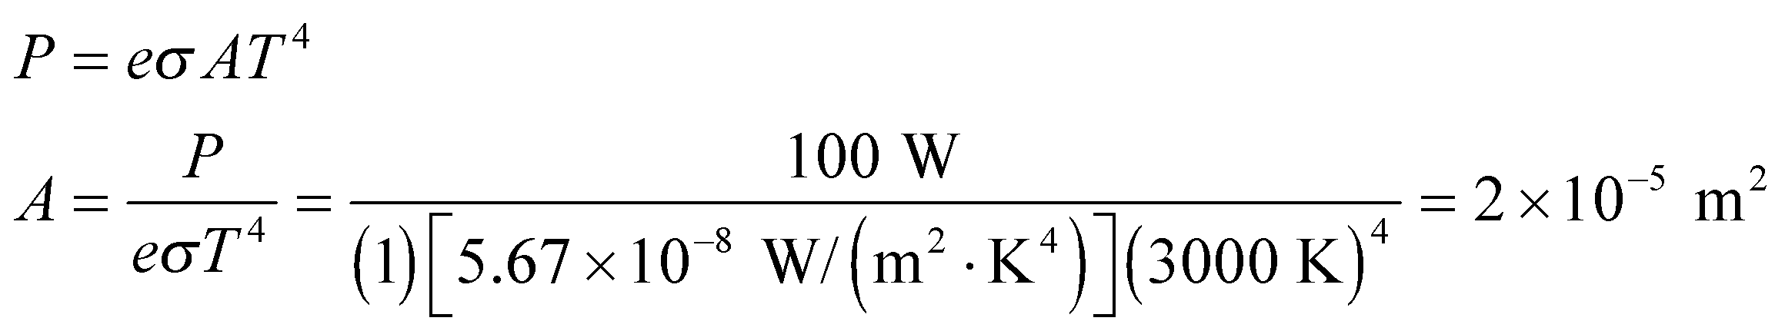

**Assess**This is about 20 square millimeters, which seems reasonable for the total area of a light bulb filament.

**38. Interpret** We want to find the net radiation from a human body.

**Develop** The Stefan-Boltzmann law tells us the rate of radiation emitted by an object of area *A* and temperature *T*: 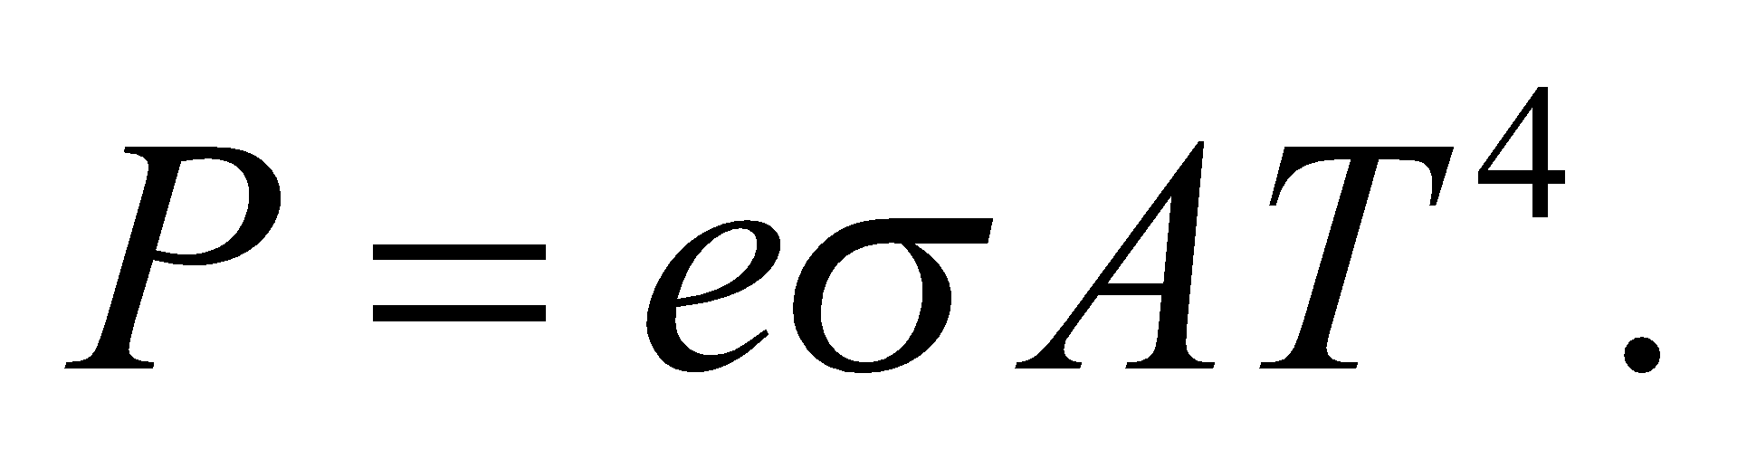 But this is also the rate radiation is absorbed by this object from its surroundings at ambient temperature, 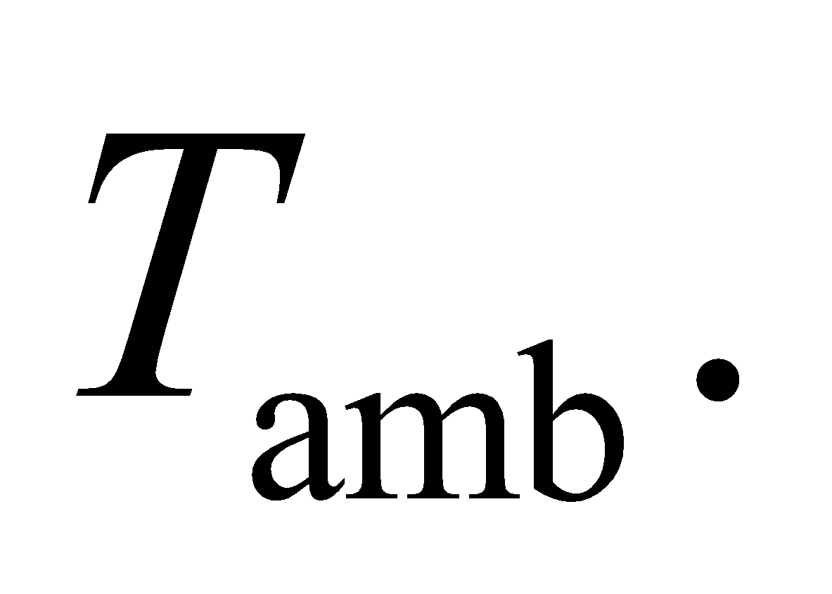 These temperatures have to be expressed in Kelvin, so 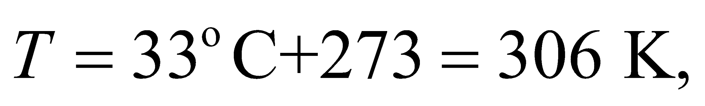and 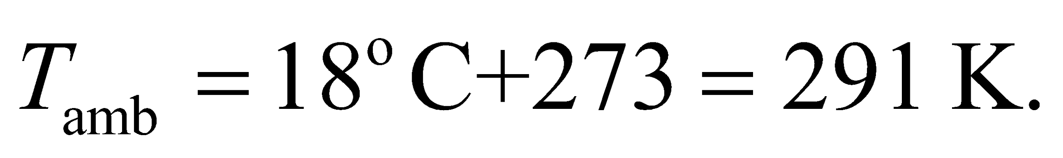

**Evaluate** Since the power emitted is a loss of heat, we'll treat it as negative, whereas power absorbed is positive. We're told to treat the body as a perfect emitter/absorber 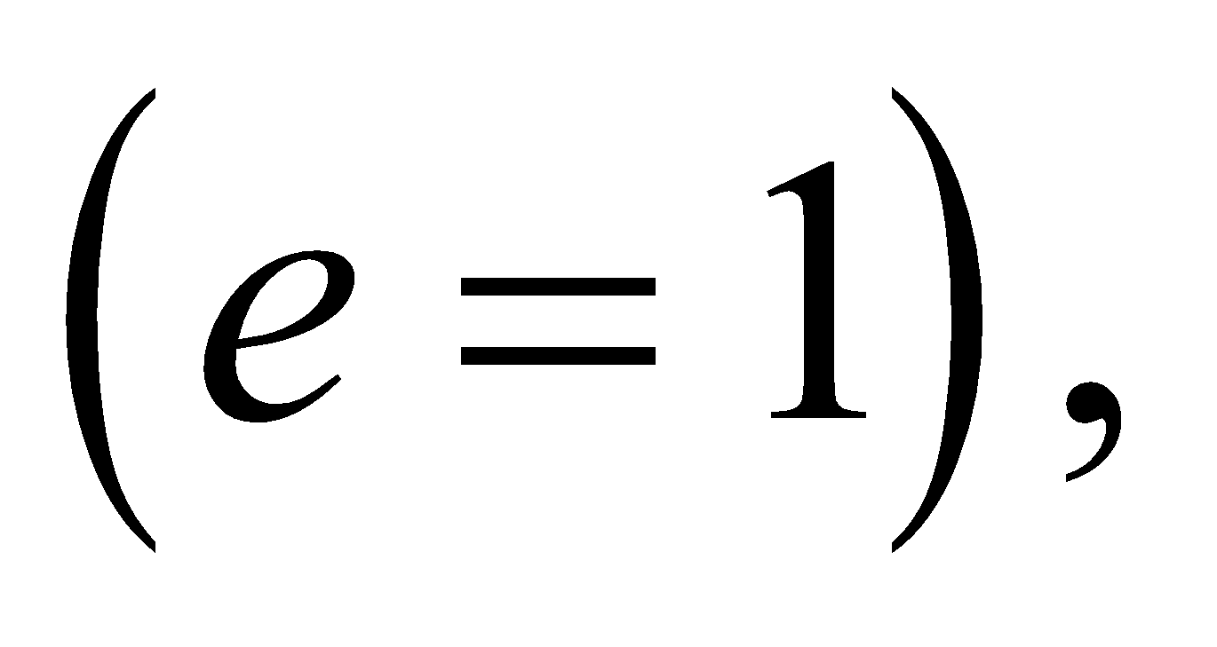so the body's net radiation transfer is

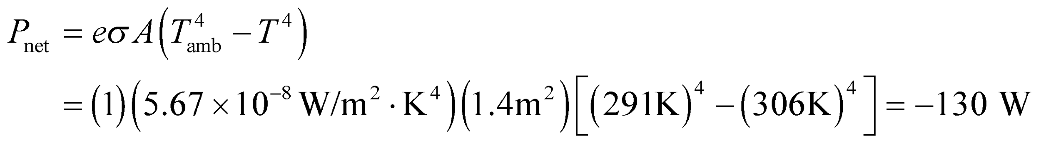

**Assess** Over the course of a day, this radiation loss corresponds to about 2600 kilocalories. This is an overestimate since wearing clothes will affect the energy balance by keeping a warm air buffer next to the body.

**Problems**

**39. Interpret** This problem is about finding the pressure at different temperatures, given its pressure at a reference temperature and that the volume is held constant.

**Develop** For a constant-volume system, the pressure will be linear in temperature (see Figure 16.3). Therefore, we can write

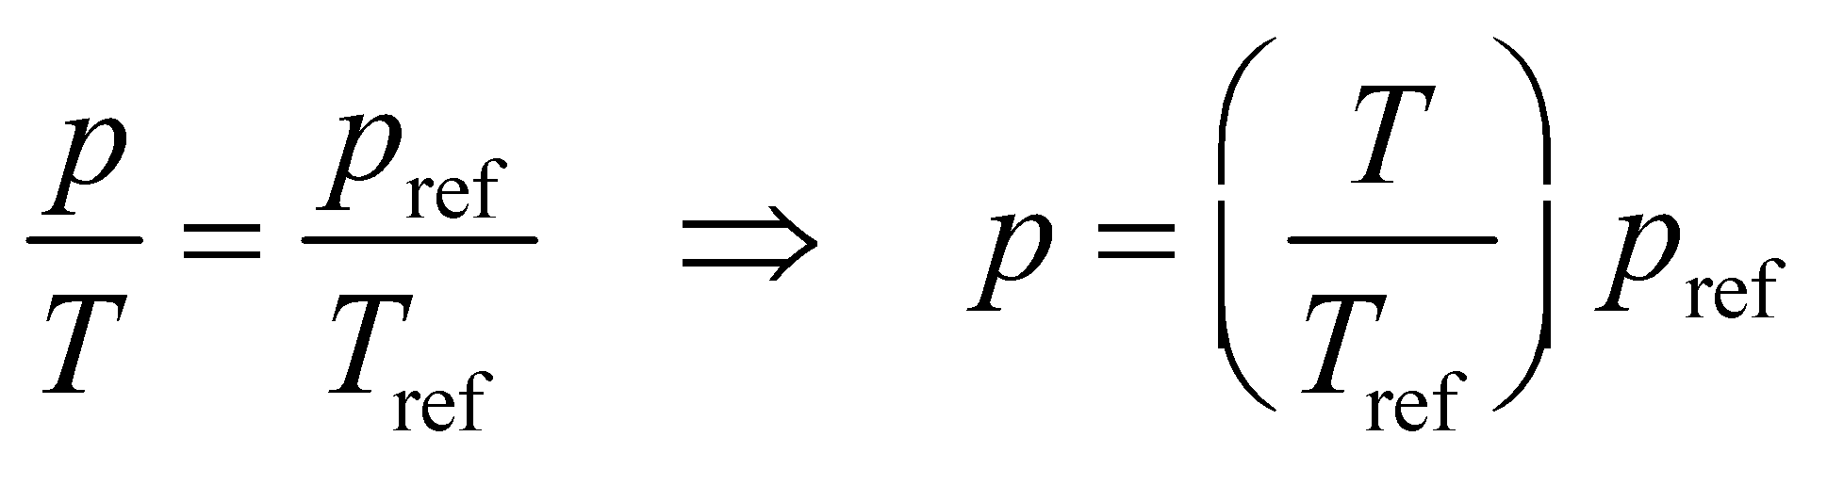

If we use the given values at the normal melting point of ice, then the pressure-temperature relationship is

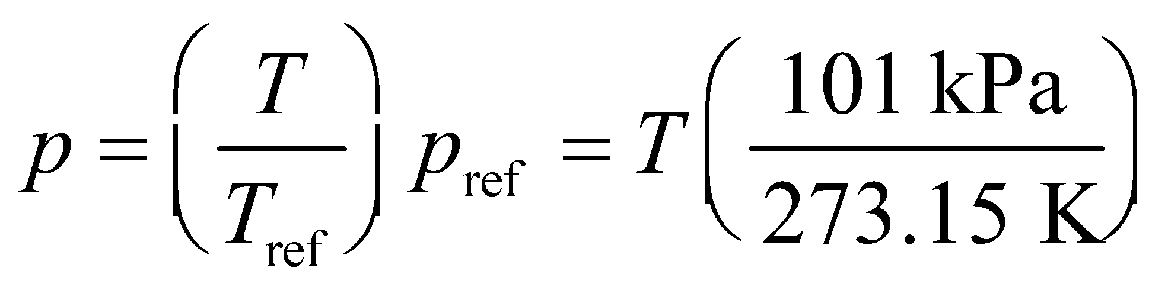

**Evaluate** **(a)** When the temperature is the normal boiling point of water *T* = 100 °C = 373.15 K, the pressure is

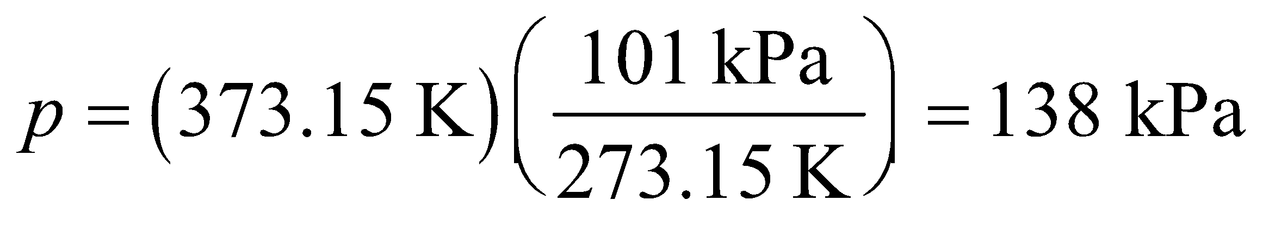

**(b)** If the temperature is the normal boiling point of oxygen (90.2 K), then

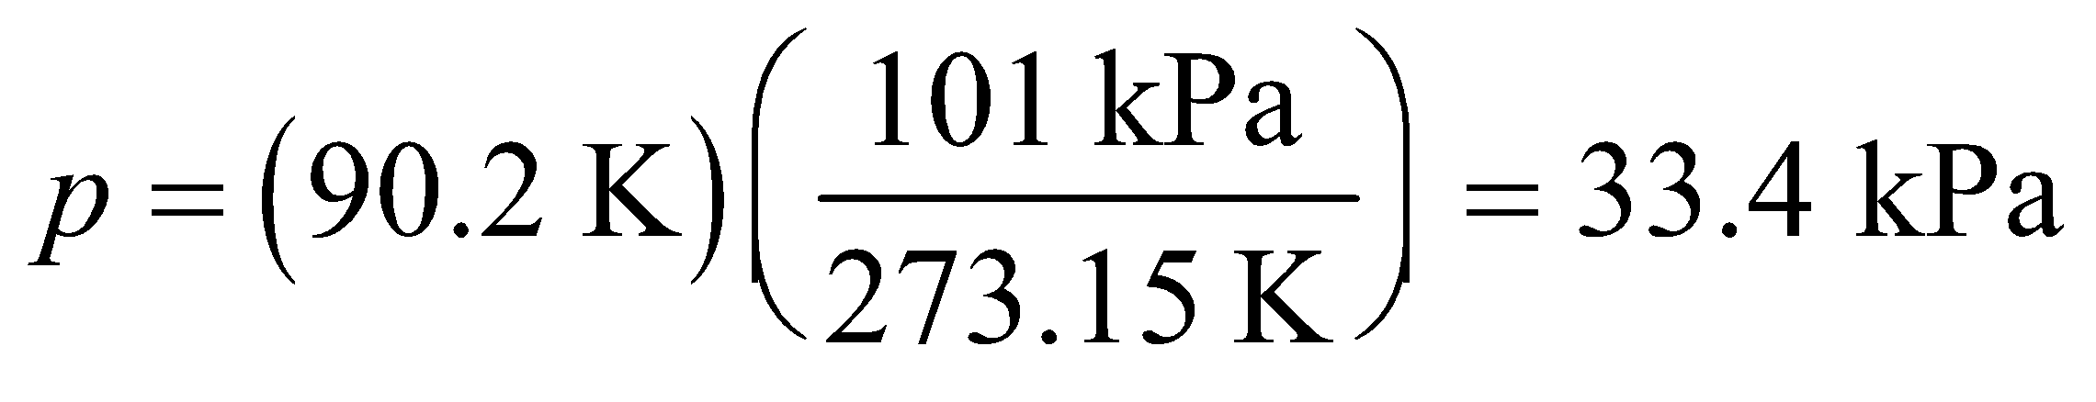

**(c)** If the temperature is the normal boiling point of mercury (630 K), then

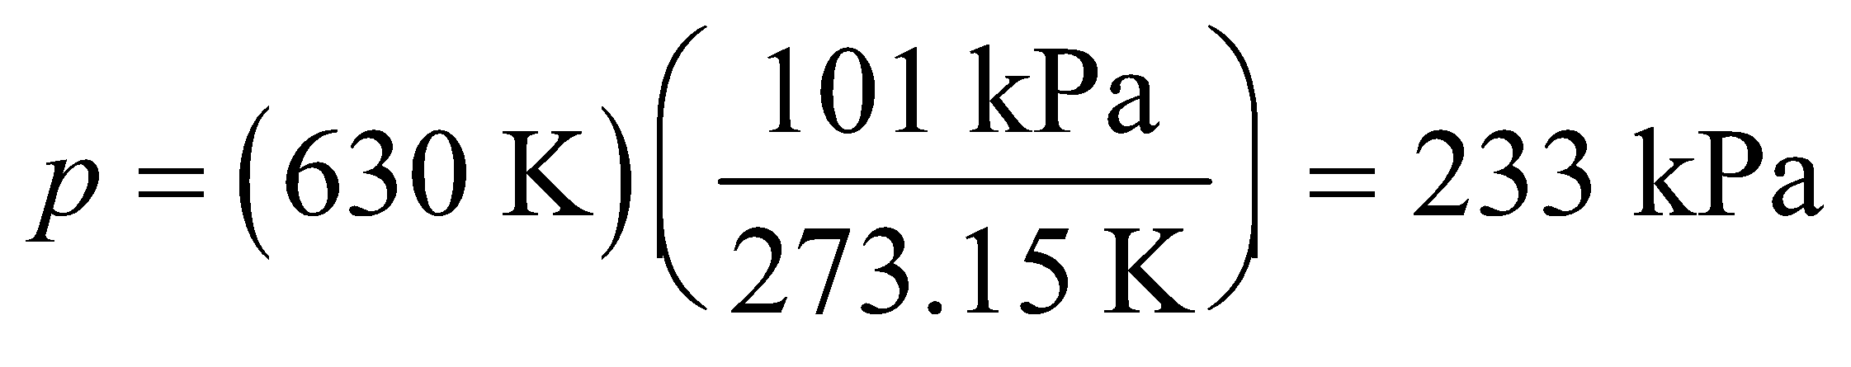

**Assess** These results hold only if the volume is held constant while the temperature varies.

**40.** **Interpret** This problem involves the change in pressure for a constant-volume system that changes in temperature, given the initial pressure and temperature and the temperature change.

**Develop** Because this is a constant-volume process, we known from Figure 16.3 that pressure and temperature are linearly related, so we can write

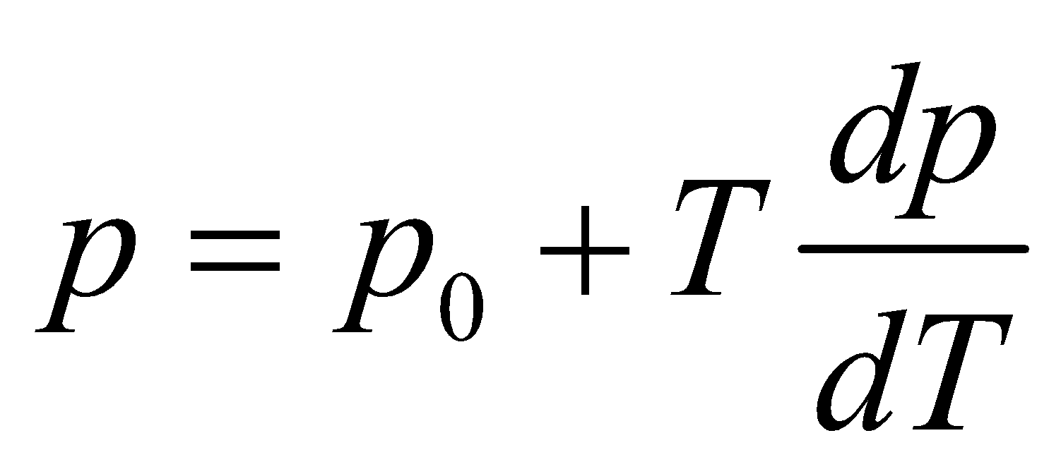

where *dp/dT* is the slope of the curve. Because the pressure is zero when the temperature is zero, *p*0 = 0. The slope of the curve is then just the ratio of pressure to temperature at any point, which is constant, which we can obtain from the given pressure and temperature of the triple point of water:

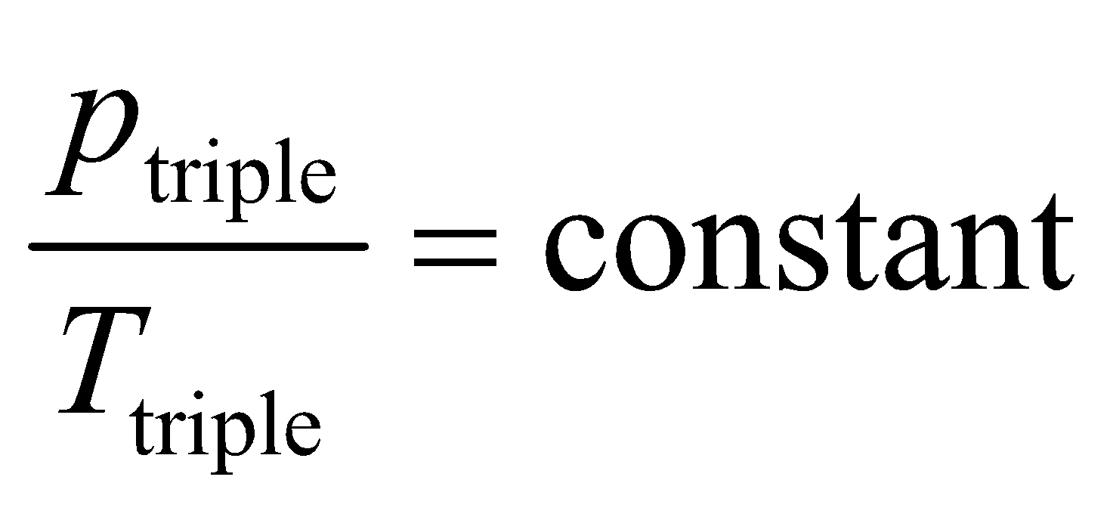

where *p*triple = 55 kPa and *T*triple = 273.16 K. Thus, the change in pressure is

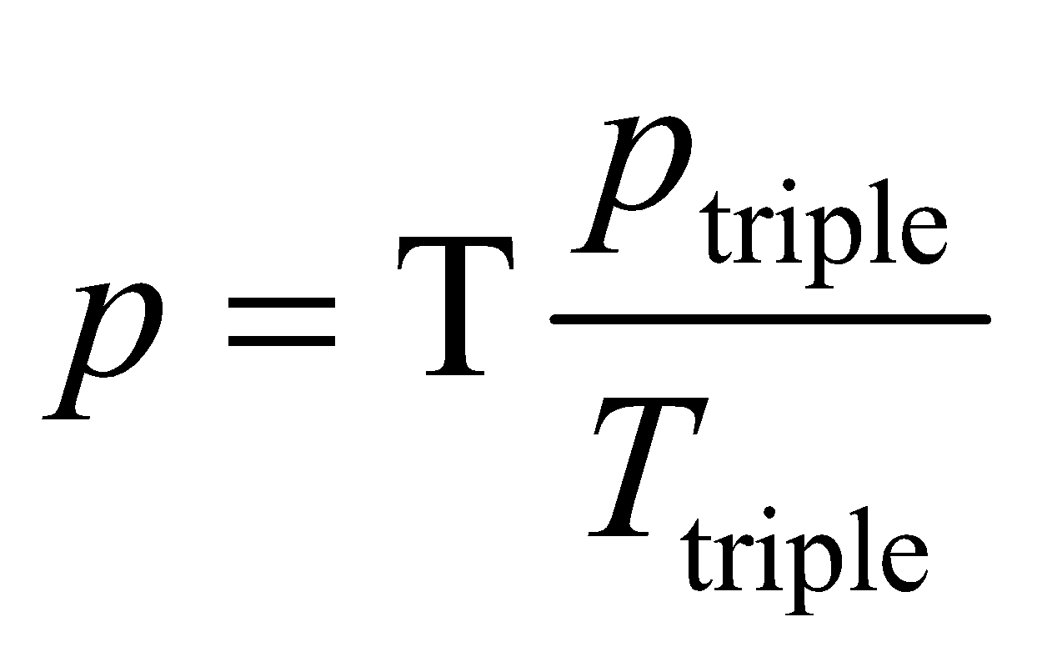

**Evaluate**  For a one-Kelvin change in temperature (*T* = 1 K), the pressure will change by

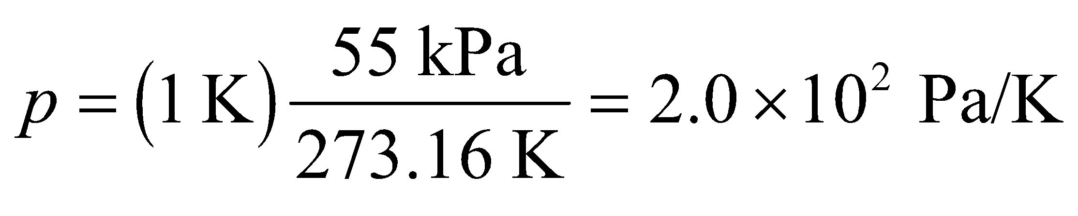

**Assess** The result is reported to two significant figures to reflect the precision of the data.

**41. Interpret** In this problem, we are asked to calculate the boiling point of SO2, given the height difference between the liquid levels in a constant-volume gas thermometer.

**Develop** The thermometric equation for an ideal constant-volume gas thermometer is (see Problem 16.39)

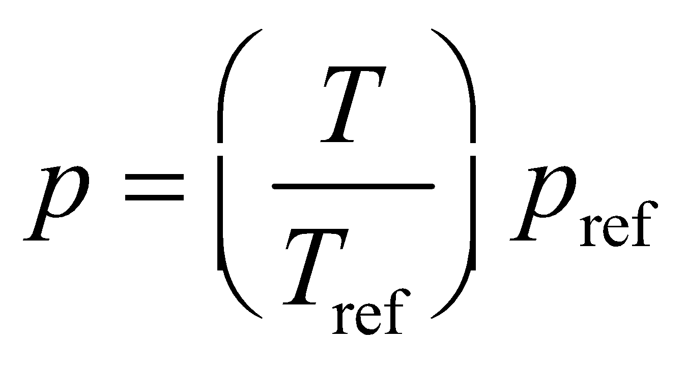

where *T* is measured in the Kelvin scale. Since the pressure in the constant-volume gas thermometer shown is proportional to *h*, the temperature of the boiling point of SO2 is

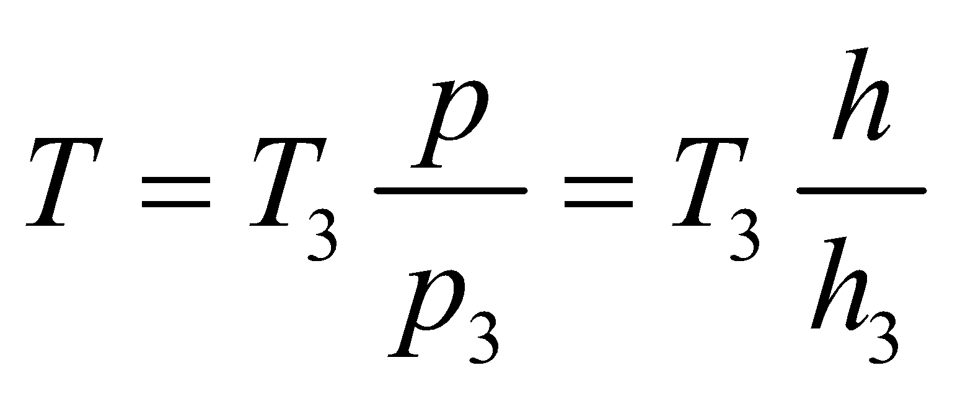

**Evaluate** From the equation above, we find the boiling point of SO2 to be

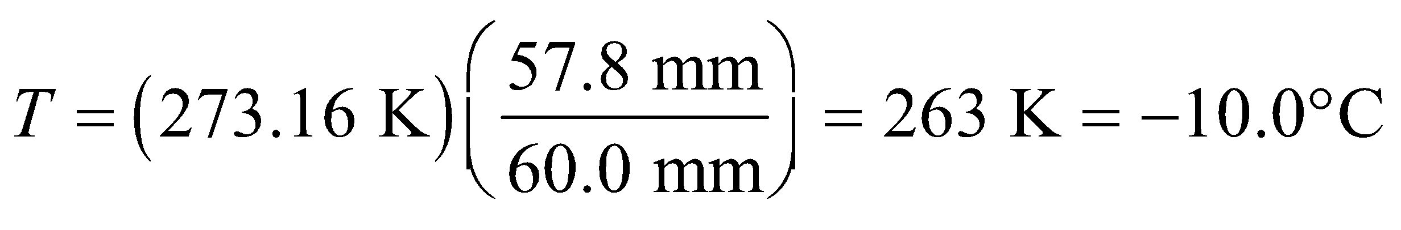

**Assess** For a constant-volume gas thermometer, *p*/*T* is constant. Since pressure can be measured in mm of mercury 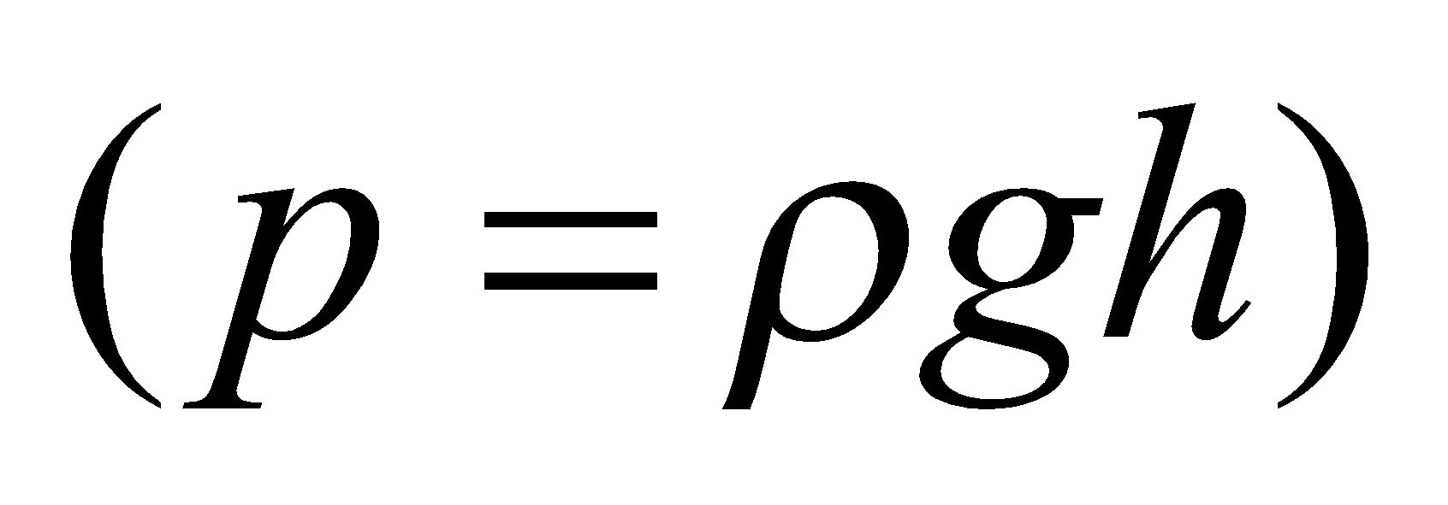, it is also true that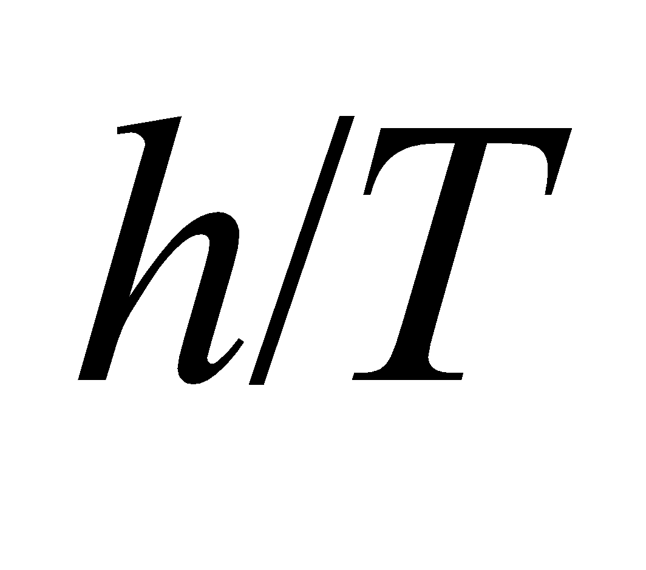is constant.

**42.** **Interpret** This problem involves calculating the minimum work done climbing a mountain, which is work done against gravity. We are then to convert this energy to kcal.

**Develop** The work done against gravity is *W* = *mgh* (Equation 7.3), which gives the result in joules. To convert this to kcal use the conversion factor 1 kcal = 4.184 kJ (Appendix C).

**Evaluate** The minimum number of Calories *Q* burned off climbing the mountain is

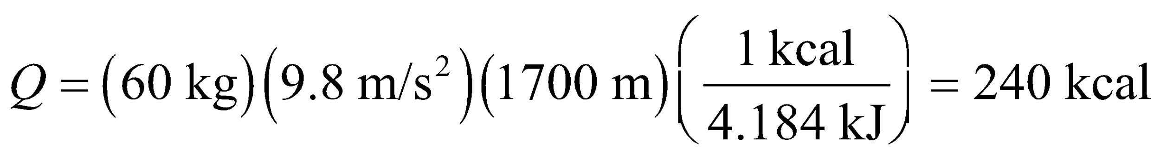

**Assess** Much more energy than this is required in reality due to the many loss mechanisms, such as friction, slippage, etc.

**43. Interpret** This problem involves calculating the amount of energy a body uses to run a marathon and, assuming that fat is converted to energy with 100% efficiency, converting this energy to an equivalent mass of fat.

**Develop** The energy expended in running a marathon for a person with the given mass is



Knowing the amount of energy per gram of fat allows us to answer the question.

**Evaluate** Since typical fats contain about 9 kcal per gram, *ΔQ* is equivalent to the energy content of

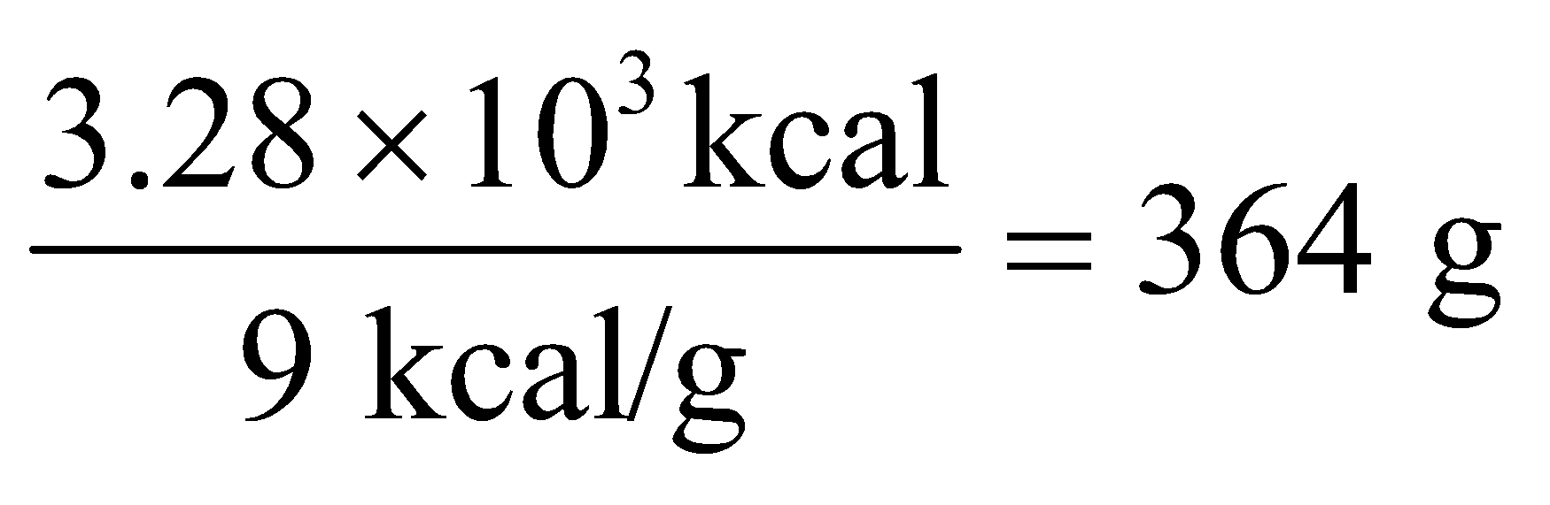

or about 13 oz of fat.

**Assess** Running a marathon is a good way to burn the fat stored in the body.

**44.** **Interpret** This problem involves calculating the temperature rise in the lake due to the given power input from the Sun. We are to assume that all the Sun’s power is absorbed by the lake water, so the energy absorbed will go to raising the temperature via Equation 16.3.

**Develop** The energy absorbed by the lake water is *Q* = *P*T*Δt*, so *Δt* = *Q*/*P*T (where the total power *P*T = *PA*, with *P* = 200 W/m2 and *A* = *πr*2). From Equation 16.3, a rise in the temperature of the lake water from 10 °C to 20 °C requires an energy *Q* = *mcΔT*, where *ΔT* = 10 C°, *c* = 4184 J/kg, and *m* = *πAd* with *ρ* = 1.0 × 103 kg/m3 and   
*d* = 10 m.

**Evaluate** Inserting the expression for *Q* and *P*T into the expression for *Δt* gives

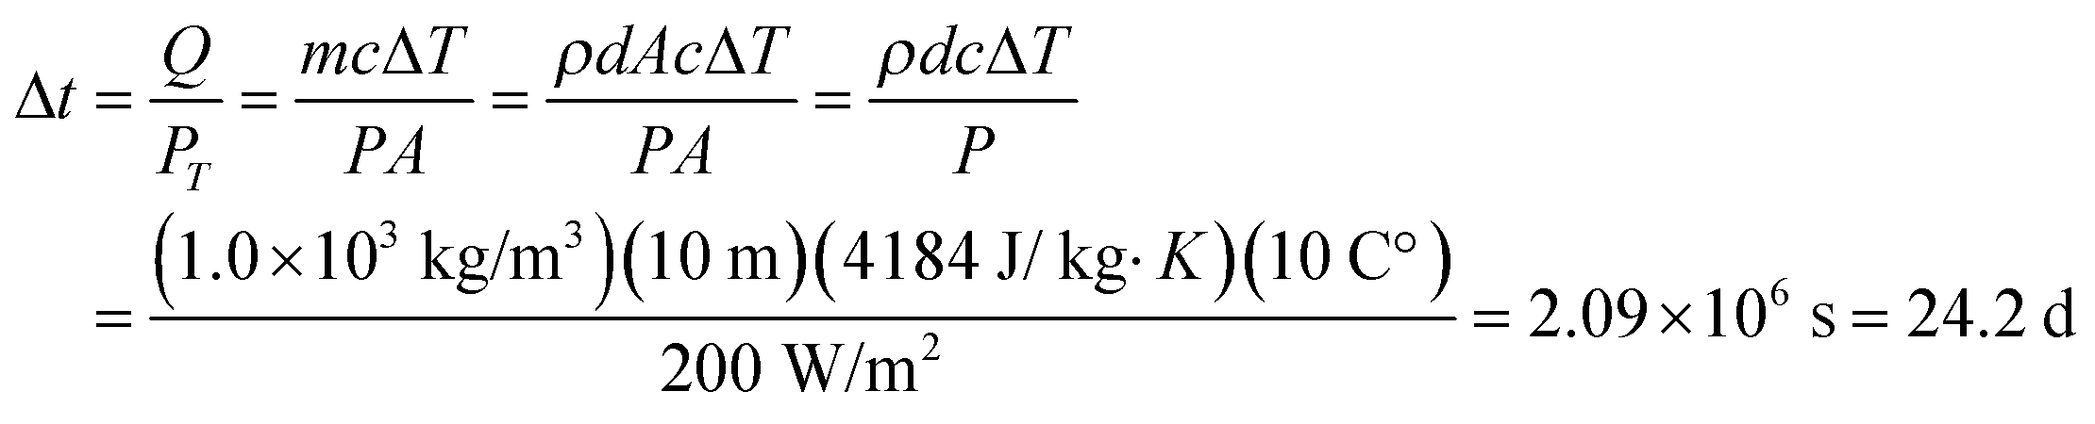

**Assess** Checking the units of this expression, we find that they work out to be units of time (i.e., s), as expected.

**45. Interpret** We are interested in the energy needed to raise the temperature of a system. We can solve this problem using the specific heat of the given substances.

**Develop** The energy *Q* required to increase the temperature by *ΔT* is given by Equation 16.3: 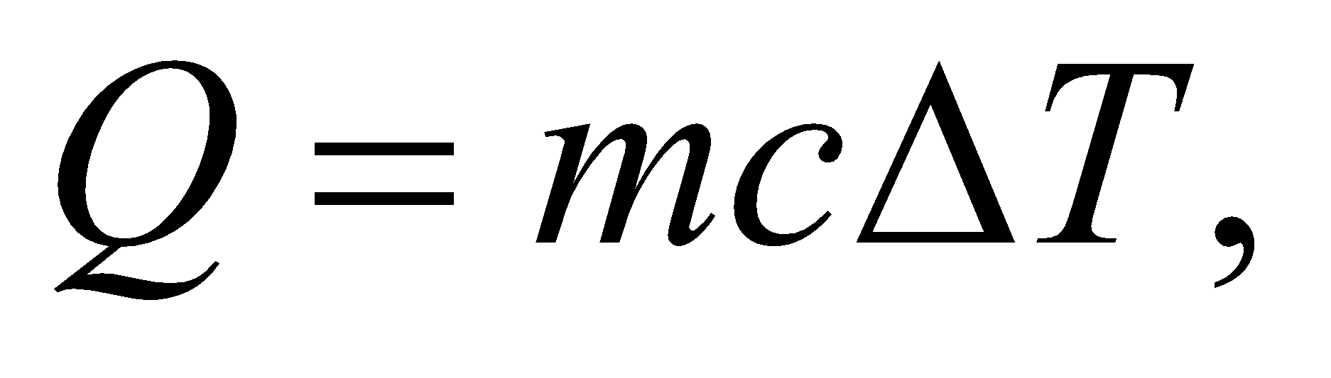 where *c* is the specific heat and *m* is the mass of the material. The specific heats of some common materials can be found in Table 16.1.

**Evaluate (a)** When just the pan is heated, with 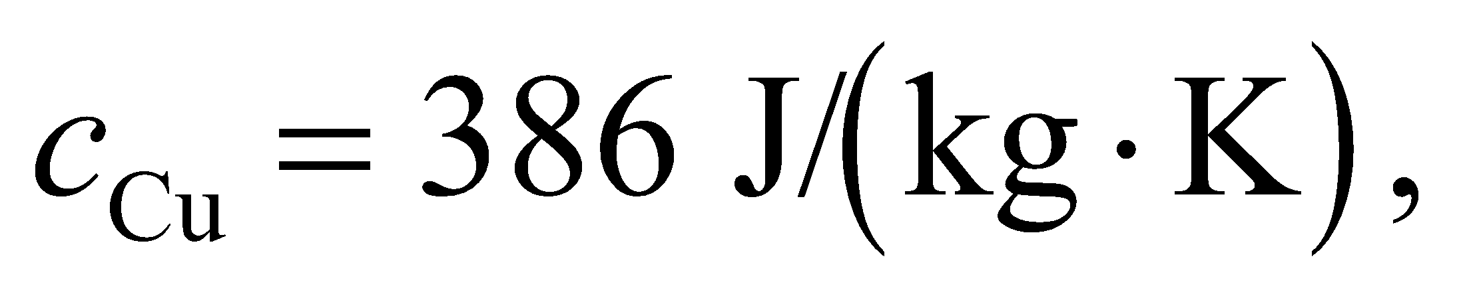 the energy required is



**(b)** If the pan contains water and both are heated between the same temperatures, we then have



**(c)** With 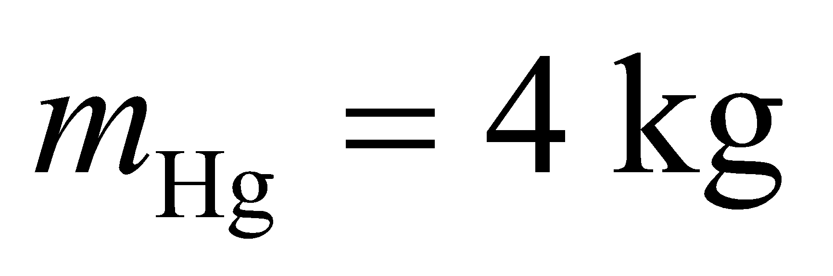 of mercury replacing the water,



**Assess** The energy required is proportional to the specific heat *c*. In this problem,



**46.** **Interpret** This problem involves finding the specific heat of an unknown substance.

**Develop** Because the heat energy transferred to both substances is the same, 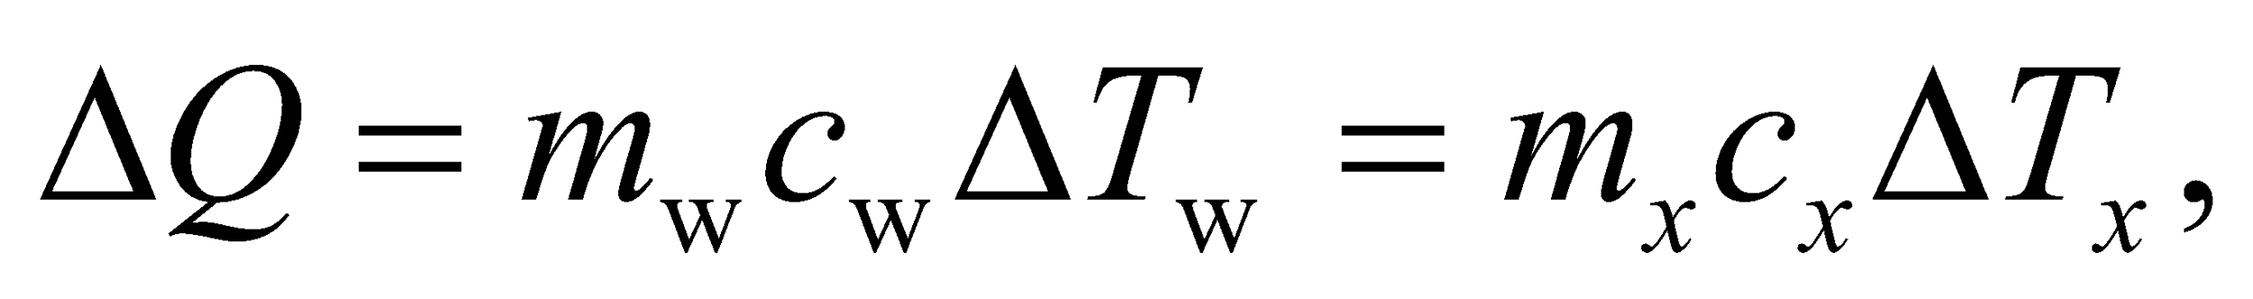 or

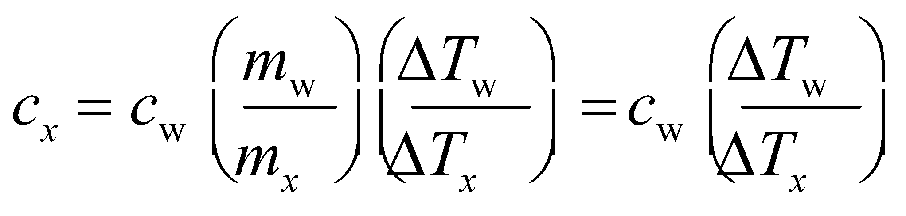

where the final equality comes from the fact that we are considering equal masses of water and unknown substance.

**Evaluate** (a) Inserting the given quantities in the expression above gives

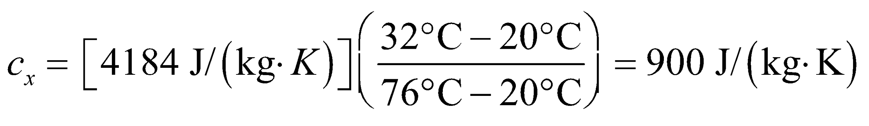

which is the value listed in Table 16.1 for aluminum.

(b) The rate of heating is .

**Assess** Notice that, for part (a), the difference in degrees Celsius is the same as Kelvin (see Equation 16.1).

**47. Interpret** You wish to know how long it will take a microwave to heat a cup of water to the boiling temperature.

**Develop** The heat needed to bring the water to the point of boiling can be found with Equation 16.3: where 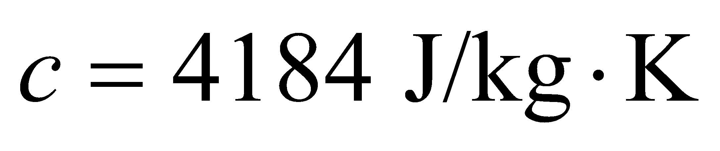from Table 16.1. The mass of 330 mL of water can be found from the density: 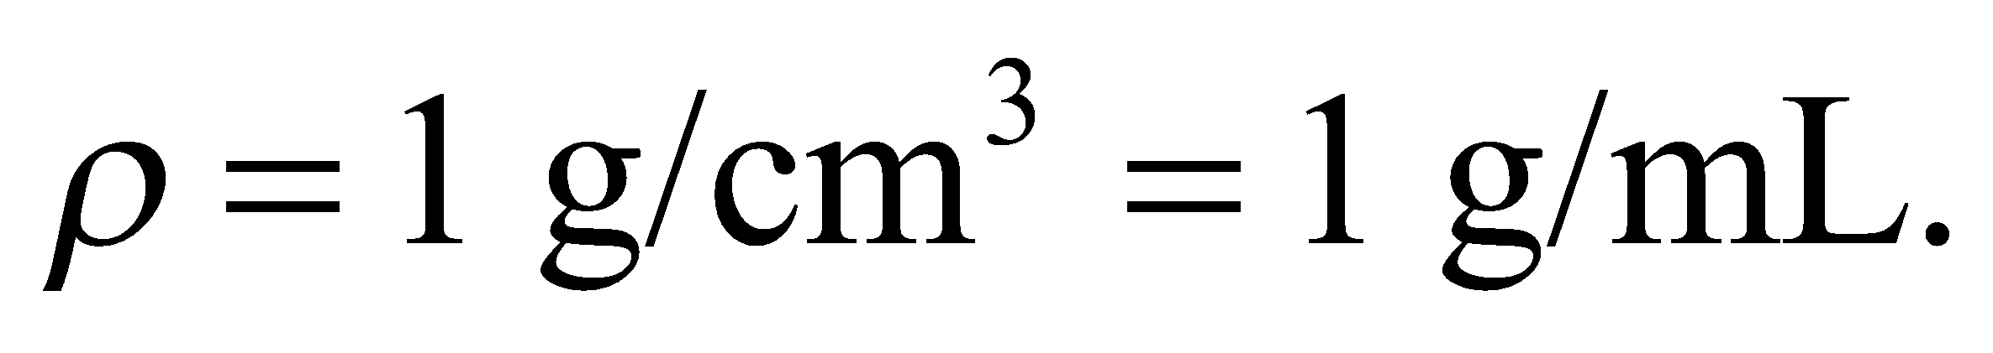 The temperature change is 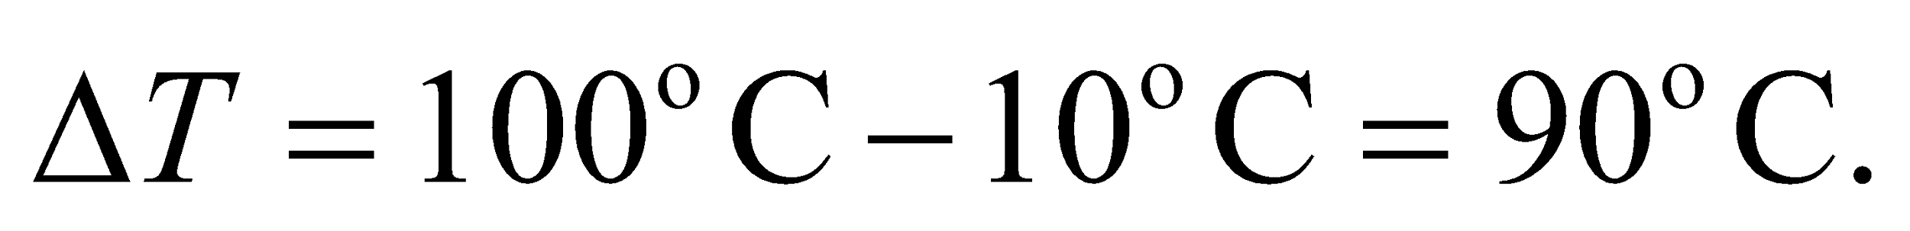Note: We don't have to convert to Kelvin, since the change in degrees Celsius is the same as the change in Kelvin. The time it takes the water to absorb this much heat comes from the energy divided by the power.

**Evaluate** The time to heat the water to the boiling temperature is

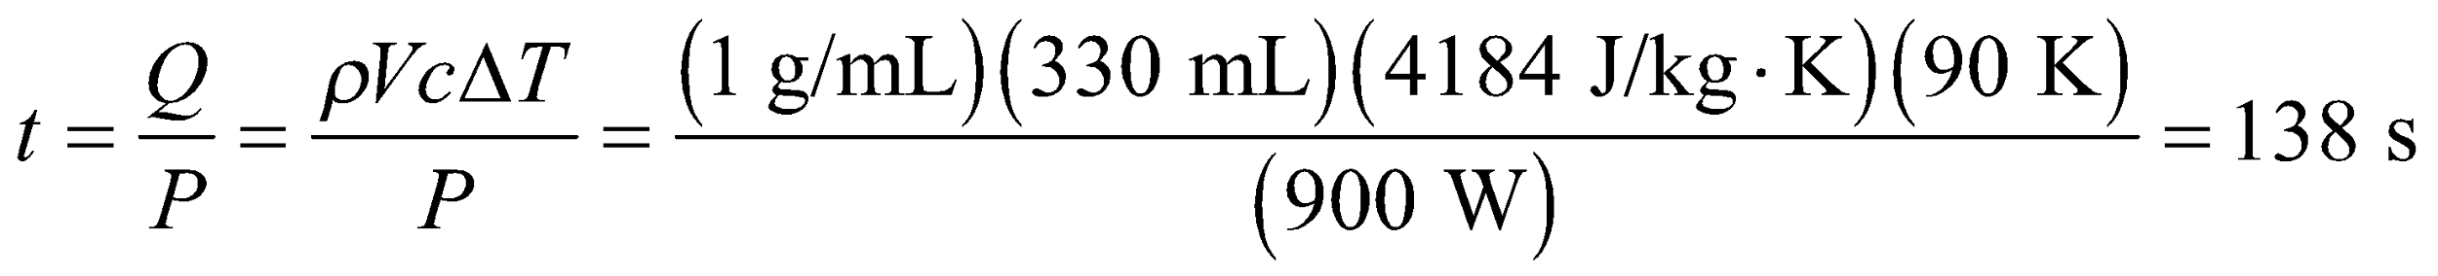

**Assess** A little over two minutes to bring the water to boil sounds about right.

**48.** **Interpret** This problem involves calculating the time it takes to heat an object given its specific heat, its mass, and the power supplied.

**Develop** Apply Equation 16.3, *Q* = *mcΔT* to find the energy required to heat each house. The time it will take for the furnace to supply this energy is *Δt* = *Q*/*P* = *mcΔT*/*P*.

**Evaluate** The time required to heat the stone house is

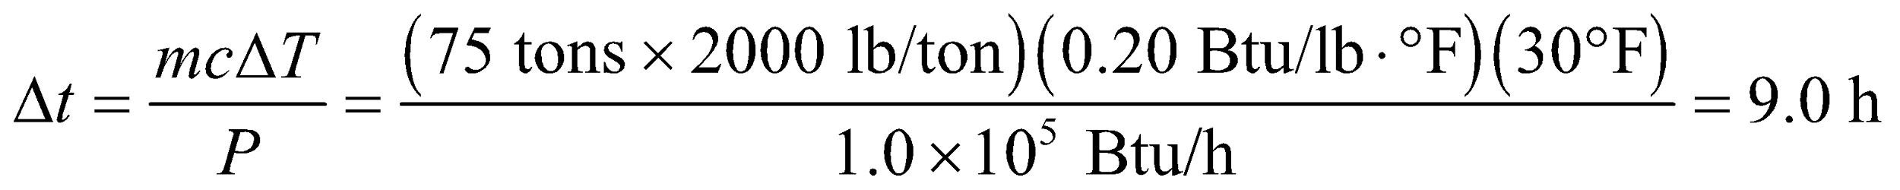

The time required to heat the wood house is

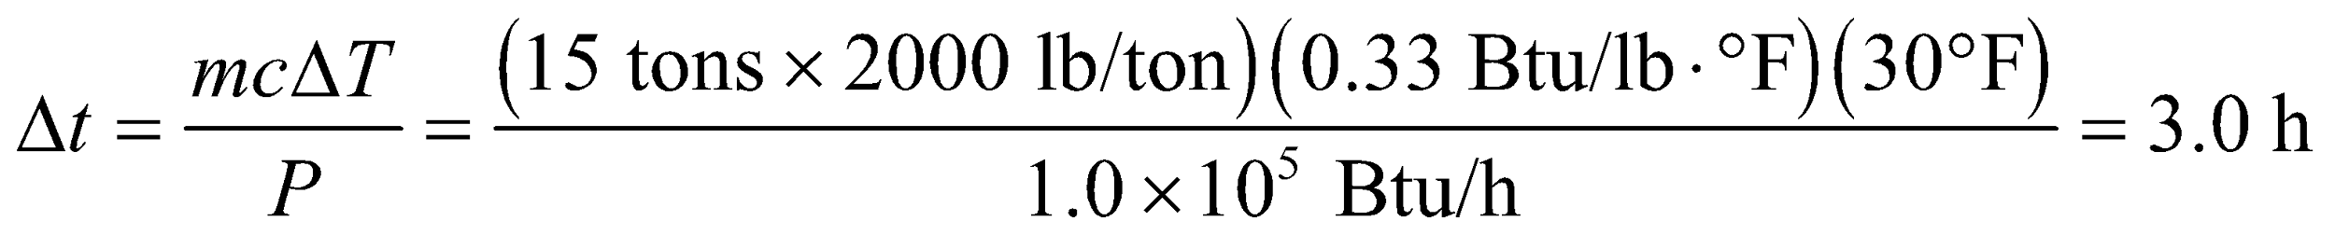

**Assess** Although the English units involve weight instead of mass, the units cancel to give units of time, as expected.

**49. Interpret** You want to compare the rate at which water is heated by a microwave in a paper cup to on a stovetop in a pan. The hitch is that the stovetop has to heat the pan too.

**Develop** The temperature rise per second is equal to the heat absorbed per second divided by the heat capacity:

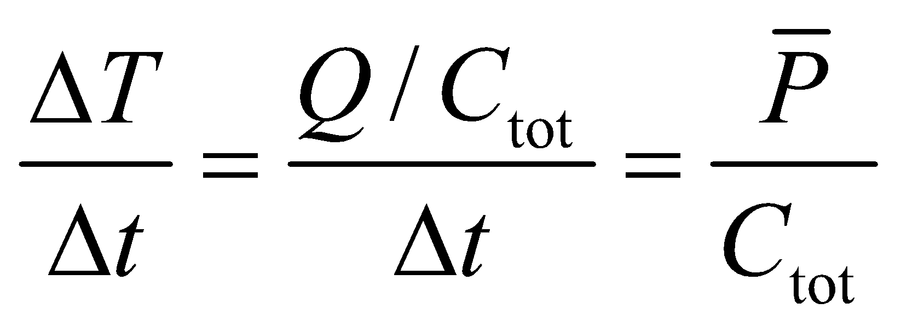

where 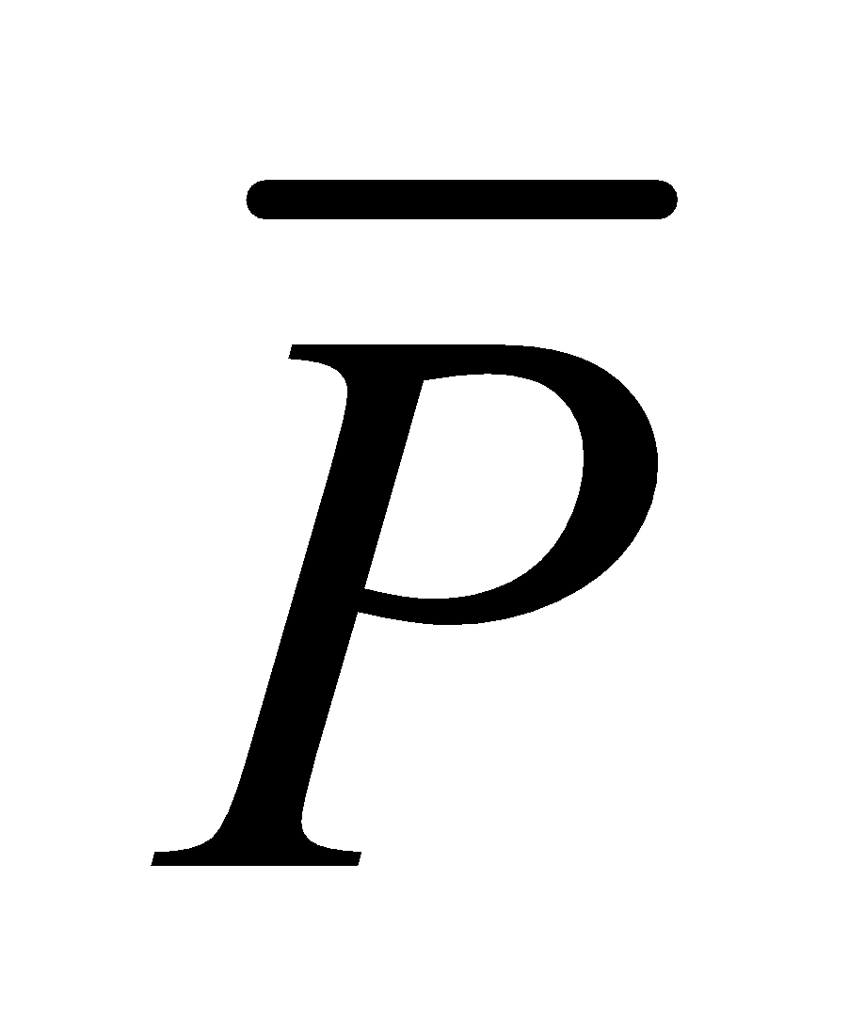is the average power supplied, and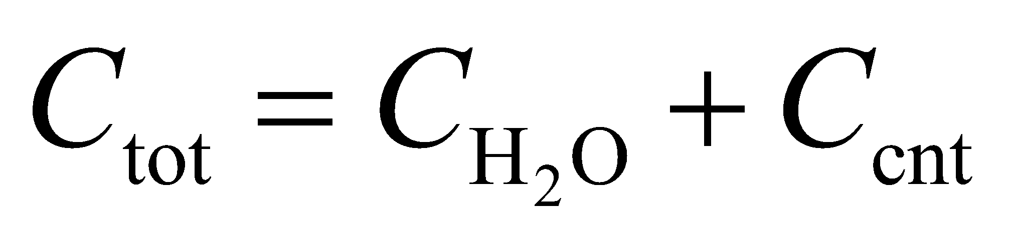is the total heat capacity from both the water and the container. This assumes that the water and container both have the same instantaneous temperature. The water's heat capacity is 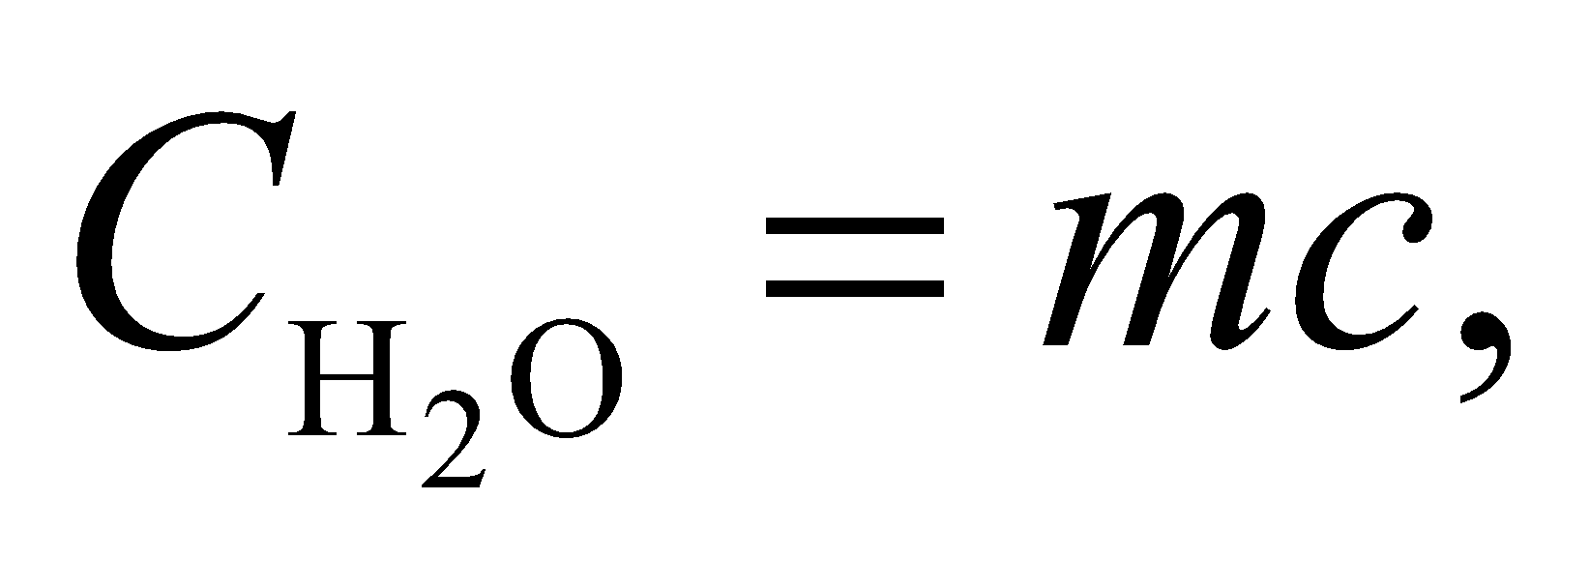where from Table 16.1. For the paper cup used in the microwave oven, 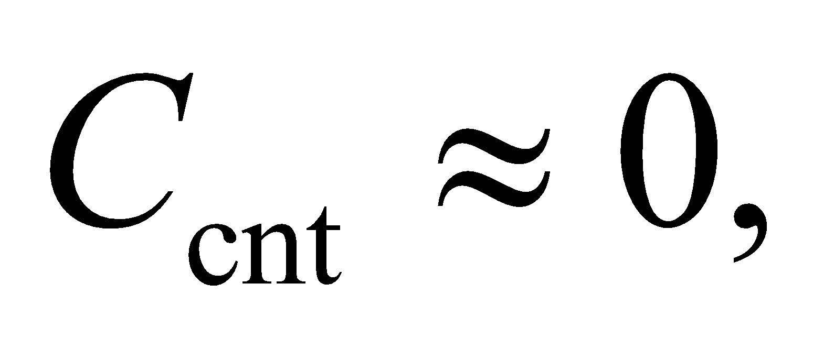whereas for the pan used on the stove burner,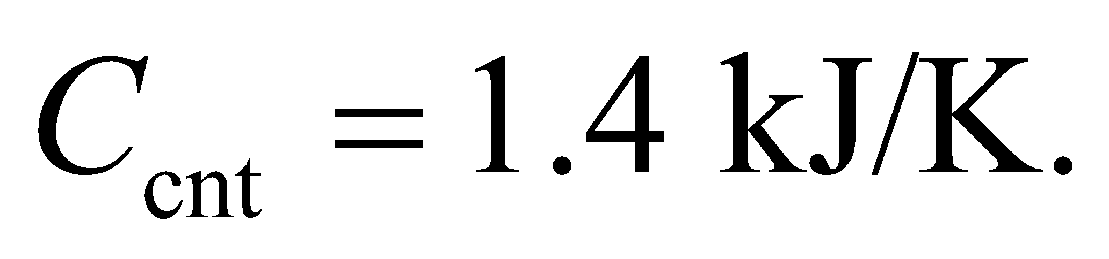

**Evaluate** If you equate the rates at which the temperatures rise,

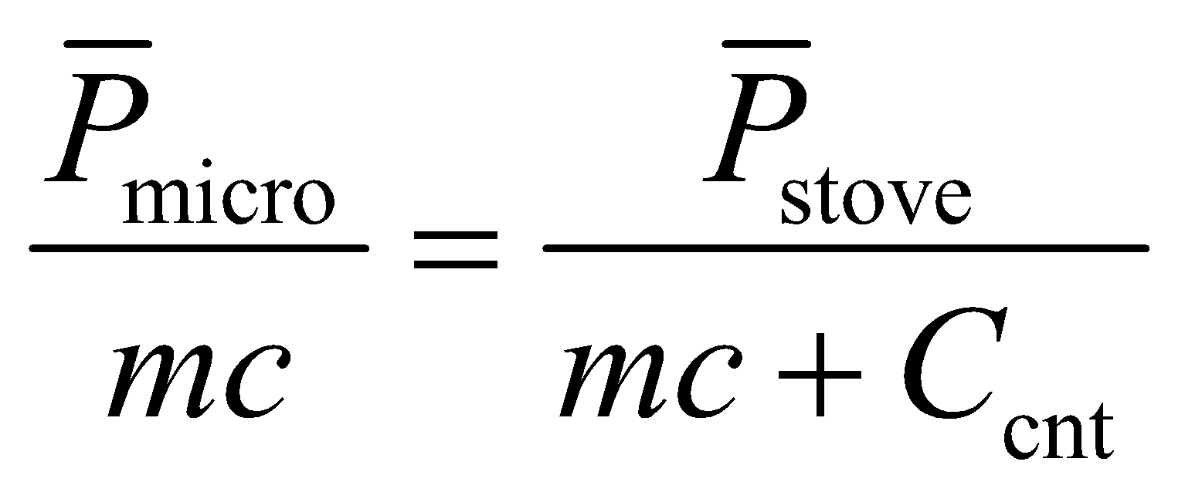

You can then solve for the mass:

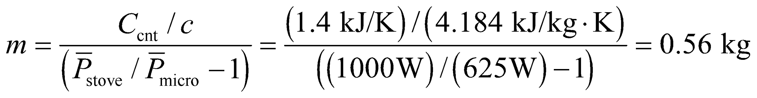

**Assess** This is a little over half a liter. Your own experience may confirm this. For heating a cup of tea, the microwave oven seems to work faster. But for heating a big bowl of soup, the stove will take less time.

**50.** **Interpret** This problem involves calculating the time it takes a raise the temperature of a given mass of water a given amount, knowing the power input. We can use the specific heat of water to solve this problem.

**Develop** The rate at which heat is supplied (i.e., the power) to the water by the shut-down reactor is 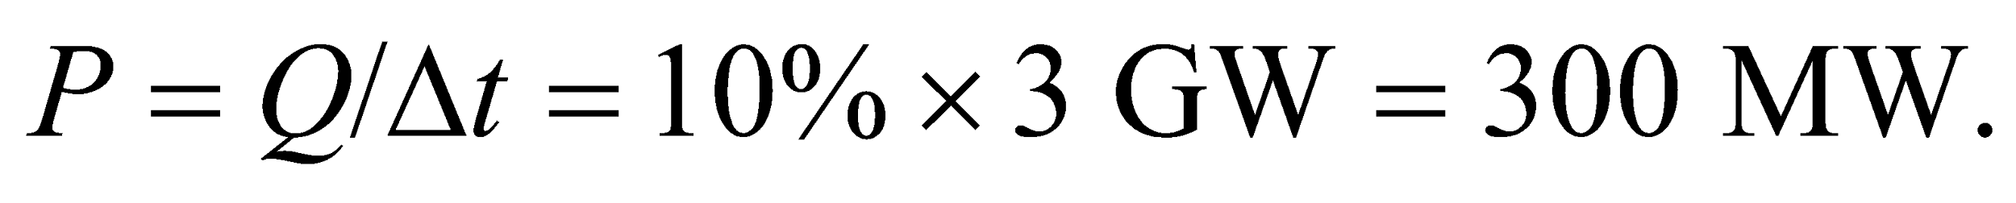 The energy *Q* needed to raise a mass *m* of water from 20°C to 100°C is given by Equation 16.3, *Q* = *mcΔ*T. Combining these expressions, we can solve for *Δt*.

**Evaluate** For 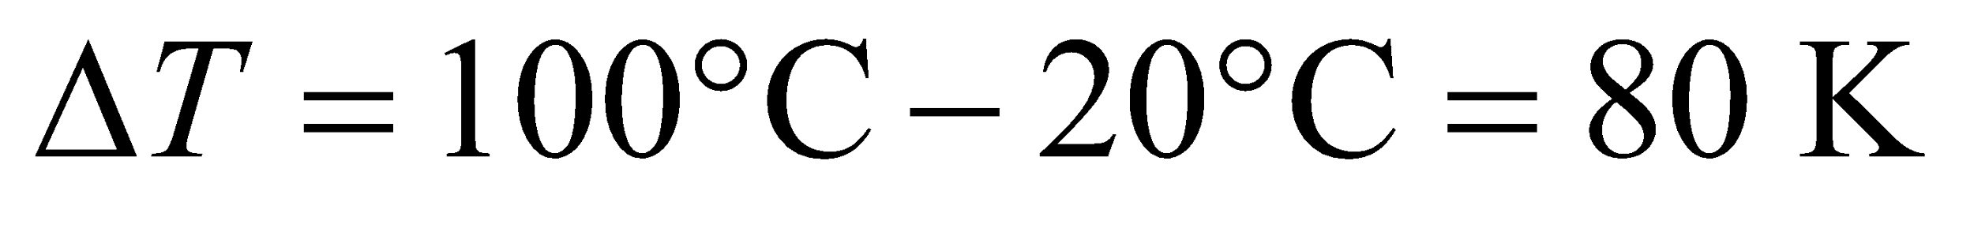 and  one finds

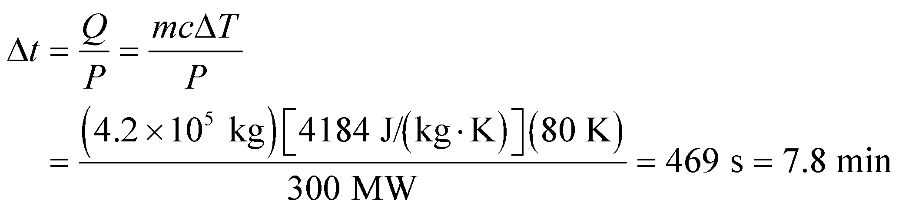

**Assess** This does not give you much time!

**51. Interpret** Given the power output of the stove and the amount of time it takes to heat up the water, we want to know how much water is in the kettle. This problem involves specific heat.

**Develop** The energy supplied by the stove burner heats the kettle and the water in it from 20°C to 100°C, so *ΔT* = 80 K. If we neglect any heat losses and the heat capacity of the burner, this energy is just the burner’s power output times the time:

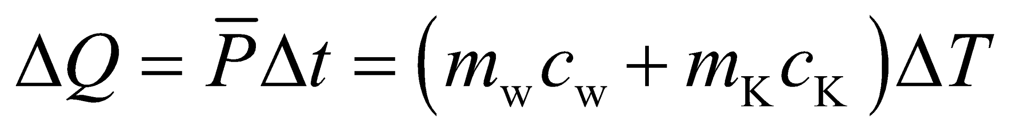

This equation can be used to solve for *m*w.

**Evaluate** Since all of these quantities are given except for the mass of the water, we can solve for *m*w:

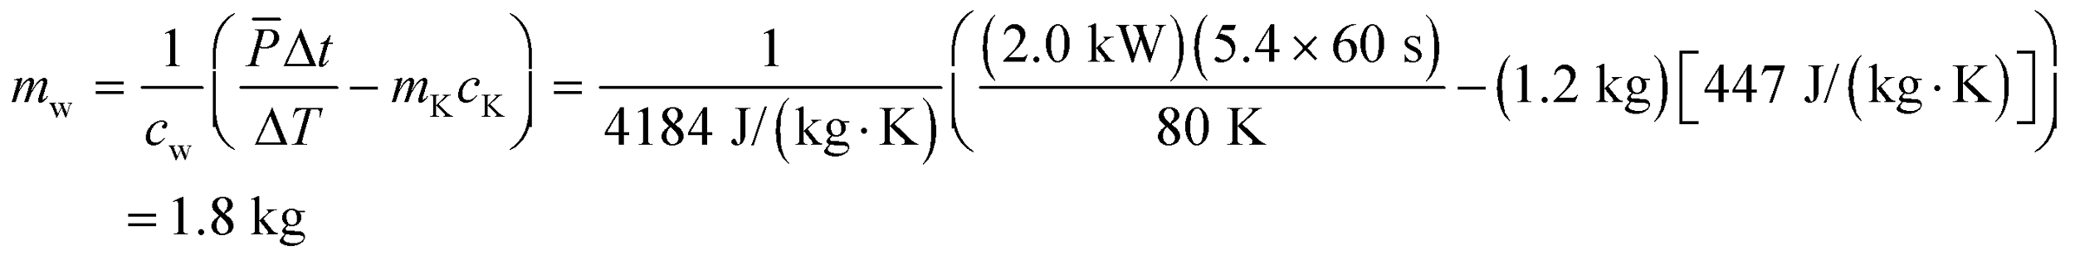

**Assess** We find that *m*w is proportional to *Δt*. This makes sense because the more water in the kettle, the more time we would expect it takes to heat up the water.

**52. Interpret** We're asked to calculate the time it takes for an ear thermometer to collect enough energy from the radiative heat coming from a small area on the ear drum.

**Develop** The eardrum will radiate heat according to the Stefan-Boltzmann law from Equation 16.9: 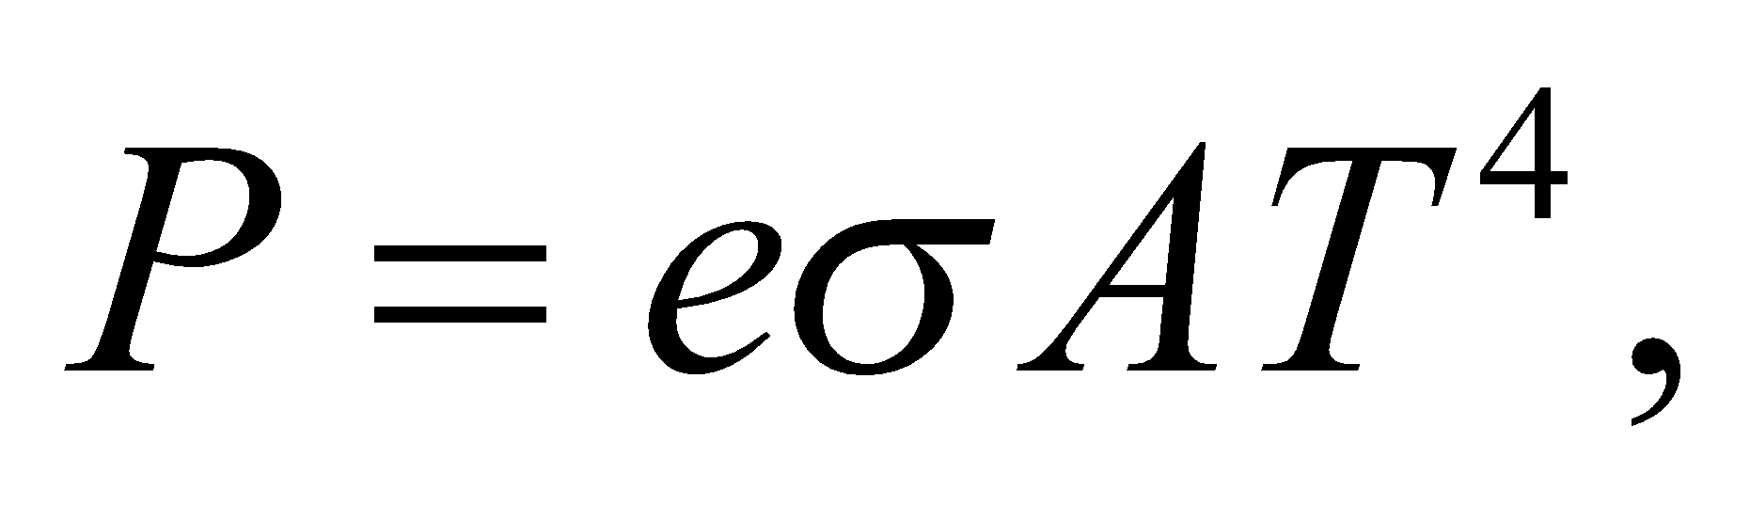where it's important to remember that the temperature must be in Kelvin: 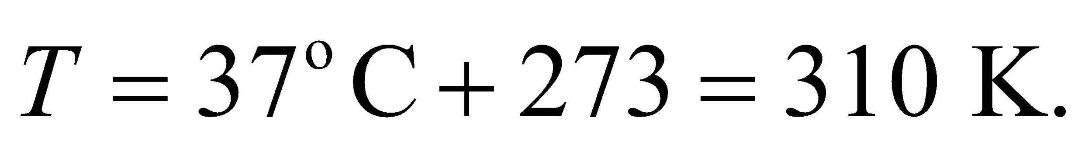The time it takes the thermometer to collect enough energy for a reading will be 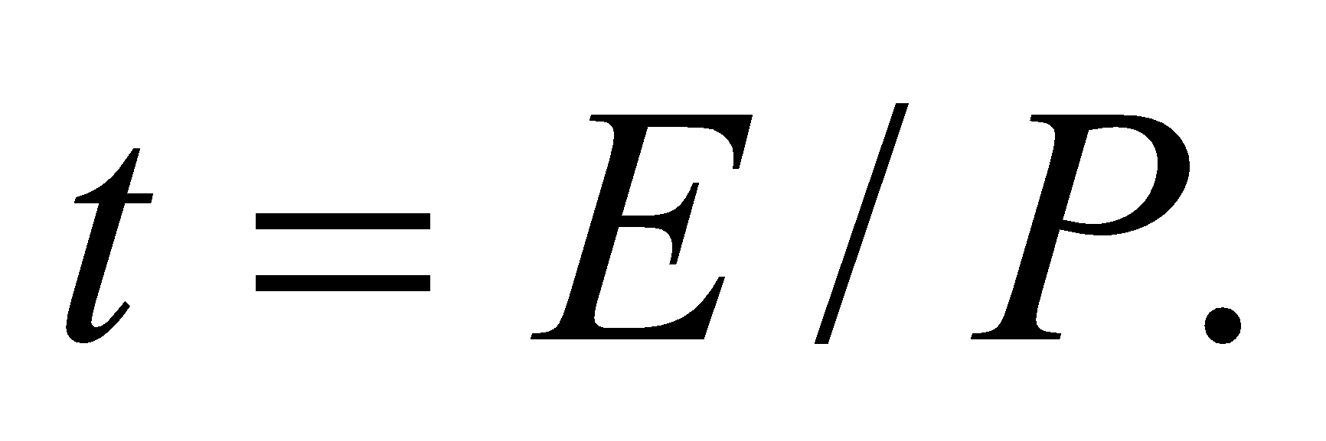

**Evaluate** We'll assume the ear drum is a perfect emitter with 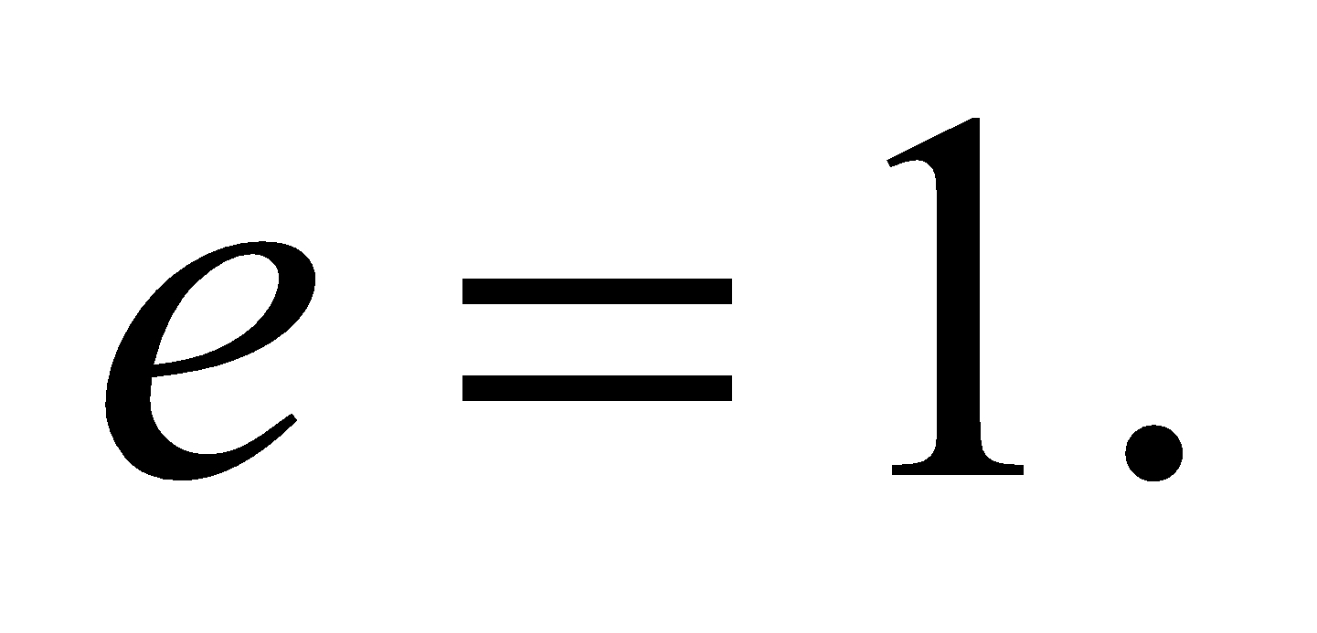

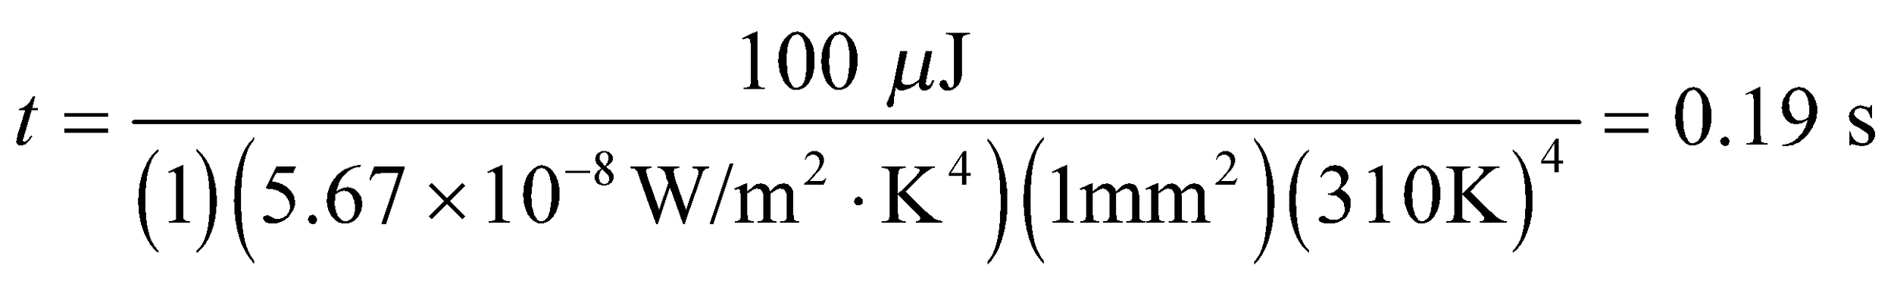

**Assess** How much faster would the reading be for someone with a fever of 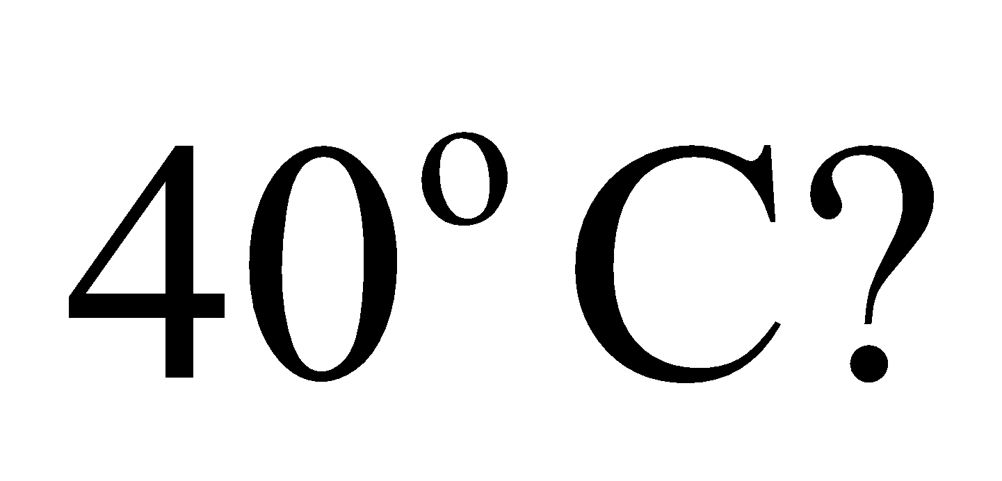In fact, only one hundredth of a second faster.

**53. Interpret** The objects of interest are the steel disks of the disk brakes. The problem deals with transformation of energy from the kinetic energy of the car to the thermal energy of the brake disks, which we can calculate knowing the specific heat of the disk-brake material.

**Develop** By energy conservation, the loss of kinetic energy of the car is equal to the thermal energy gained by the four brakes:

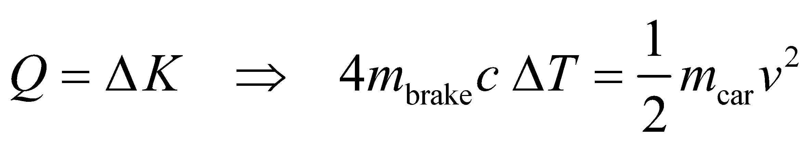

**Evaluate** From the equation above, with 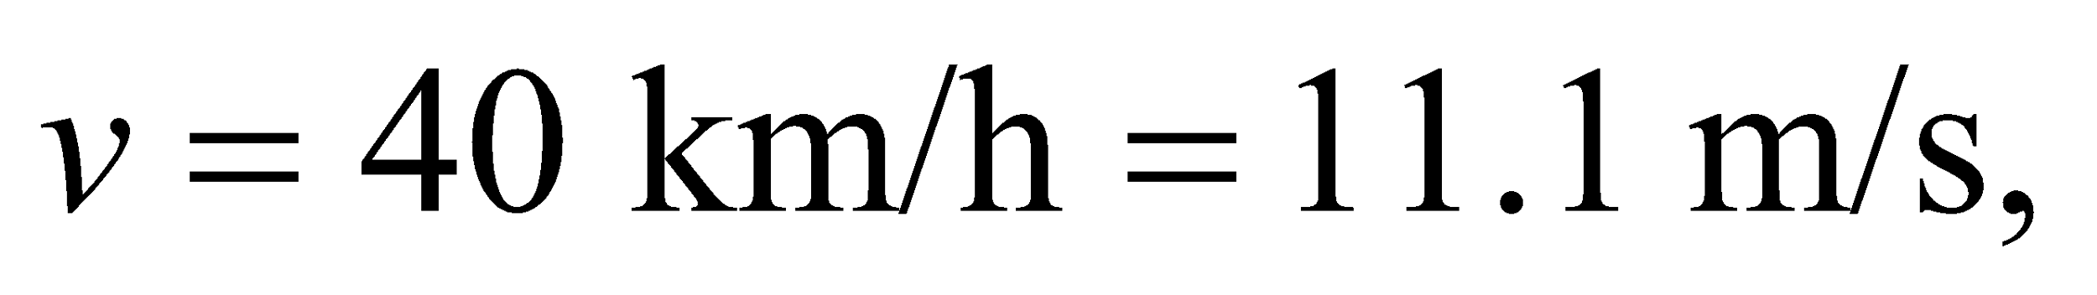 the change of temperature is

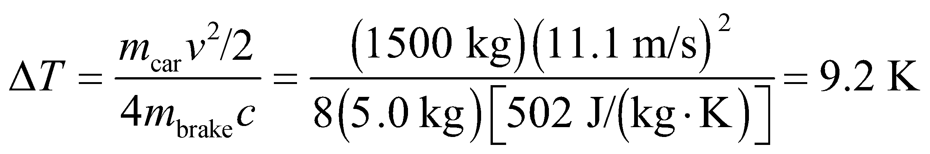

**Assess** This is a big increase in temperature. The brakes can get very hot depending on how fast the car was moving initially.

**54.** **Interpret** This problem involves the specific heat of a liquid, which we can use to calculate the equilibrium temperature of the child’s cocoa after adding the given quantity of milk at the given temperature.

**Develop** If the specific heats are the same, Equation 16.4 reduces to 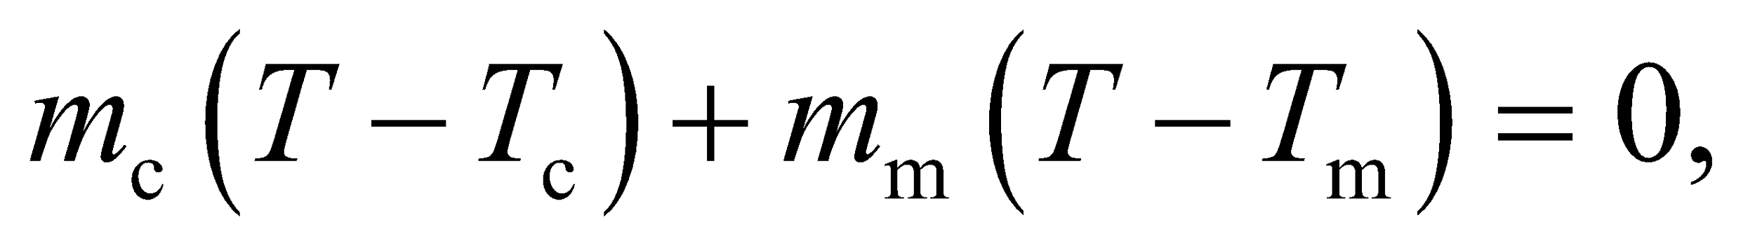 where *T*m = 3°C and *T*c = 90°C are the original temperatures of the cocoa and milk, respectively. Solving for *T*, we find

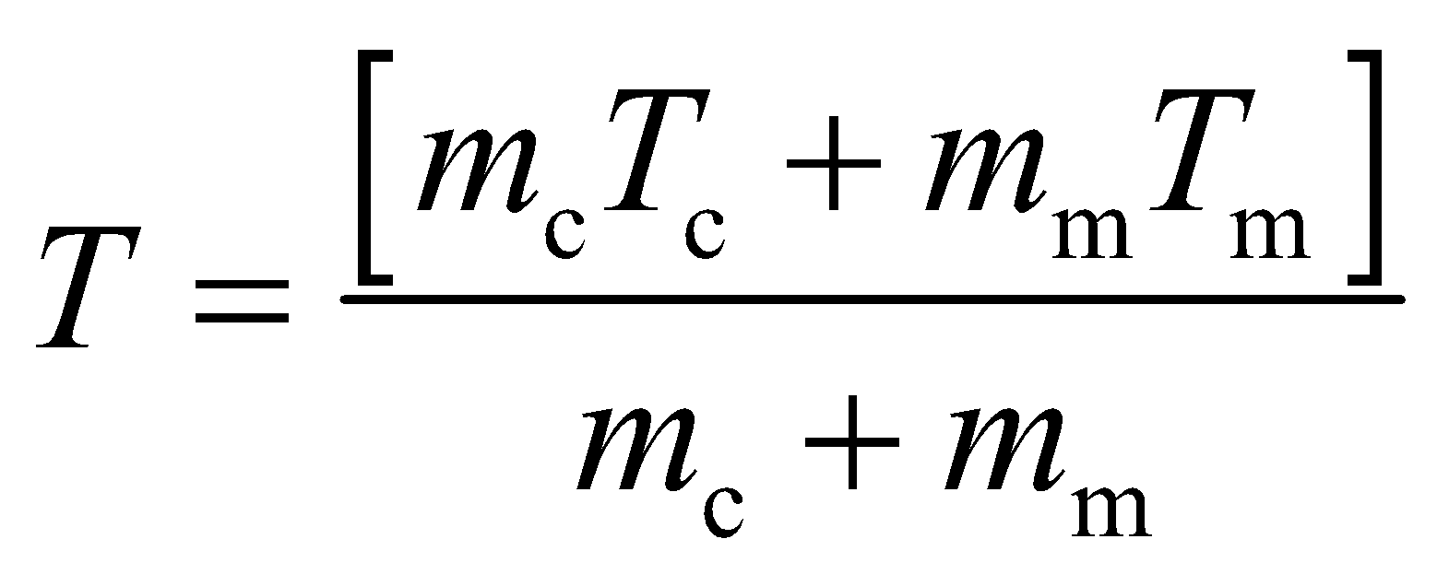

**Evaluate** If “ounce” means avoir du pois, the masses of milk and cocoa are proportional to the weights given, and

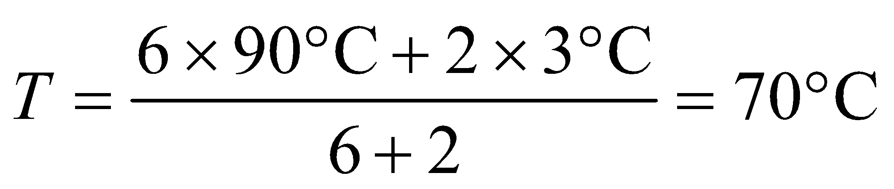

to a single significant figure.

**Assess** More commonly, “ounce” means fluid ounce, a volume, but the assumption of equal densities for cocoa and milk gives us the same result.

**55. Interpret** Our system consists of two materials, water and copper, which are initially at different temperatures. They are brought together and reach a thermal equilibrium. We want to find the mass of the copper, for which we can use the specific heat of copper.

**Develop** Let us assume that all the heat lost by the copper is gained by the water, with no heat transfer to the

container or its surroundings. Then 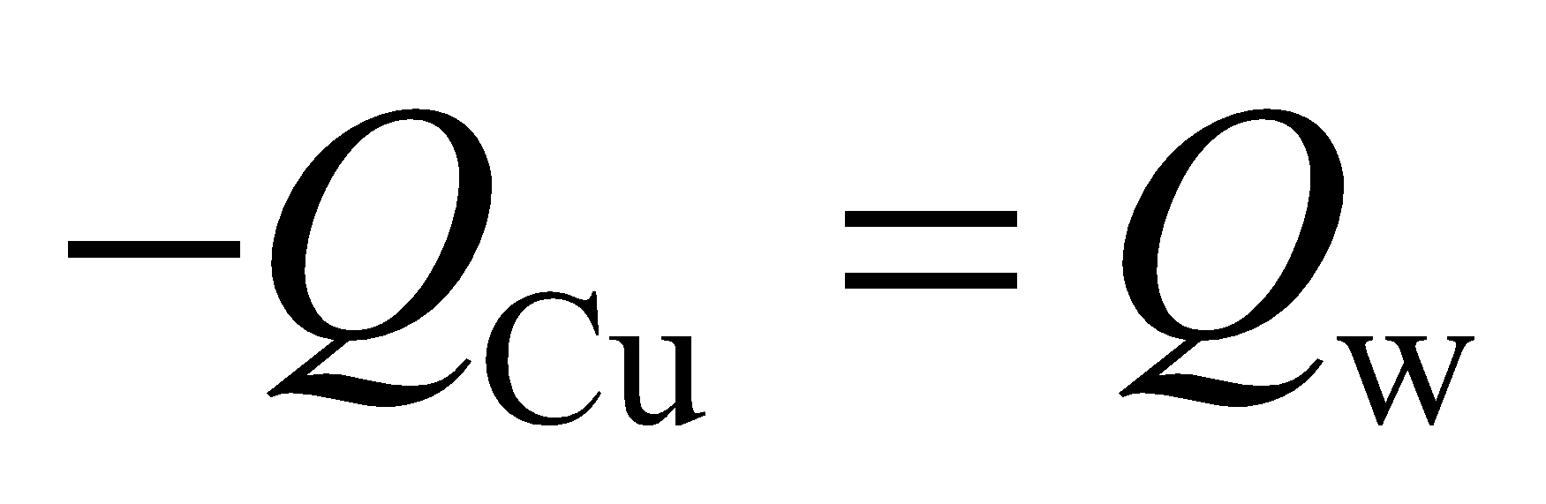 (as in Example 16.2). Expressing each side of this equation using Equation 16.3, we find

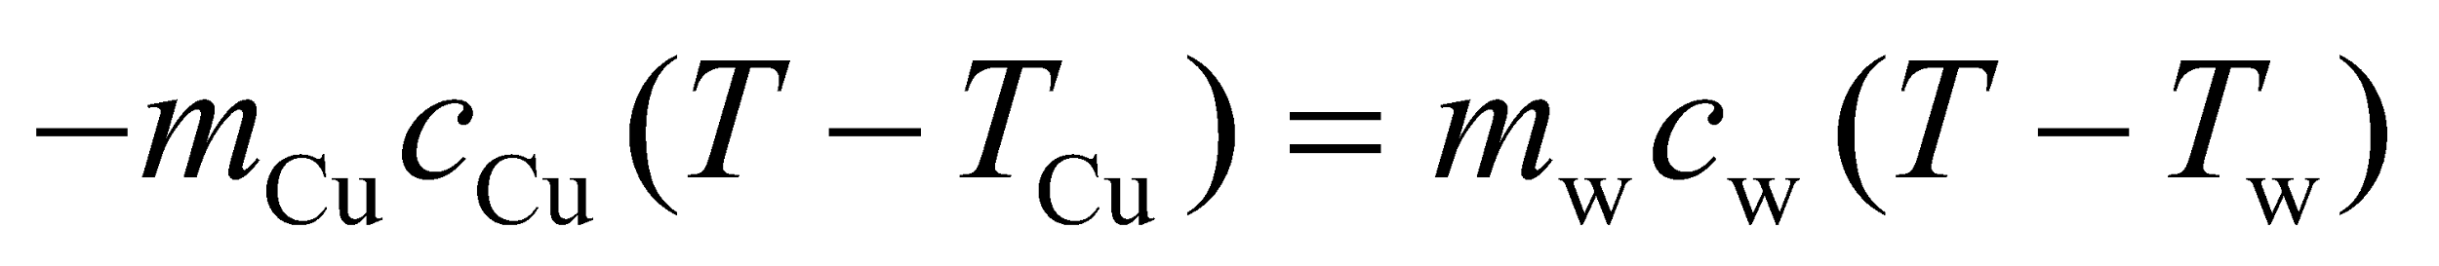

The specific heats of copper and water can be found in Table 16.1.

**Evaluate** Expressing all the temperatures in the Kelvin scale and solving for *m*Cu, one finds

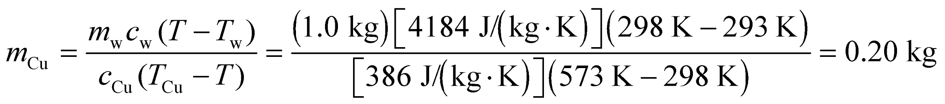

**Assess** Since the water has much greater mass and higher specific heat, its temperature change is less compared to copper.

**56. Interpret** You want to know how long it will take your camping stove to bring water to a boil, given the formula for the heat flowing into the water as a function of time.

**Develop** You can integrate the given power, *P*, to find the total heat that the water has absorbed. You can then equate that to the amount of energy needed to bring the water up to 100°C using Equation 16.3: where for water. From this, you can solve for the boiling time.

**Evaluate** The heat absorbed by the water over a given time is:

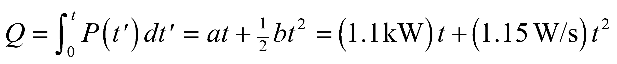

You want to know how long until this absorbed heat changes the water temperature by 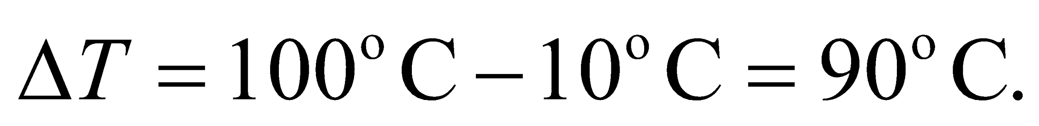



This requires solving a quadratic equation with the quadratic formula from Appendix A:

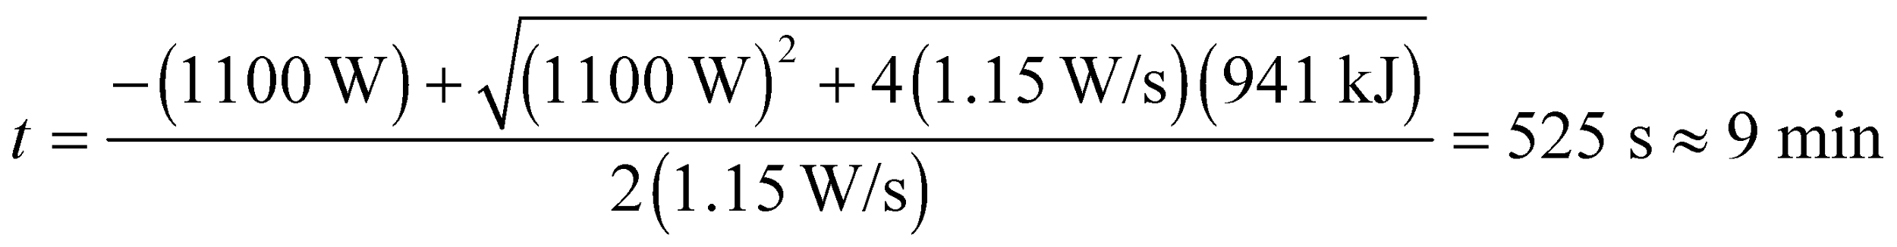

**Assess** There's 2.5 L of water to boil, so 9 minutes sounds about right.

**57.** **Interpret** This problem involves the thermal resistance of a material, which we can use to calculate the rate of heat lost through the material given the temperature difference between the different sides of the material.

**Develop** The total surface area (sides, top, and bottom) of the cooler is  A thickness of 8 cm of Styrofoam of this area has a thermal resistance of *R* = *Dx*/(*kA*) (Equation 16.6), and the heat-flow Equation 16.7 gives

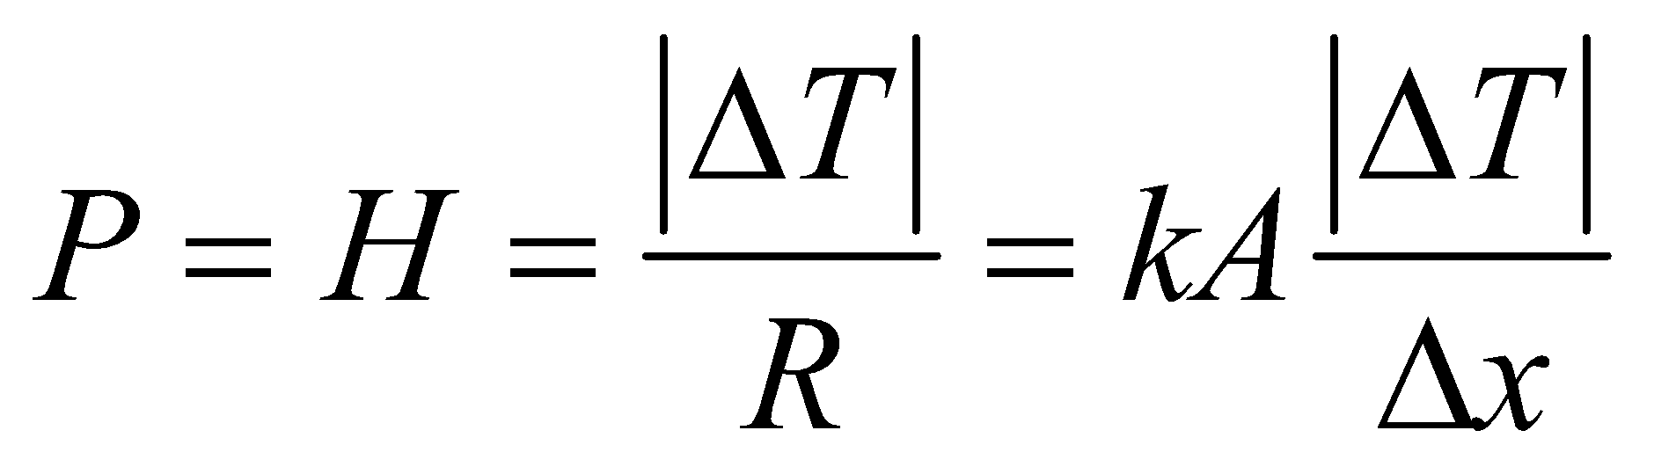

**Evaluate** Using *k* = 0.029 W/(m·K) from Table 16.2 gives

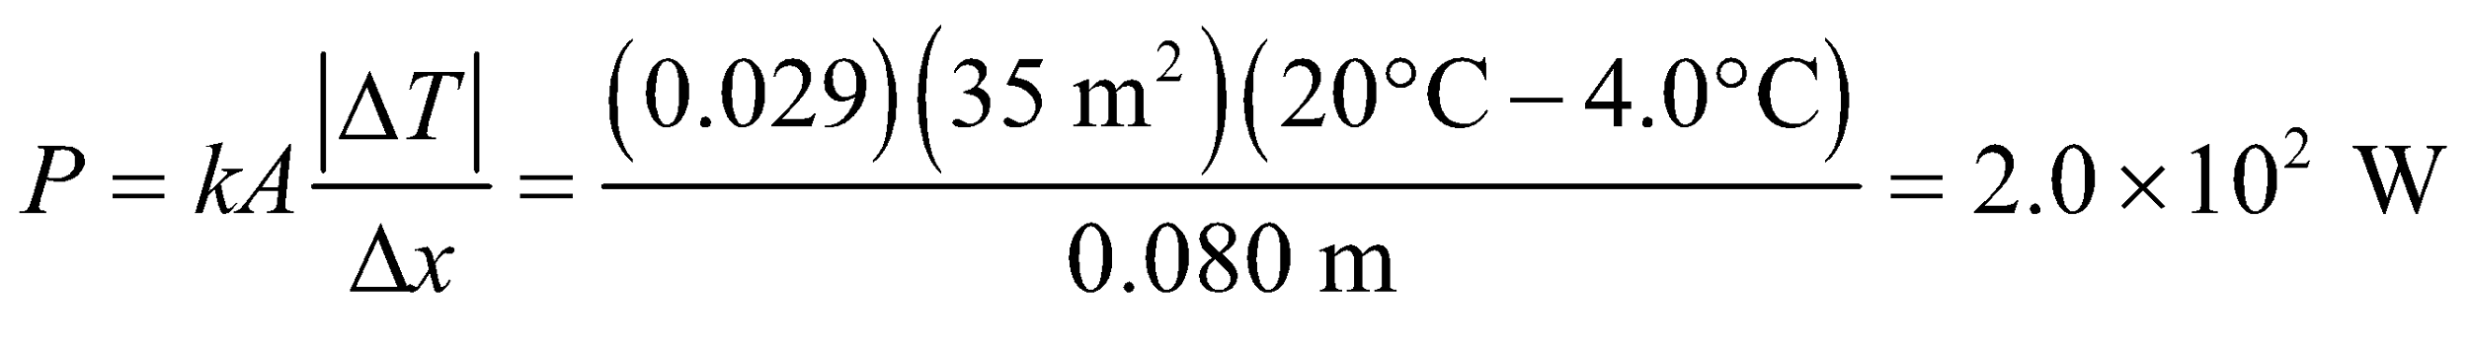

to two significant figures.

**Assess** The power requires is equivalent to about 3 60-W light bulbs.

**58. Interpret** This problem is about conductive heat flow. We want to find the heat flow rate along an iron rod. Note that the rod is insulated so no heat is lost out through the sides of the rod, only through the ends of the rod.

**Develop** We assume a uniform variation of temperature along the length of the rod and no heat-flow through its sides. The heat flow rate is given by Equation 16.5:

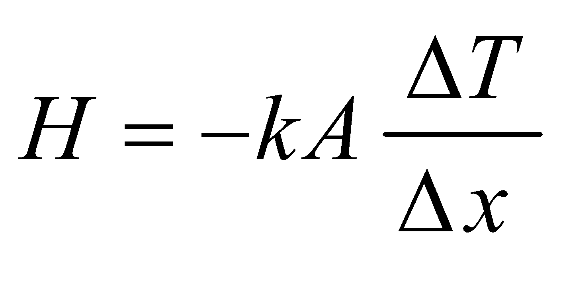

If we let the origin of our coordinates system be at the hot-water end of the rod, we have *Δx* = *x*cold − *x*hot = 0.40 m and *ΔT* = *T*cold − *T*hot = 0°C − 100°C = −100 K.

**Evaluate** Entering the numerical values, we get

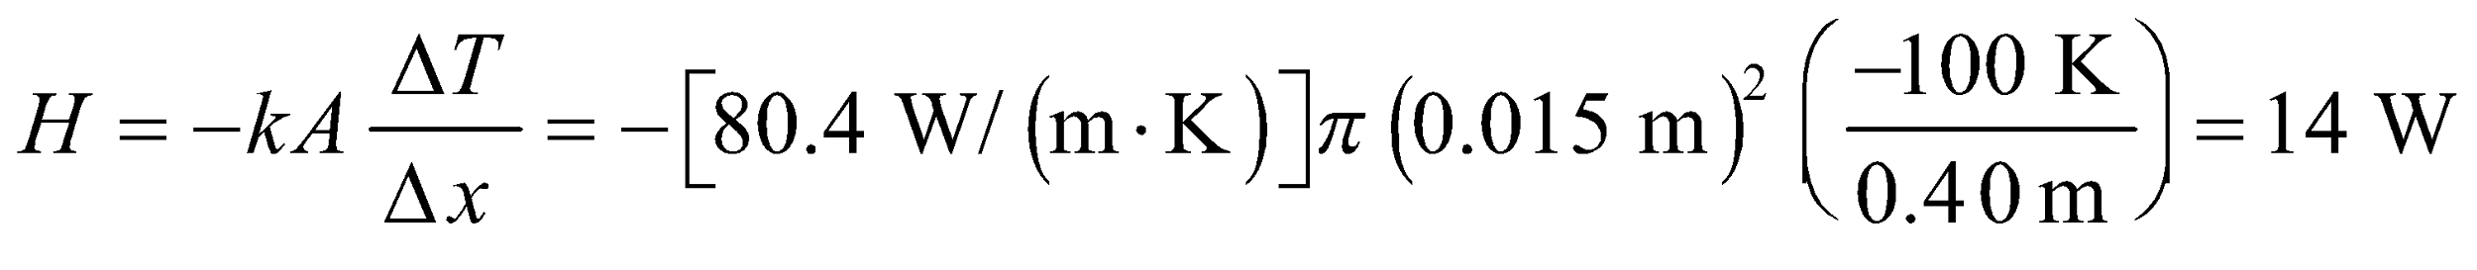

to two significant figures. Here, the minus sign signifies a heat-flow from the hot to the cold.

**Assess** The flow rate *H* increases with the temperature gradient, *ΔT*/*Δx*. With our choice of coordinate system, the fact that H > 0 signifies that the heat flows from the hot water to the cold water, as expected.

**59. Interpret** You want to see if the power output from the party guests can compensate for the heat-loss from the house.

**Develop** Combined, the 36 people will generate 3600 W of heat. The house will be in energy balance when the inside temperature results in a heat loss that matches what the people produce:



**Evaluate** Solving for the inside temperature

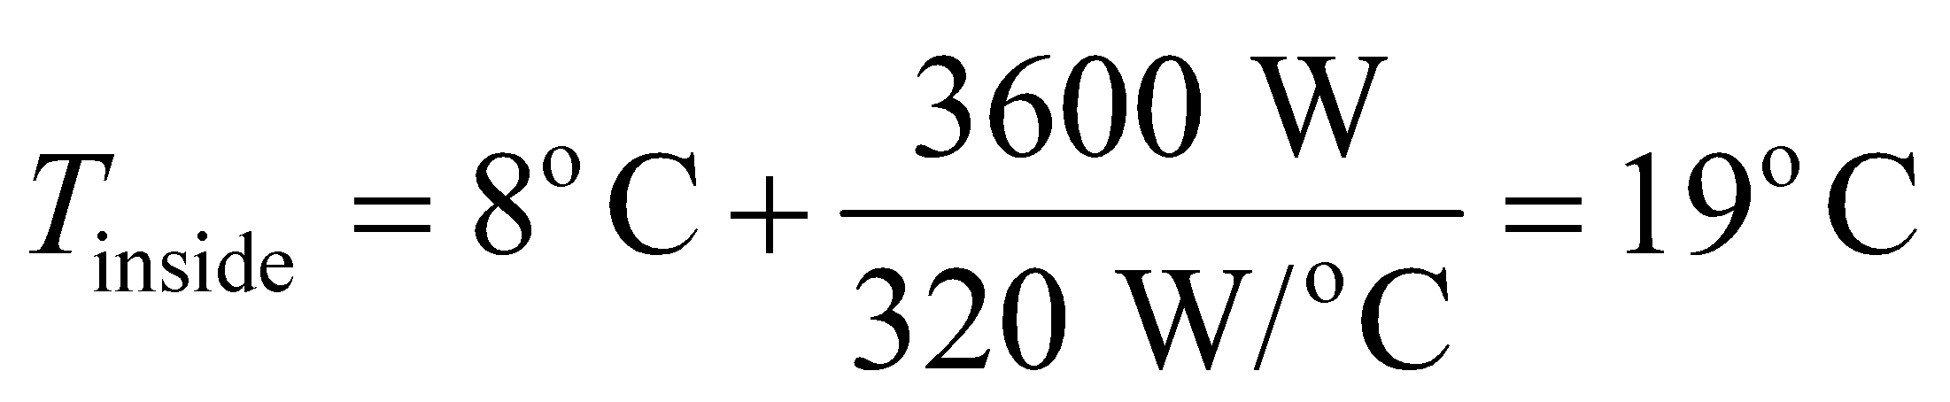

This is equal to about 66°F, which means the house will remain at a comfortable temperature.

**Assess** If you wanted the house even a little warmer, you could ask some of the people to do a little light exercise to generate more than a 100 W of heat.

**60.** **Interpret** This problem involves thermal energy balance. The heat source is the electric stove and the main heat loss mechanism is radiation (we ignore convection).

**Develop** From the Stefan-Boltzmann law (Equation 16.9), the net power radiated (emitted at *T*1, absorbed at *T*2) is

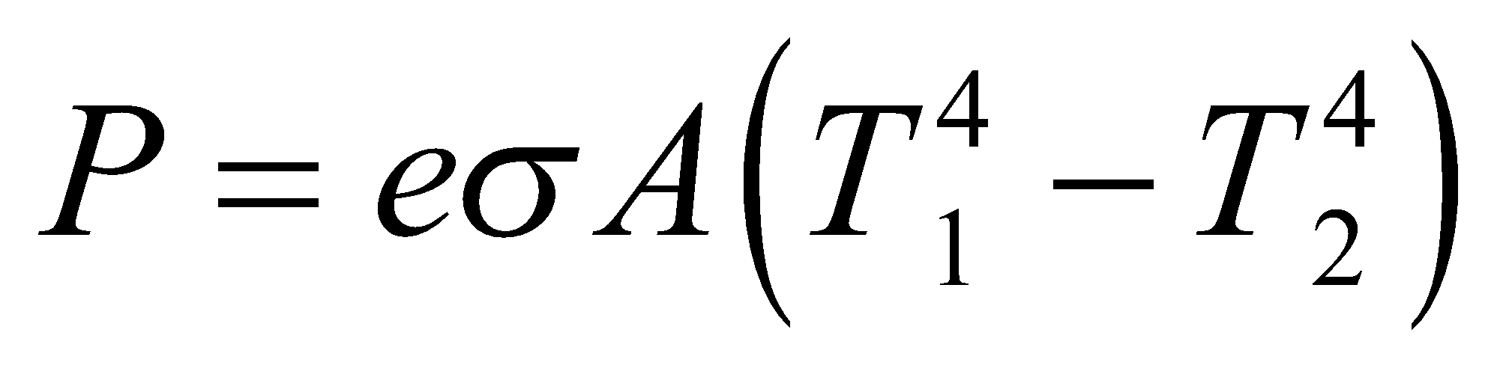

**Evaluate** Inserting the given quantities in the expression above, we find

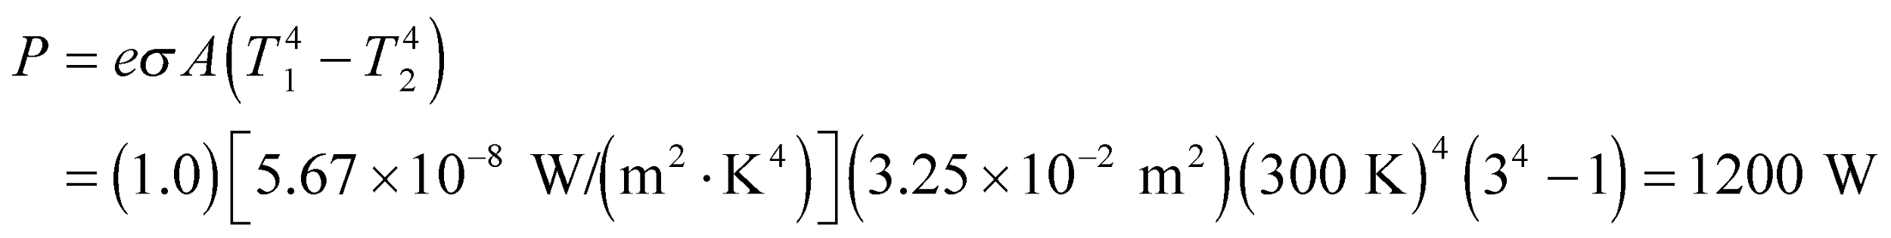

which is 80% of the input power of 1500 W.

**Assess** The actual power loss will be greater than this because of heat loss due to convection.

**61. Interpret** This problem involves thermal energy balance. The source of power is the electric current that heats the wire, and the loss mechanism is by radiation for part (a), and by thermal energy conduction for part (b).

**Develop** The strip is in energy balance between the input power and the net power radiated [the only transfer mechanism available for part (a)]. Thus, according to Equation 16.9,

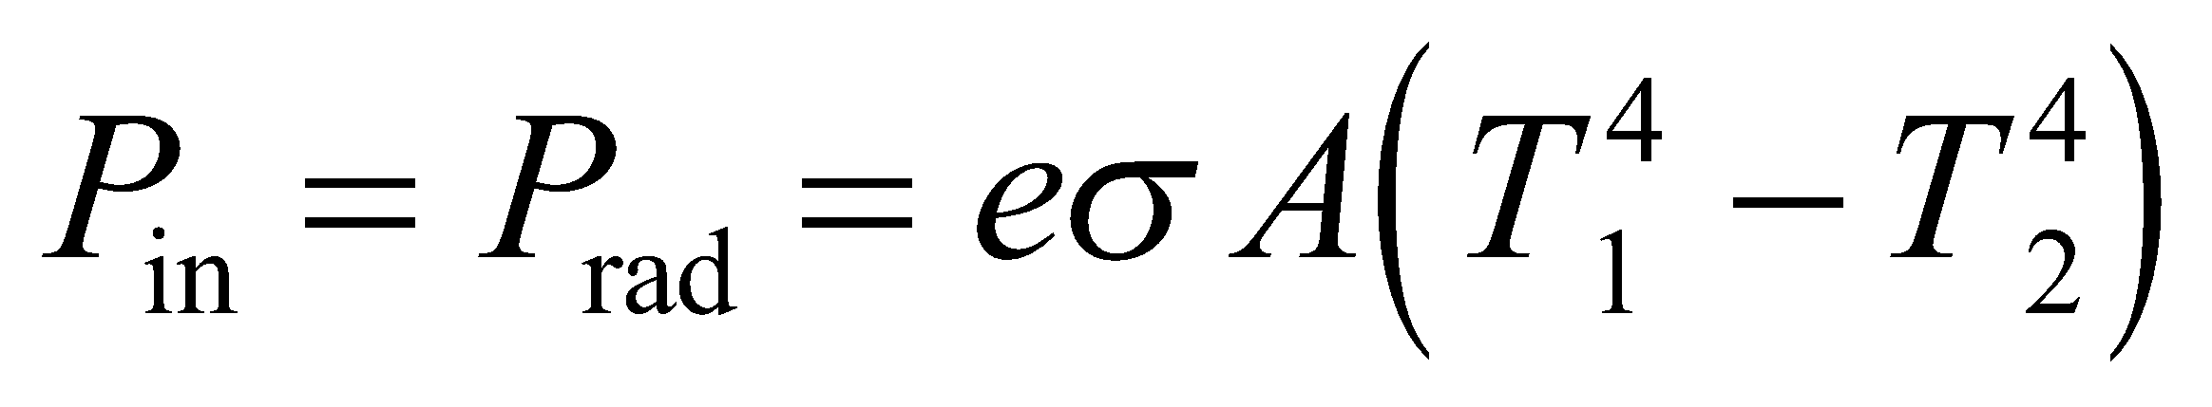

where *P*in = 50 W and . This equation allows us to determine the temperature of the strip,For part (b), the input power is the same, but the output heat loss is only through thermal conduction, so

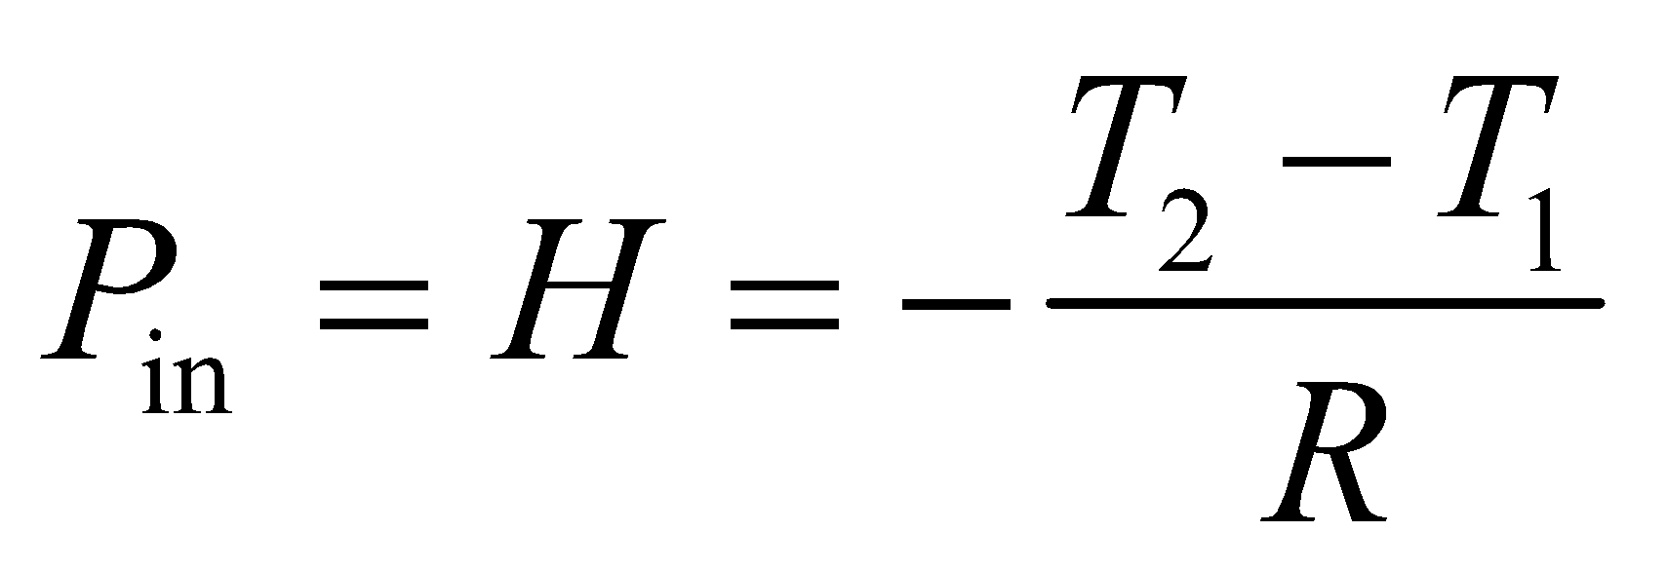

**Evaluate** (a) Inserting the given quantities into the energy-balance equation above gives

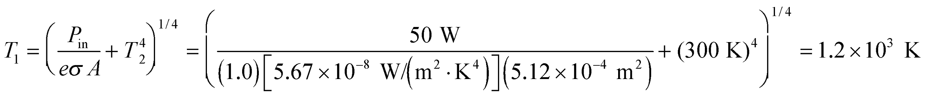

**(b)** Solving the equation above for part (b) for the temperature *T*1 gives



**Assess** We get a higher temperature of the strip when heat transfer is caused by radiation than by conduction. At these temperatures, conduction transfers more thermal energy than radiation. However, radiation dominates at higher temperatures because of its *T*4 dependence.

**62. Interpret** A sleeping bag is like the insulation in the walls of a house. It doesn't generate heat, but it slows the rate at which heat leaves your body. You want to check if a certain sleeping bag really can keep you warm at the minimum temperature that its manufacture specifies.

**Develop** If the outside temperature is –10°F (or –23°C) , there will be a temperature difference of 60°C between the inside and outside of the sleeping bag. We can find the conductive heat flow using Equation 16.5: 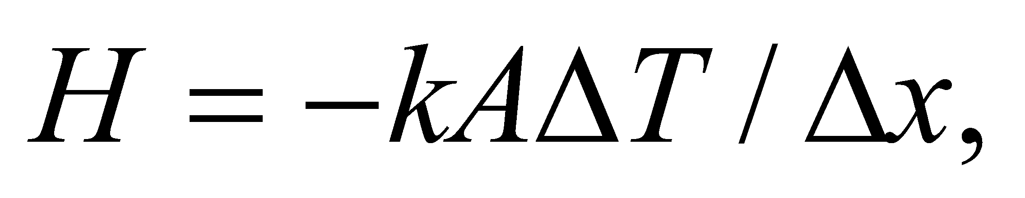where the thermal conductivity of goose down is given in Table 16.2: 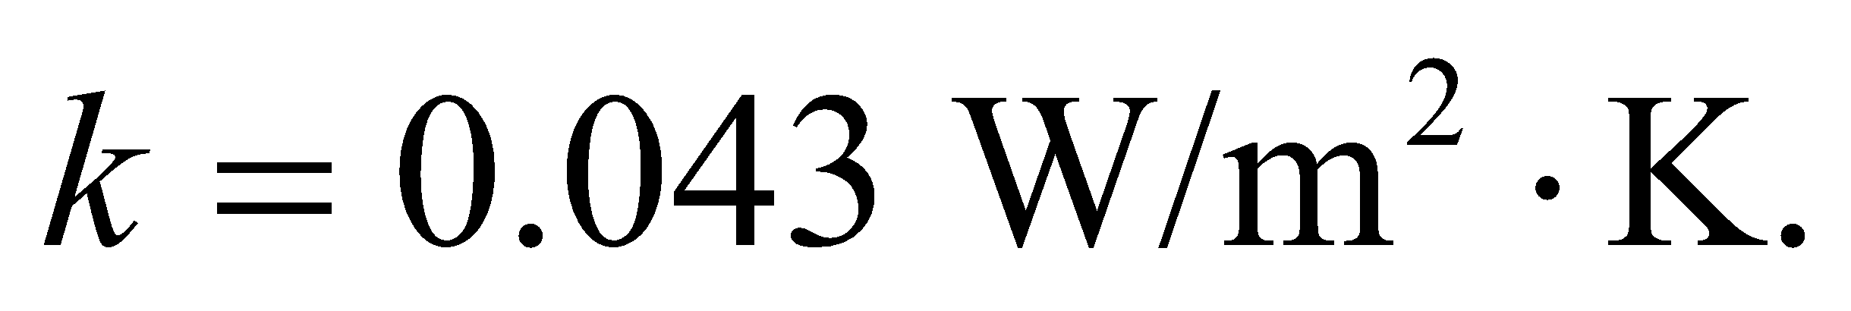 If this heat loss is greater than the 100 W that your body produces, then you will feel cold.

**Evaluate** Assuming the sleeping bag conforms to your body, it will have essentially the same surface area as you. The heat flow through the bag is then

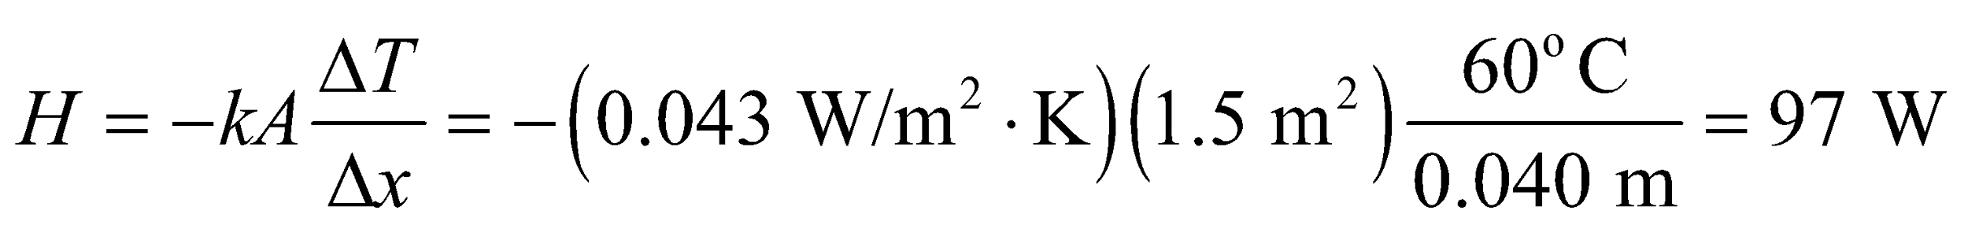

The heat loss is less than what your body produces, so you will be able to maintain normal body temperature when the outside temperature drops to –10°F.

**Assess** The heat loss is actually 3W less than what your body produces, so you may start to feel a little too warm in the bag. In actuality, though, your body can regulate how much heat it makes.

**63. Interpret** Our system consists of two materials, water and an iron horseshoe, which are initially at different temperatures. They are brought together and reach a thermal equilibrium. We want to find the equilibrium temperature.

**Develop** Let us assume that all the heat lost by the horseshoe is gained by the water, with no heat transfer to the container or its surroundings. In this case, 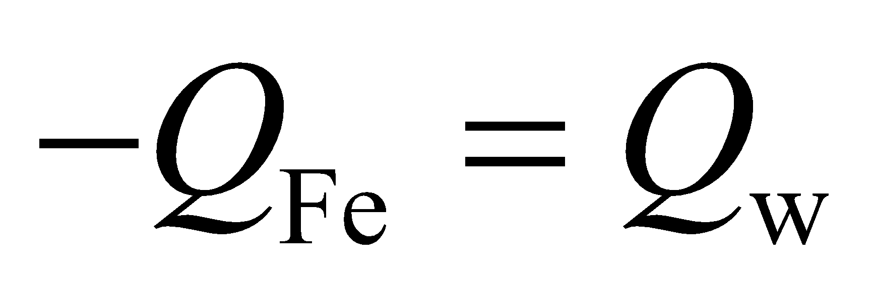 (as in Example 16.2). Using Equation 16.4 gives

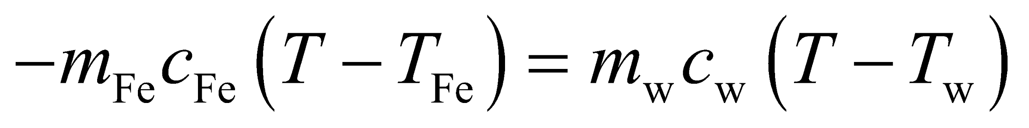

The specific heats of copper and water can be found in Table 16.1.

**Evaluate** Solving for *T*, one finds

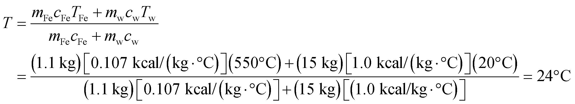

**Assess** The change of water temperature is  while the change of temperature of the iron horseshoe is 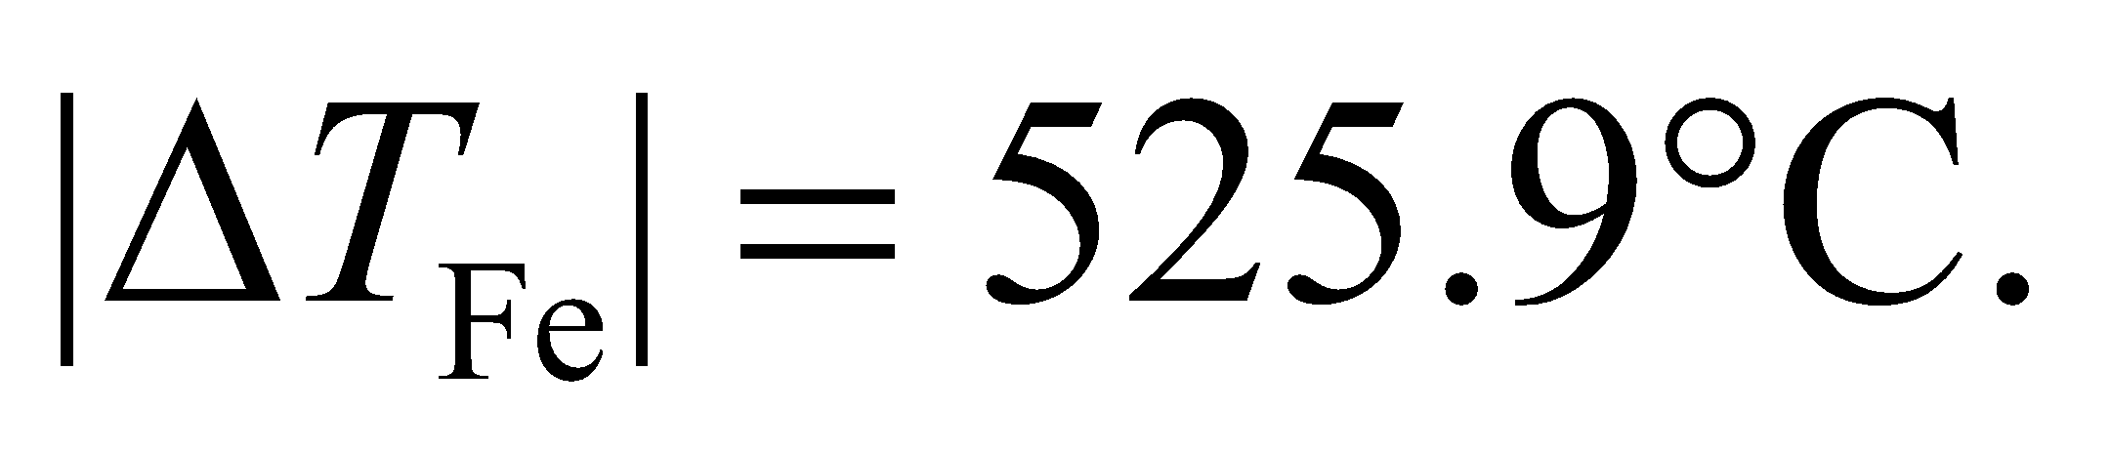 Because there is more water (by mass) and it has a much higher specific heat, its temperature changes less compared to the horseshoe.

**64. Interpret** The problem asks for the power output of a microwave given the time it takes to boil a certain quantity of water.

**Develop** If we assume microwave is 100% efficient, then all the energy it produced in the given time, 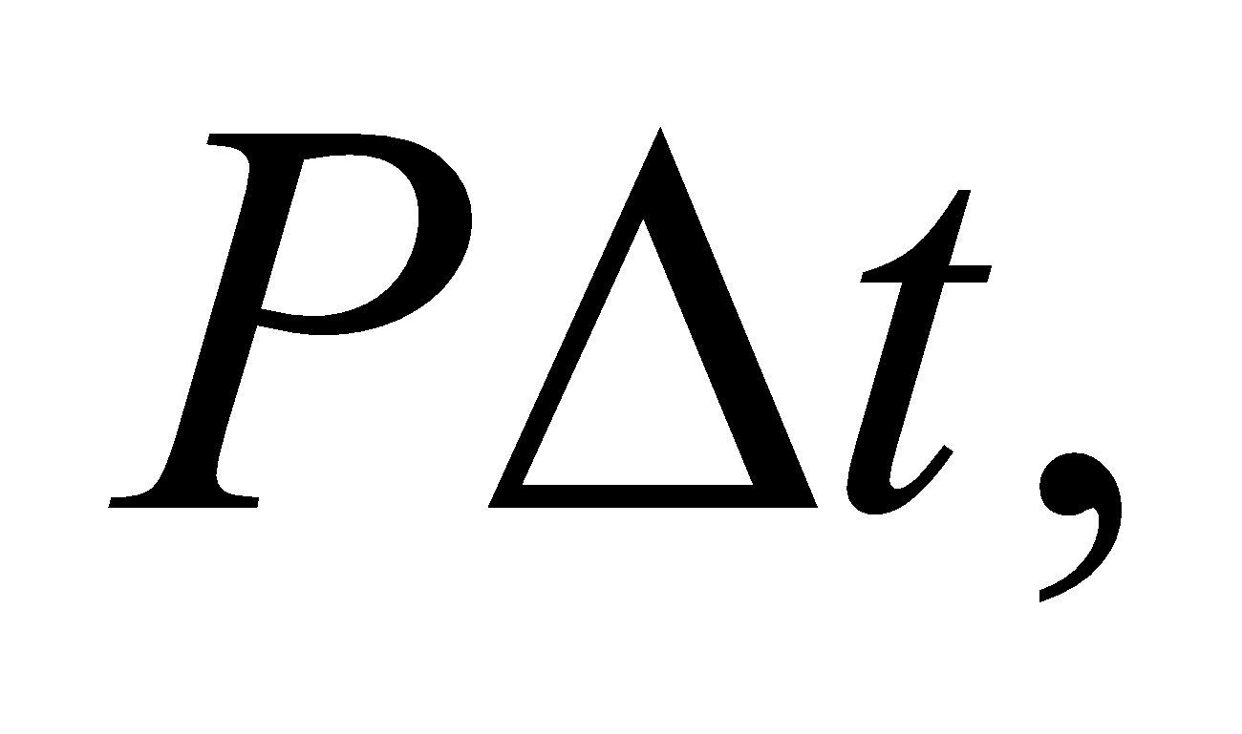will be used heat the water: 

**Evaluate** Solving for the power gives

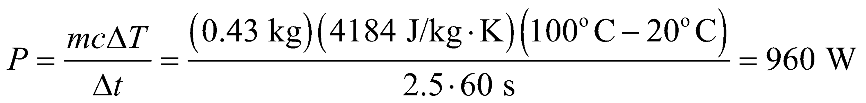

**Assess** This is about the typical power for a microwave oven. But in reality some of the power is lost, heating the container or the oven walls.

**65. Interpret** This problem is about the radiation emitted by a burning log. Given its emissivity and its radiating power, we are to calculate its temperature.

**Develop** If we neglect the radiation absorbed by the log from its environment (which should be negligible because the temperature of the log is much, much greater than room temperature), then the net power radiated by the log is just that given by the Stefan-Boltzmann law (Equation 16.9):

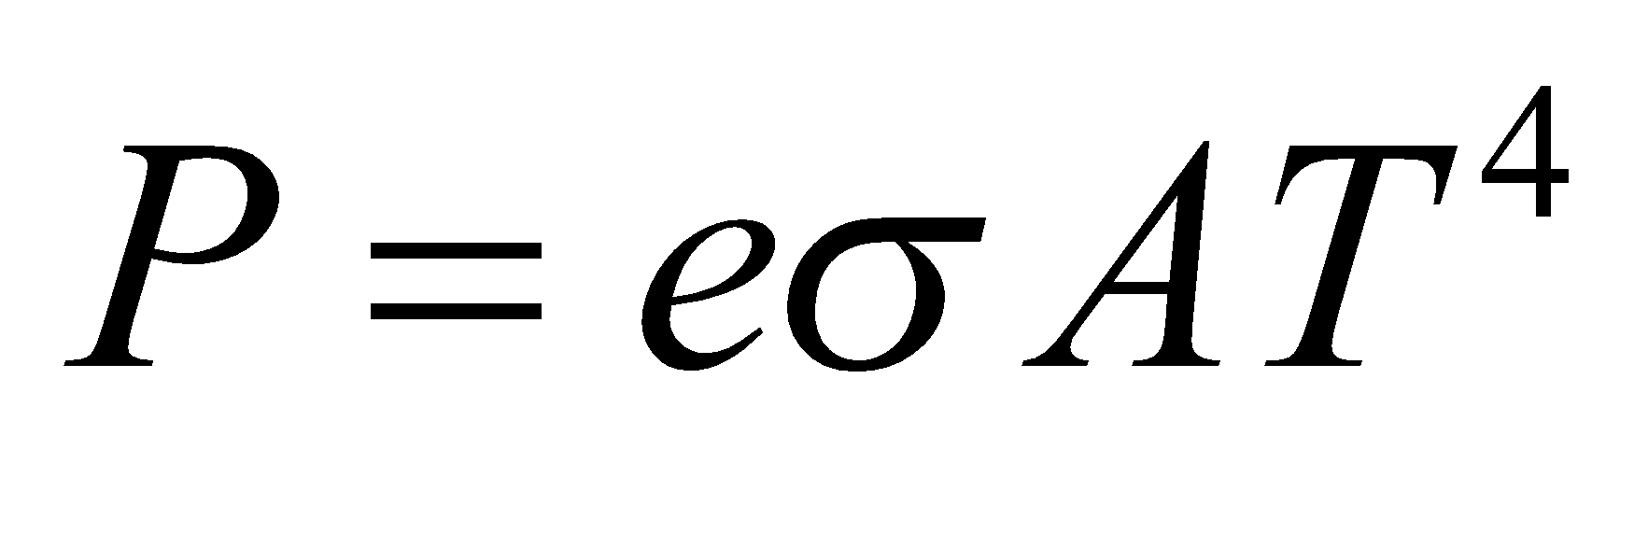

Knowing the surface area of the log allows us to determine *T*.

**Evaluate** The surface area of the log is



Solving for *T*, we find

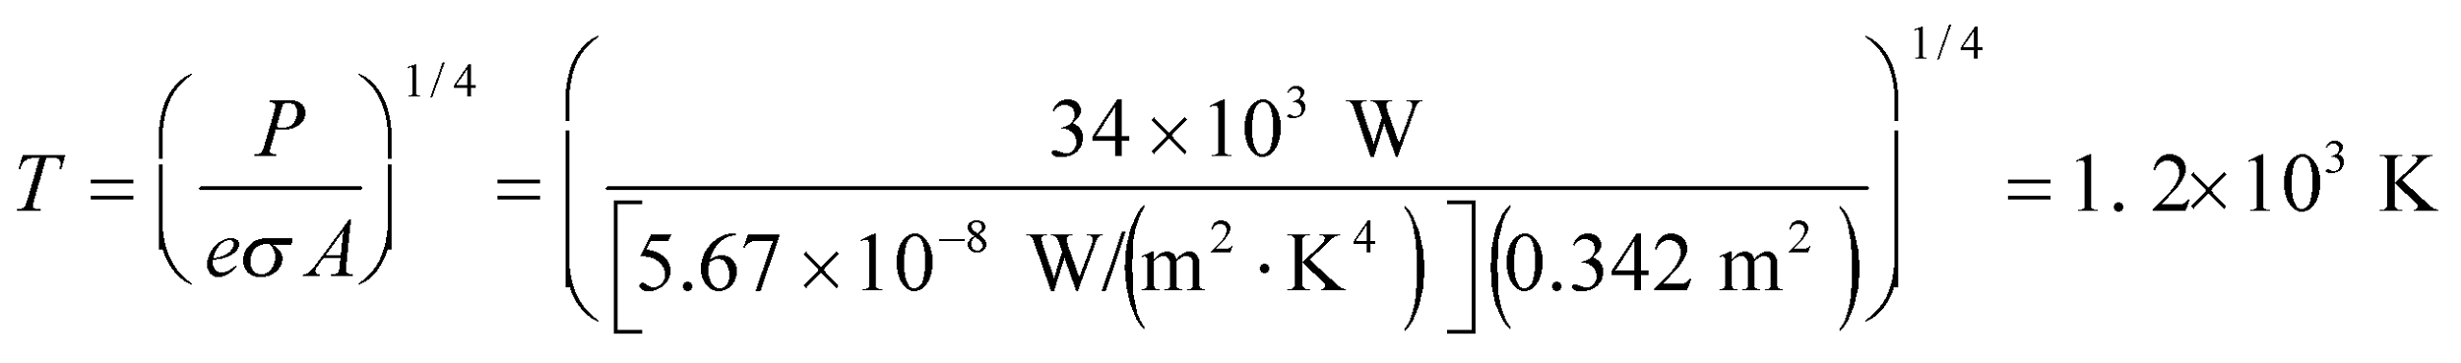

**Assess** When a burning log is glowing red hot, its temperature is above 1000°C. If the temperature continues to rise, its color will turn orange, then yellow, then white when it emits over a broad range of visible wavelengths.

**66.** **Interpret** This problem involves blackbody radiation. Given a star’s surface temperature and its radiating power, we are asked to calculate the radius of the star.

**Develop** Apply the Stefan-Boltzmann law, Equation 16.9, *P* = *eσAT*4. The surface area of the star is *A* = 4*πr*2, so we can solve for its radius *r*. If the star behaves as a blackbody, its emissivity is *e* = 1.0.

**Evaluate** Solving the Stefan-Boltzmann law for the radius gives

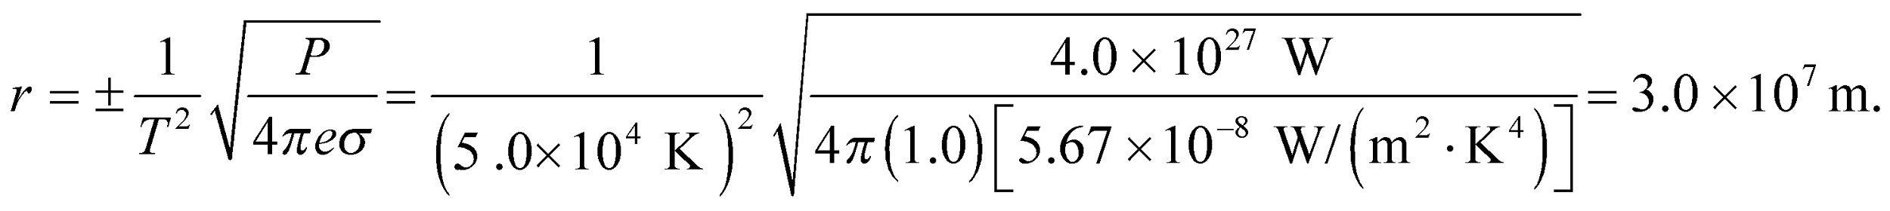

**Assess** The two signs for the radius indicate that the radius may be measured in either the positive or the negative direction.

**67. Interpret** This problem is about the heat loss through various structural parts of the house via conduction.

**Develop** Follow the approach outlined in Example 16.4. By Equation 16.8, 16.6, and 16.5, the heat-flow rate is related to the -factor as

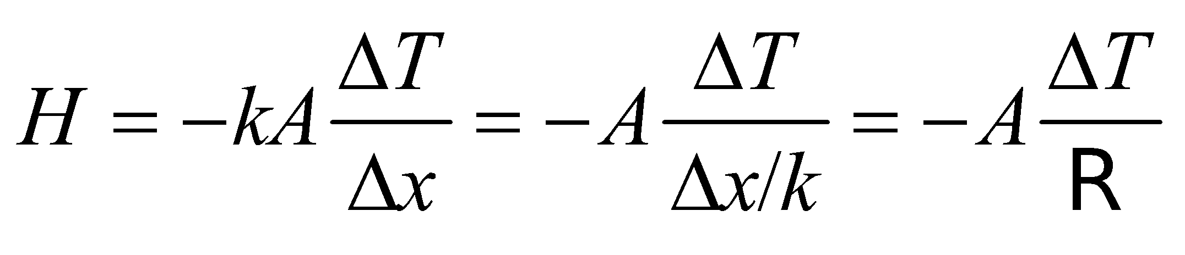

The window area here is 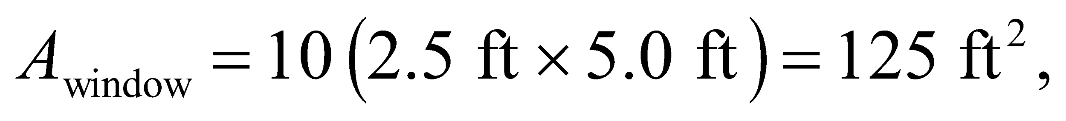 and the wall area is 125-ft2 less than in Example 16.4, or 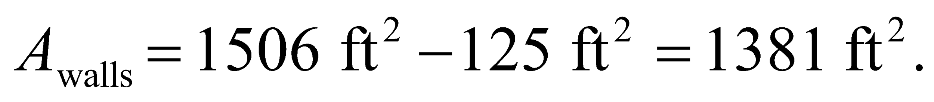 Thus, the heat lost through these structural parts are:

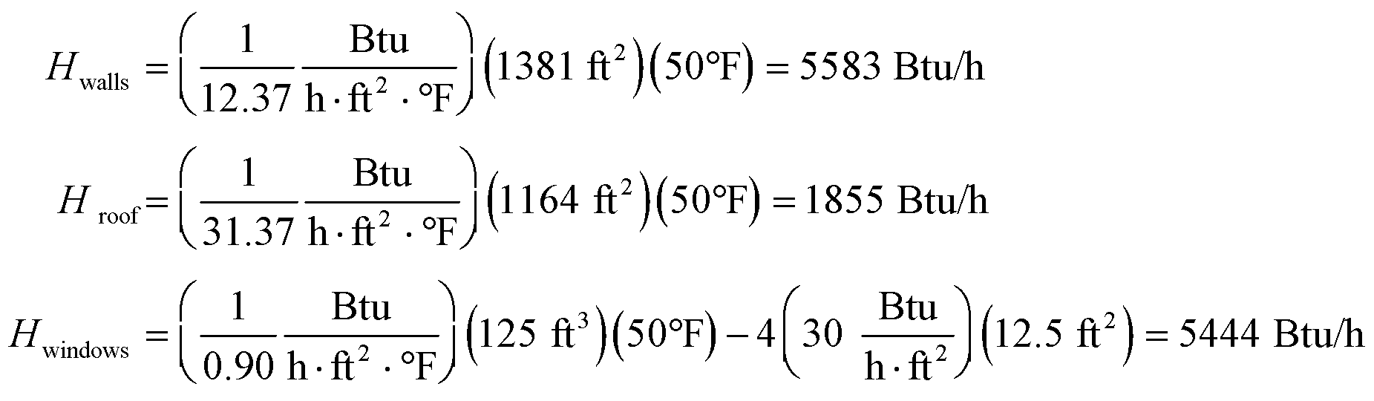

where we have included the heat gain by solar energy (= 1500 Btu/h) in *H*windows. Thus, the rate of thermal energy loss from the entire house is



**Evaluate** **(a)** The monthly fuel bill is



to two significant figures.

**(b)** The solar gain from the south windows is worth



**Assess** This is an expensive fuel bill. You probably would want to improve the insulation.

**68.** **Interpret** This problem involves heat transfer by conduction through the wall of the stove, and heat transfer by radiation for the stove radiating heat into the environment. We are asked to find the rate of heat conduction through the walls of the stove, the rate of heat loss by radiation from the stove, and the total rate of heat loss into the environment by the combination of conduction and convection.

**Develop** If we assume steady one-dimensional heat-flow across the thickness of the stove, Equation 16.5 gives

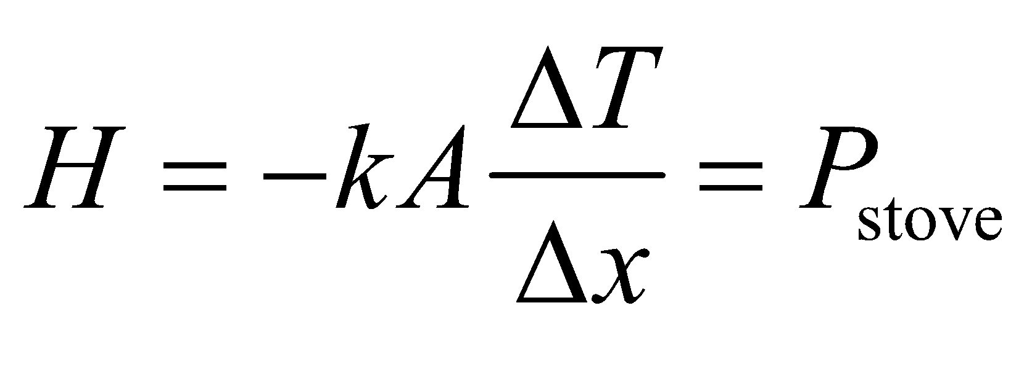

which is the heat transfer by conduction through the wall of the stove. For part (b), if we ignore the power absorbed by the stove from its surroundings and assume its emissivity is *e* = 1, the Stefan-Boltzmann law (Equation 16.9) gives

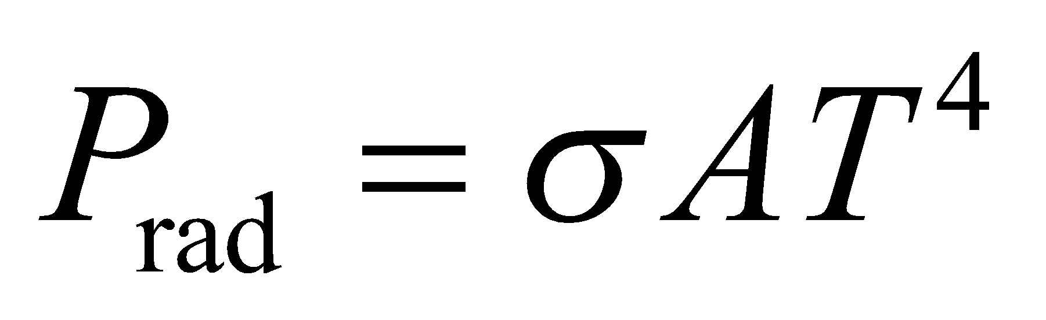

which is the heat transfer by radiation from the stove to its environment. Finally, for part (c) we apply the concepts of thermal energy balance. The source of power is the stove, whose power is found in part (a). The two loss mechanisms are the loss by radiation, which we find in part (b), and the loss by convection. Equating the sources and the losses of power (by the demands of thermal energy balance), we find



which we can solve for *P*conv.

**Evaluate** (a) Inserting the given quantities into the expression for heat transfer by conduction gives



to two significant figures.

(b) The power lost by radiation is



(c) The power lost by convection is



**Assess** Notice that we use the intermediate results to calculate part (c). Had we used the final results, we would have obtained an incorrect result.

**69. Interpret** This problem is about radiation received by Pluto from the Sun. Treating Pluto as a blackbody, we want to find its average surface temperature.

**Develop** From Example 16.5, the power radiated by the Sun is 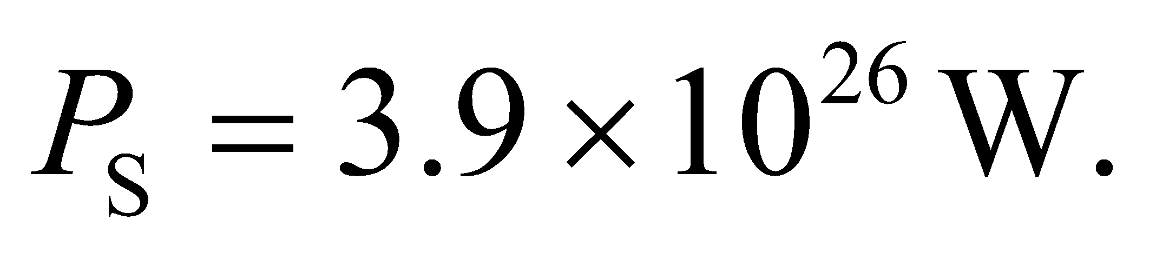This radiation spreads evenly out to the orbital radius of Pluto, 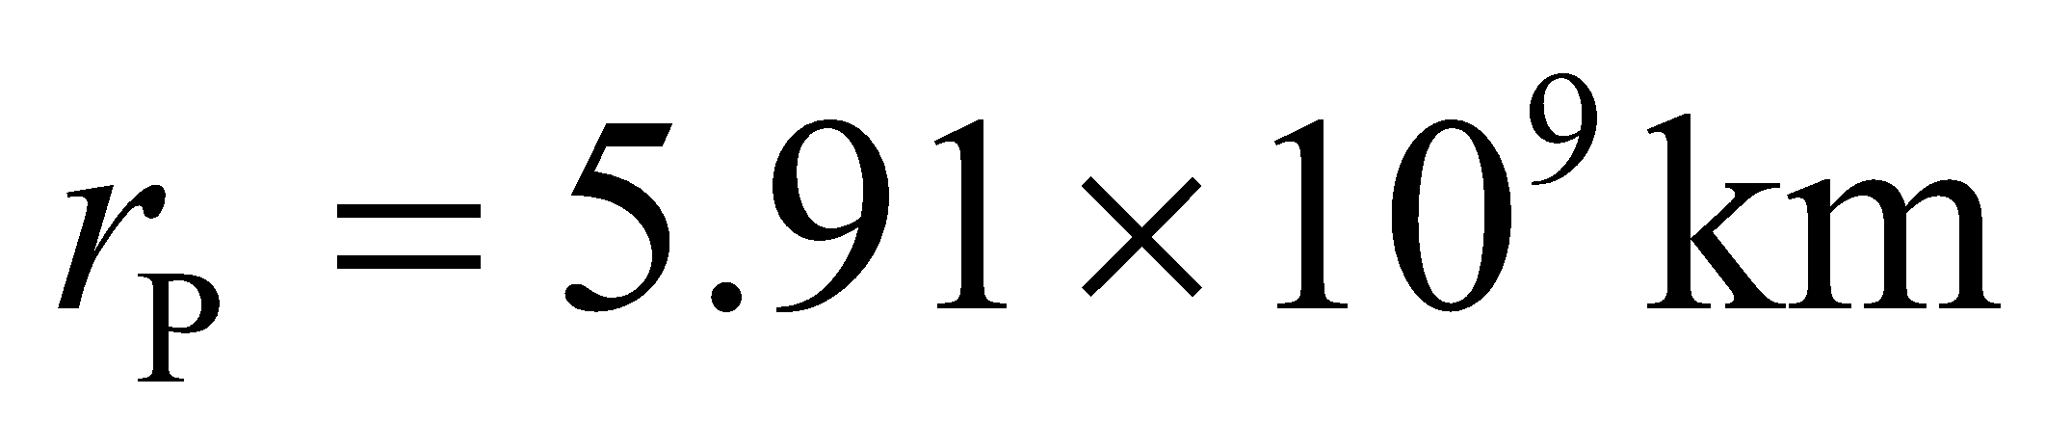(from Appenix E). If we assume that Pluto absorbs the fraction of radiation falling on its cross-sectional area 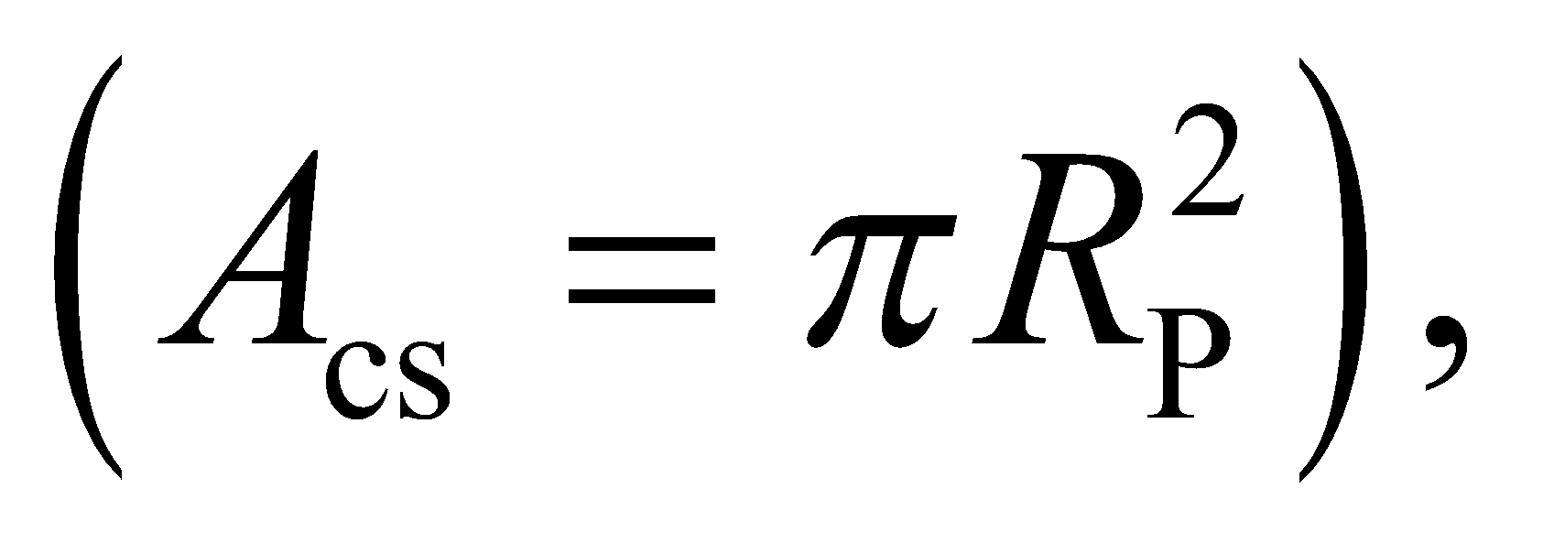then Pluto's heat input from the Sun is

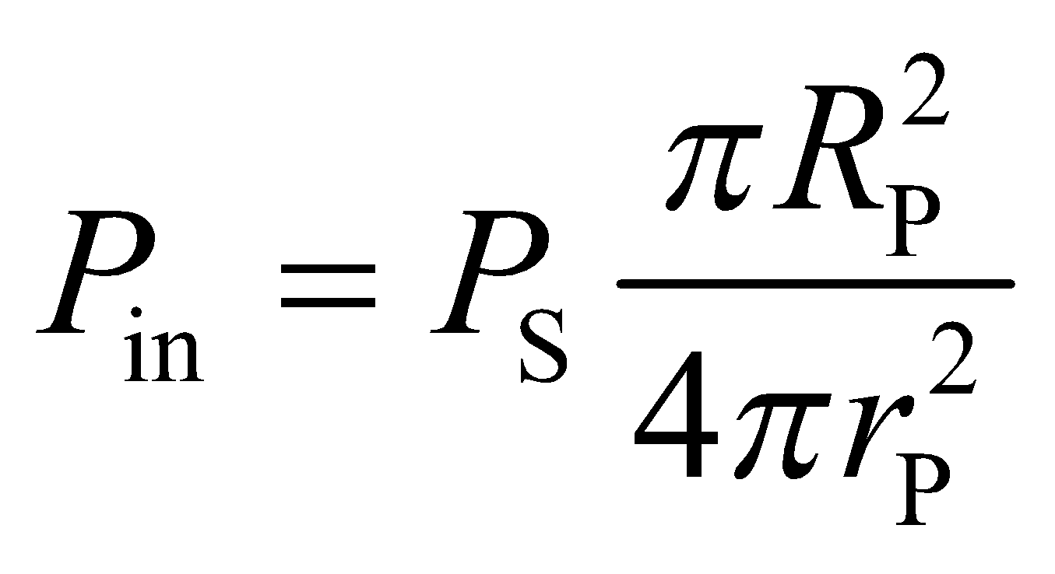

Pluto will be radiating away this heat, according to Stefan Boltzmann's law: 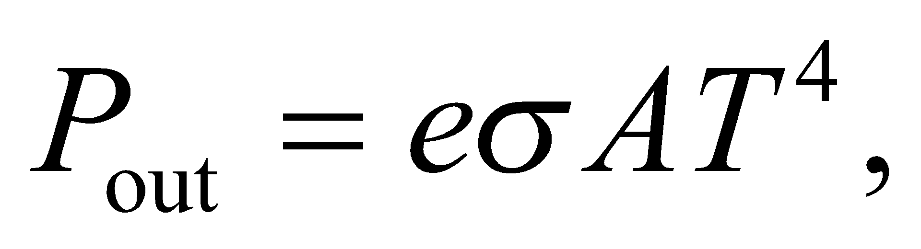where the area in this case is the total surface area,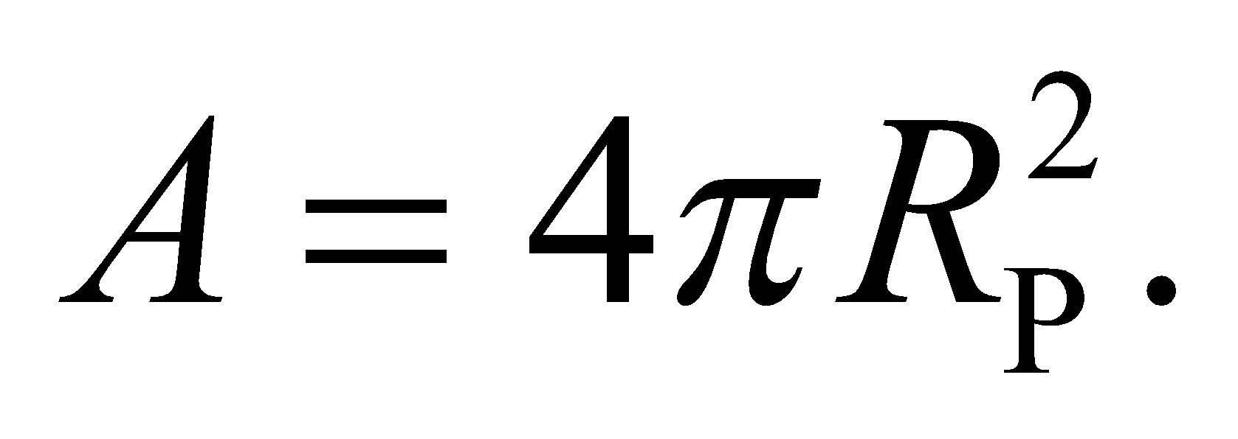The surface temperature, *T*, will settle to a value where the outgoing radiation matches the incoming radiation.

**Evaluate** Equating the two powers gives the following for the surface temperature:

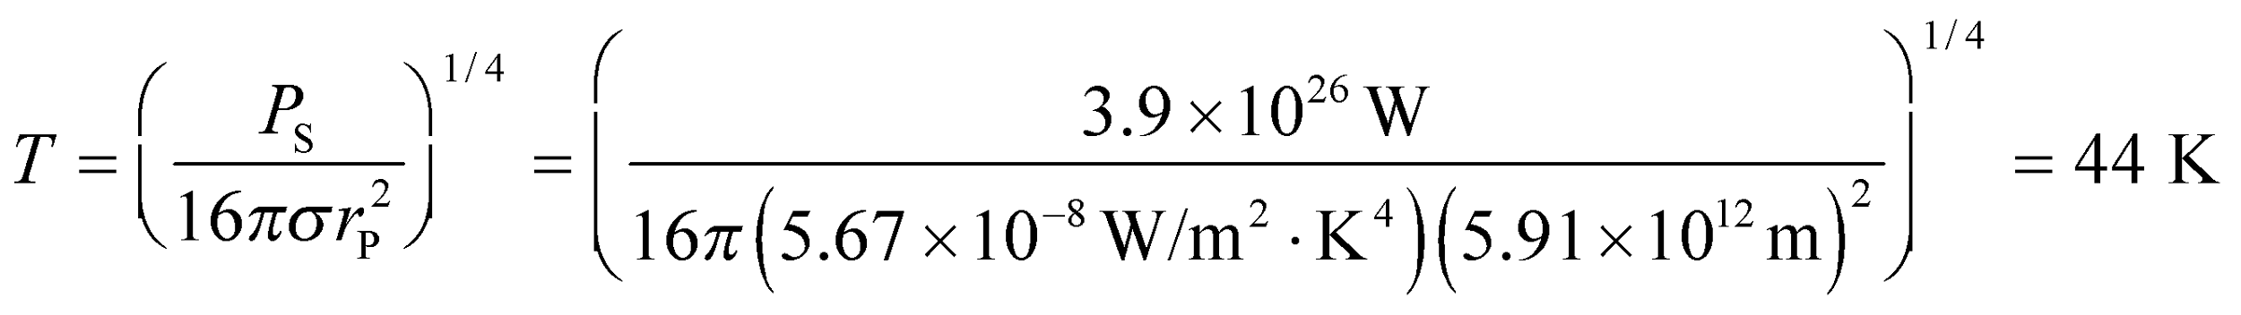

**Assess** Astronomers have recently estimated the temperature on Pluto to be about 43 K, so this answer is in agreement with that. One effect that we didn't account for is Pluto's albedo, i.e., how much of the incoming sunlight gets reflected away instead of absorbed.

**70. Interpret** We are to show that the equation for conductive heat loss through a cylindrical surface is as given. To do this, we consider the differential form of Equation 16.5 and integrate the heat loss through thin cylindrical shells.

**Develop** The rate of heat flow is given by 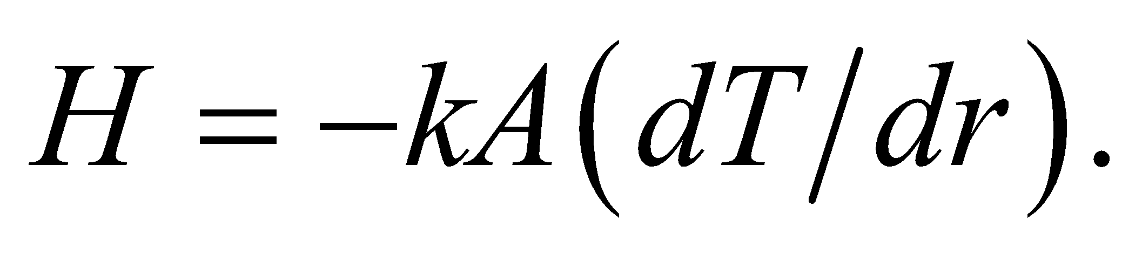 Consider the heat loss through thin cylindrical shell of thickness *dr* and length *L*, which is

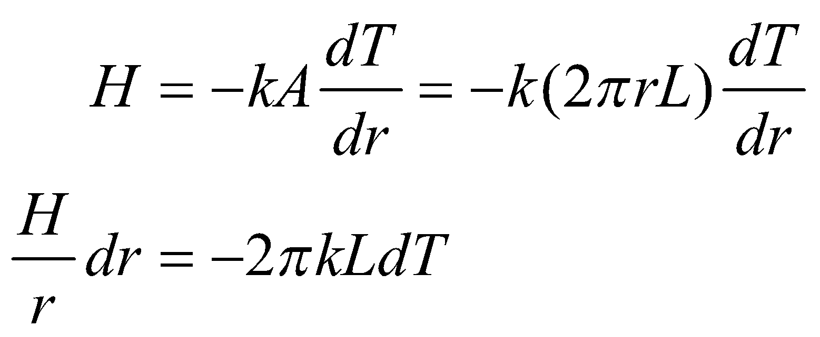

We can integrate this expression to find an expression for the heat loss through the macroscopic cylinder.

**Evaluate**Performing the integration gives

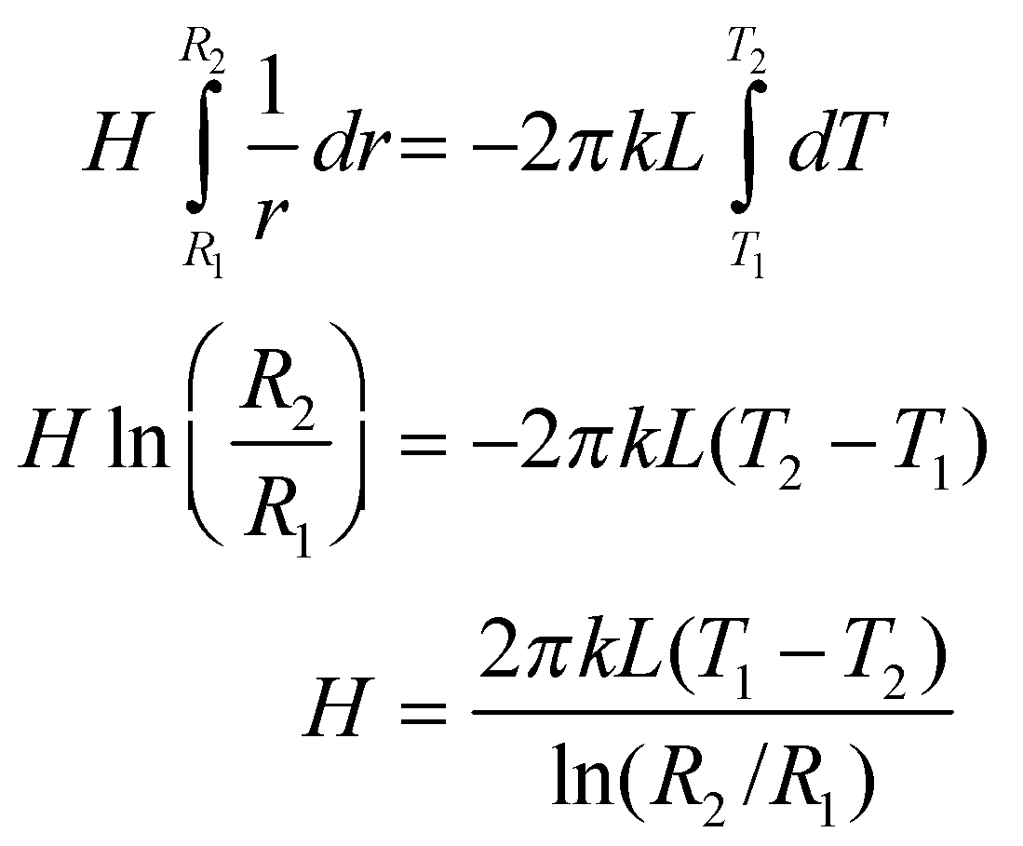

**Assess**We have shown what was required.

**71. Interpret** You want to check whether the Sun's recent increase in power output can explain the rise in the global average temperature. This is your friend's argument against human-induced global warming.

**Develop** From the Application "The Greenhouse Effect and Global Warming," you were told that the Earth currently absorbs energy from the Sun at a rate of 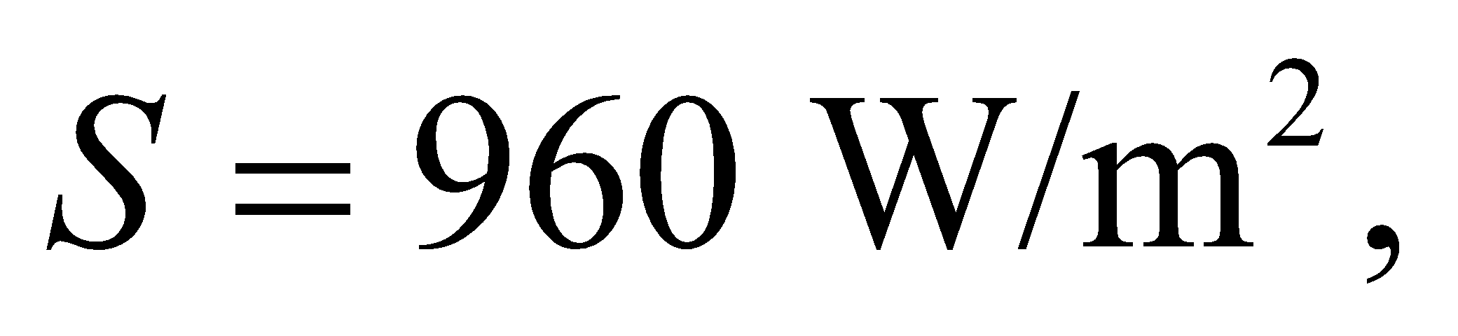 averaged over the cross-sectional area of the planet, 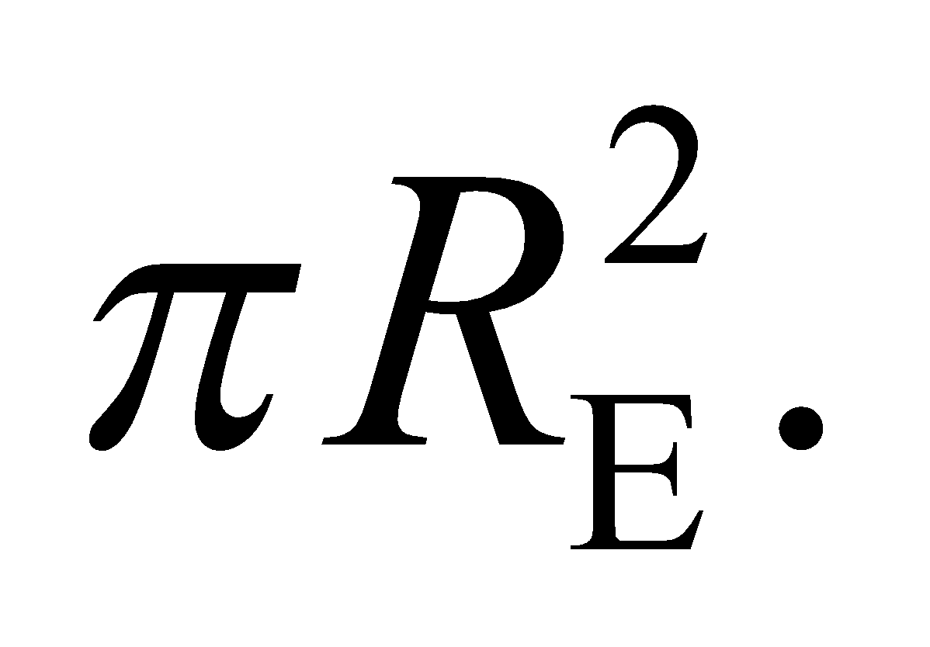 Using energy balance arguments and a assuming the Earth's emissivity is 1, a formula was derived for the Earth's average temperature:

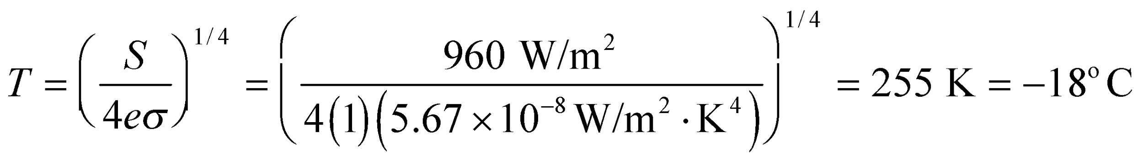

This is too cold. The global average temperature is actually about 15°C, due to the greenhouse effect. Effectively, the greenhouse effect reduces the Earth's emissivity to about 0.61. Let's assume that the emissivity has been constant since the start of the industrial era. Then 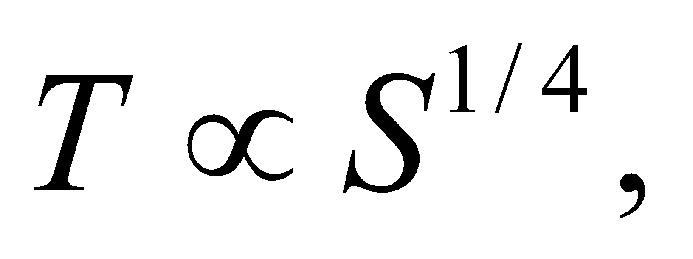 and we can verify if the change in the solar flux can account for the measured temperature change since the start of the industrial era.

**Evaluate** The solar flux has increased by 0.04% since pre-industrial time, which can be expressed as 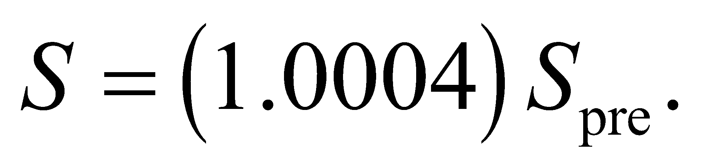The temperature should correspondingly be higher due to this change:

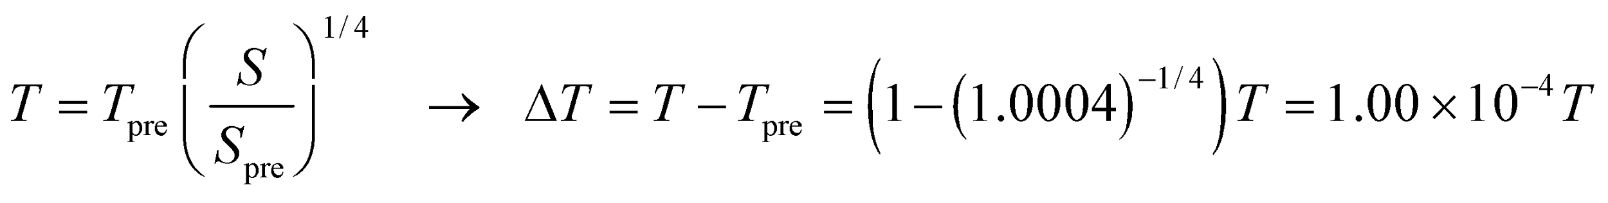

In Kelvin, the current global average temperature is 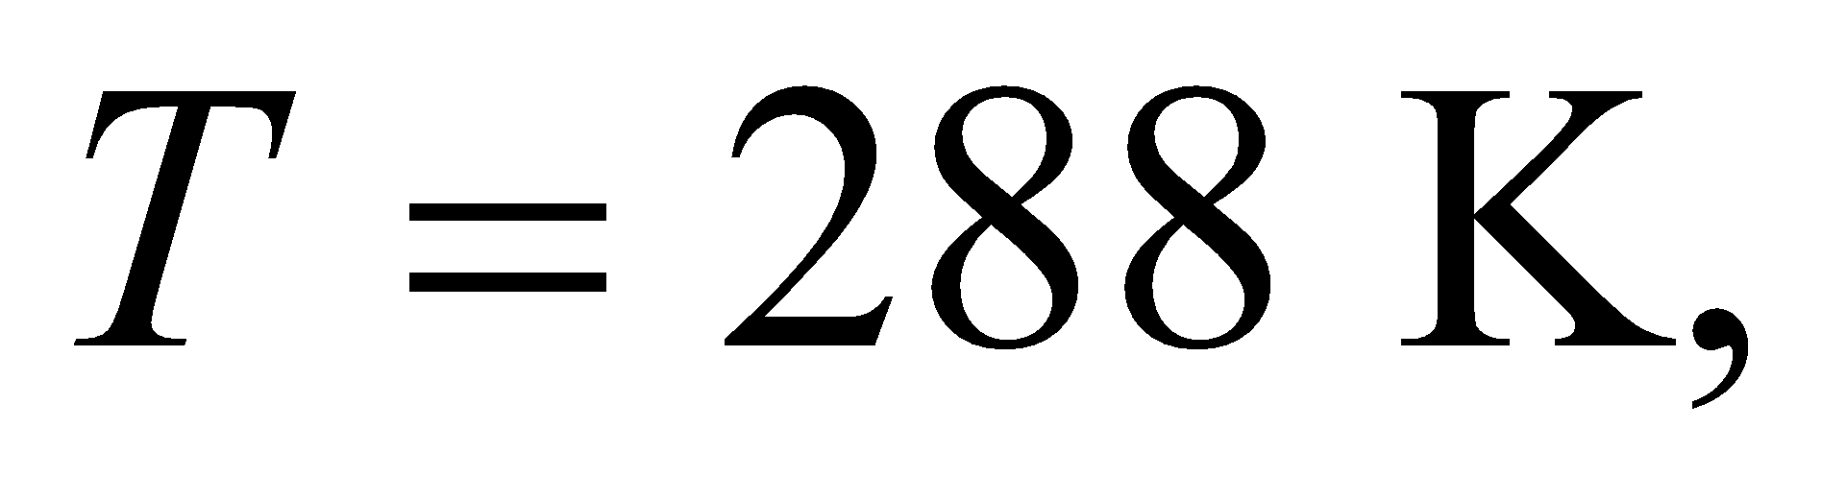so the temperature change from the solar flux increase is 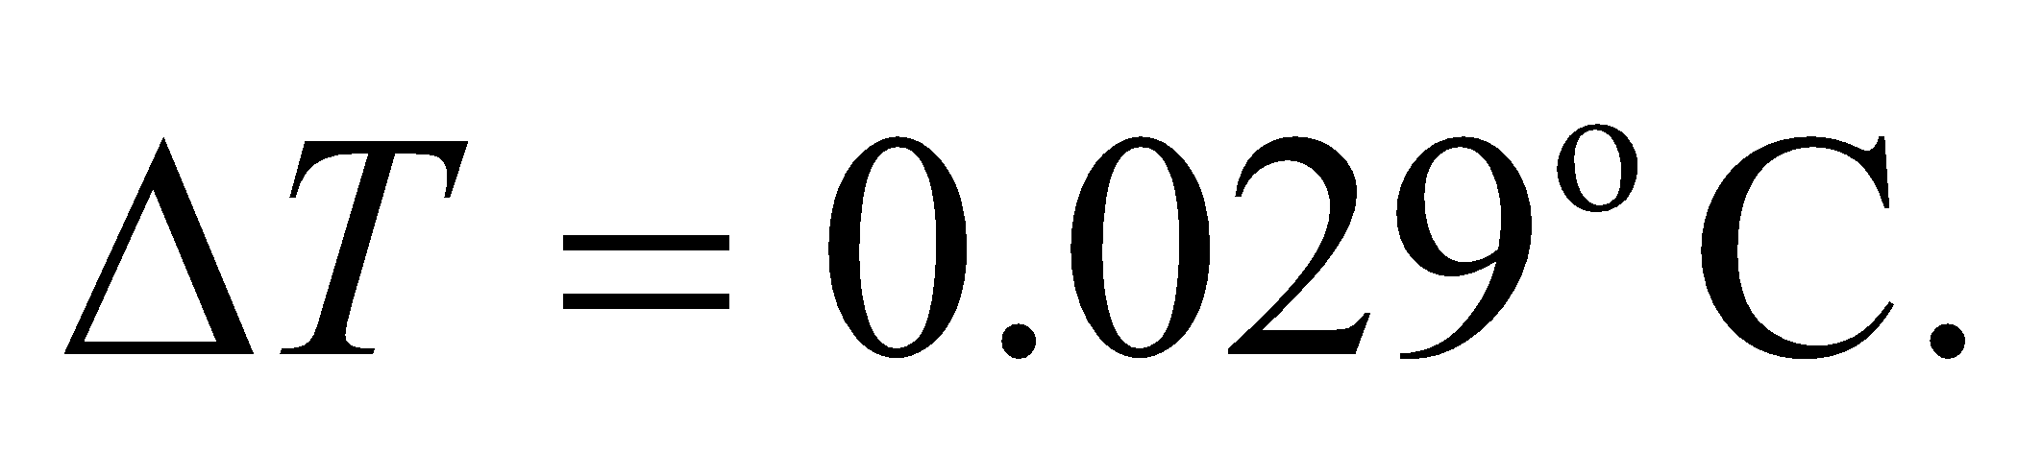 This only accounts for about 4% of the measured temperature increase, so your friend is wrong.

**Assess** The argument for human-induced global warming is that the temperature increase is due to a decrease in the effective emissivity. Rising levels of greenhouse gases since the beginning of the industrial era allow less of the infrared radiation from the Earth's surface to be emitted into space.

**72. Interpret** This problem involves converting units from SI to English. Specifically, we are to convert from m2K/W to *R*-factor.

**Develop**The units of *R* are 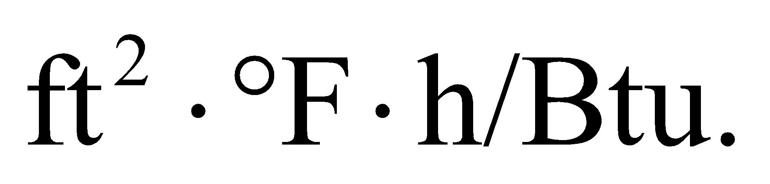 Use the conversion factors 1 = 3.28 ft/m, 1= 1.8°F/K, and 1054 J/Btu from Appendix C.

**Evaluate** Inserting these conversion factors gives

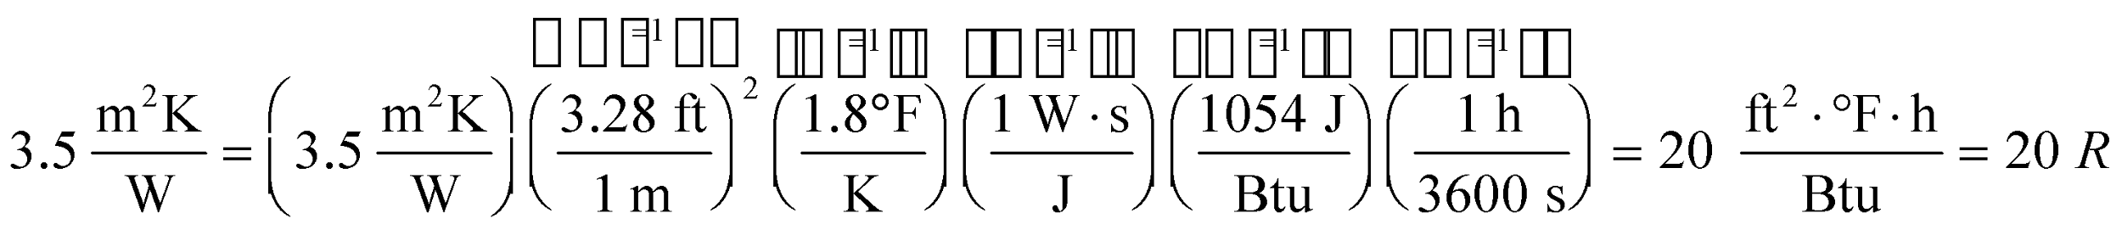

so the insulation will be sufficient.

**Assess** Notice that the units in the above expression cancel to give the correct result.

**73. Interpret** This is an energy balance problem. The rabbit hutch loses energy at a given rate. In equilibrium, the heat lamp provides energy at the same rate that the hutch loses energy. You will find the equilibrium temperature difference to see if the interior temperature can stay above freezing.

**Develop** The thermal resistance is given as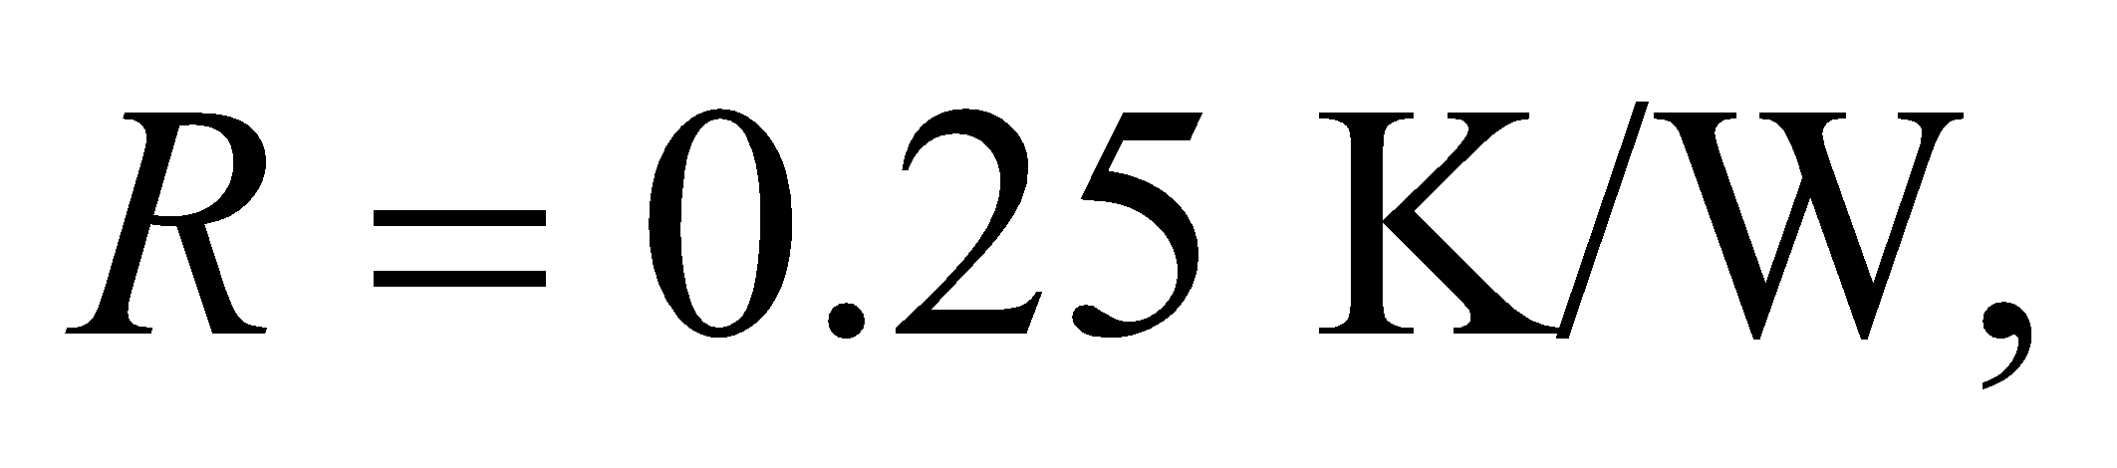which means the hutch loses heat at a rate of 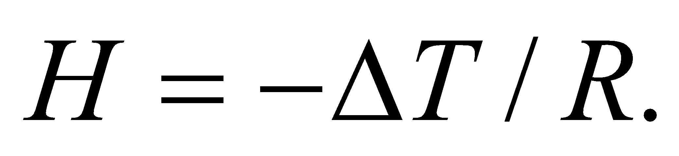The power of the heater is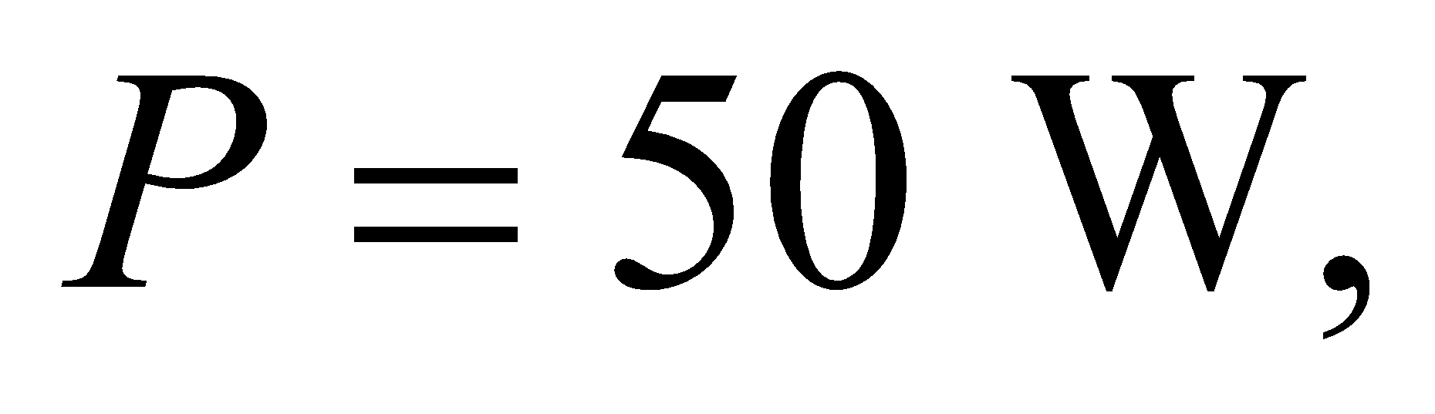so in equilibrium the temperature difference is 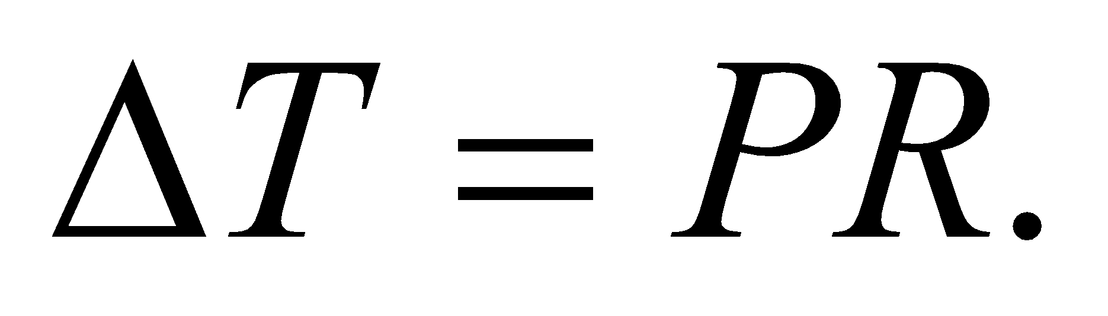

**Evaluate** Since the outside temperature is –15°C, the interior temperature of the hutch is



The rabbit's water will freeze.

**Assess** You need to get a bigger heater, or insulate the cage better, otherwise your niece's rabbit will not fare very well.

**74. Interpret** This is a heat-capacity problem, but with a heat capacity that changes with temperature. We can solve for the heat *Q* by integrating over *T*.

**Develop** The mass is given as *m* = 40 g and, from Equation 16.3, we have *dQ* = *mcdT*. The specific heat is *c* = 31(*T*/343 K)3 J/(g·K). We can thus integrate from *T*1 = 10 K to *T*2 = 25 K to find *Q*.

**Evaluate** Performing the integration gives

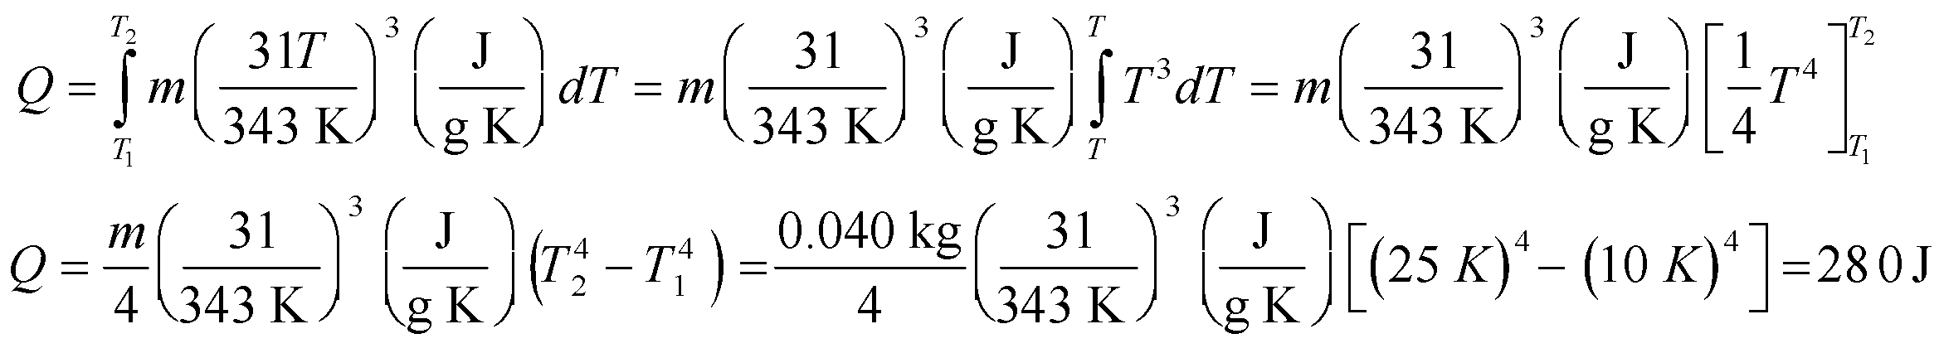

**Assess**At more normal temperatures, the specific heat of copper is 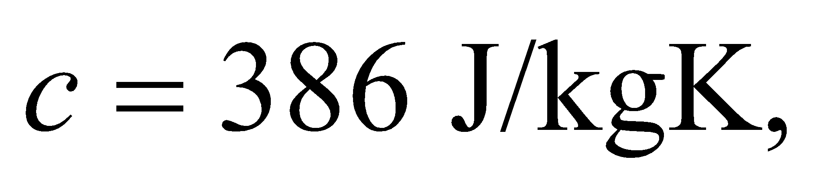 so the heat required to change the temperature of 40 grams of copper by 15°C would be 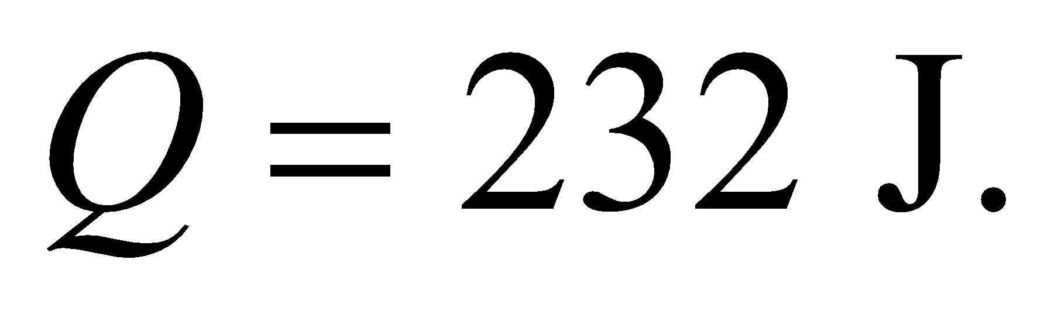 Our answer is probably in the right ballpark.

**75. Interpret** We are to show that the equation for conductive heat transfer through a conical solid is as given. To do this, we will integrate the conductive heat transfer through thin circular disks normal to the cone axis.

**Develop** We will integrate the heat flow through the cone, treating the cone as a stack of circular disks. The radius of any disk depends on *x* as

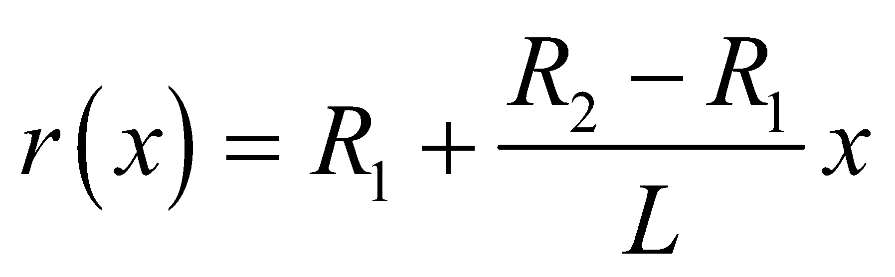

so the area of a disk is

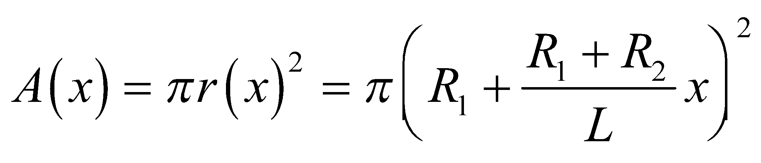

The heat transfer rate is given by the differential form of Equation 16.3, which is *H* = −*kA*(*dT*/*dx*). Inserting the expression for area gives

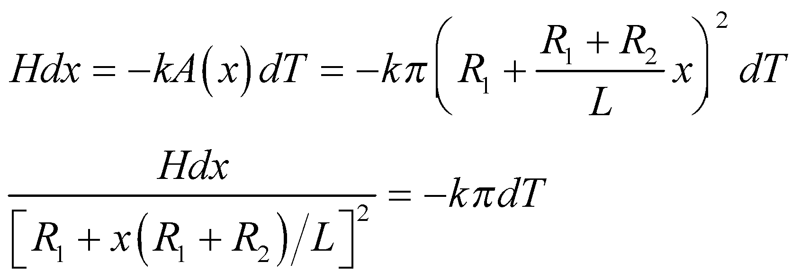

which we can integrate to find the heat transfer rate H.

**Evaluate** Integrating both sides gives

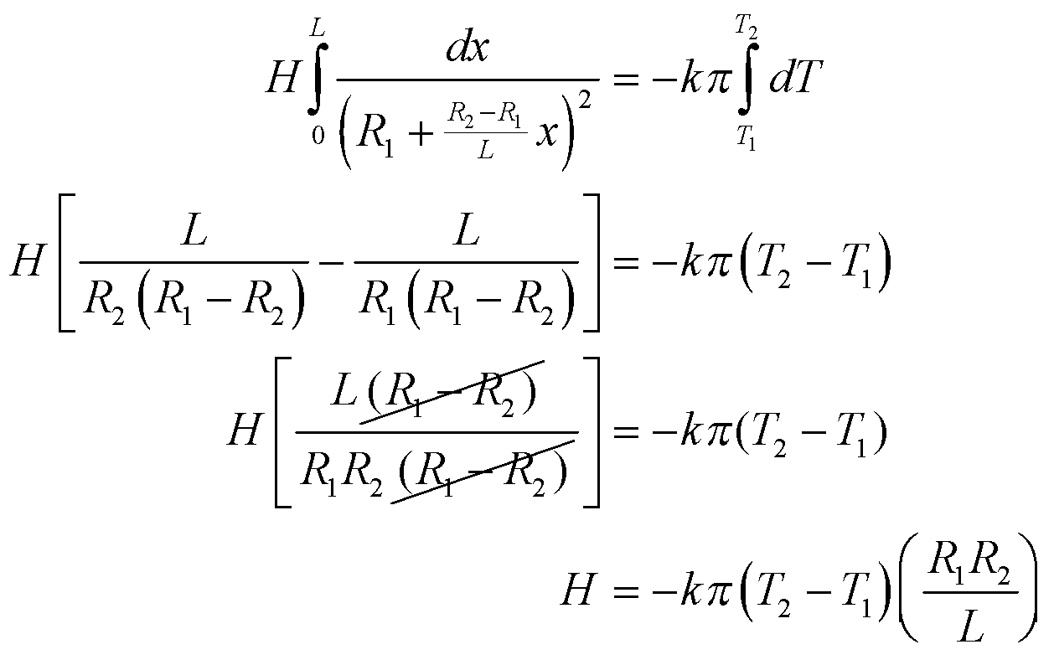

**Assess** We have shown what was required.

**76. Interpret** We derive Newton’s law of cooling, and apply it to the time it takes a house to freeze.

**Develop** We start with the differential forms of the heat capacity, 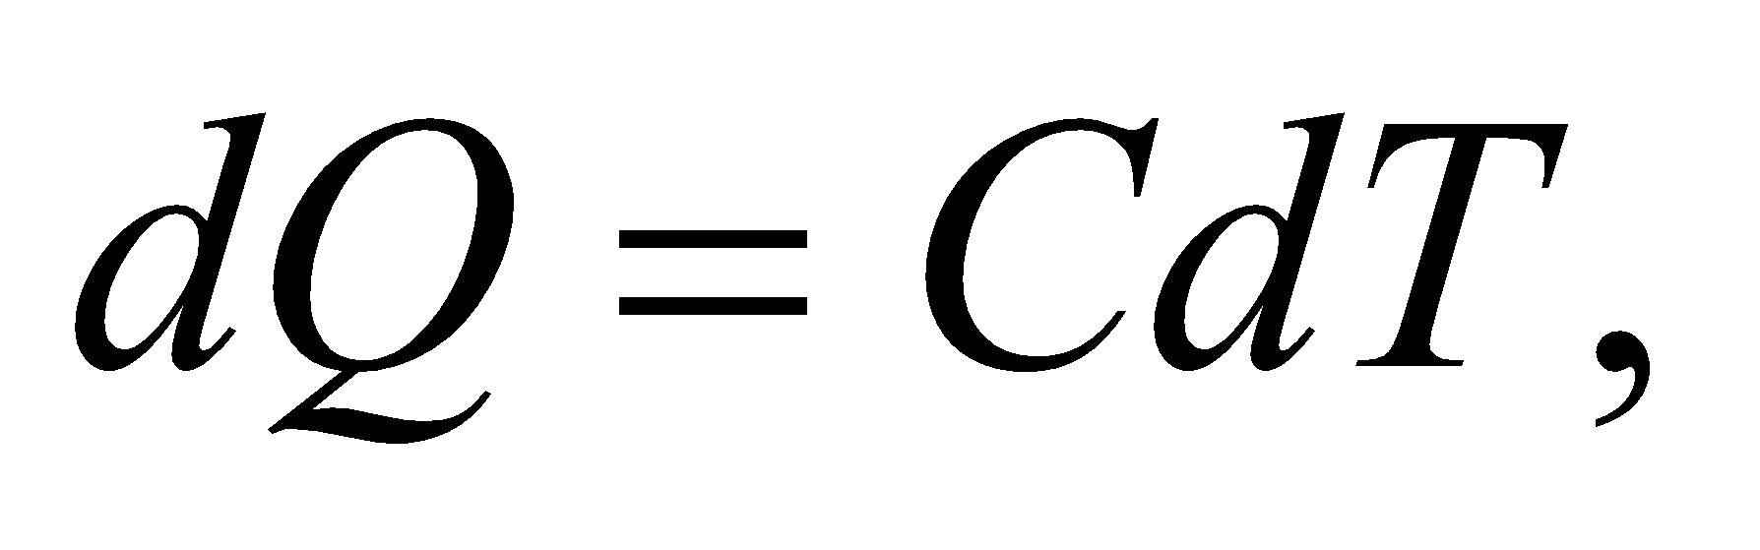and the heat loss, 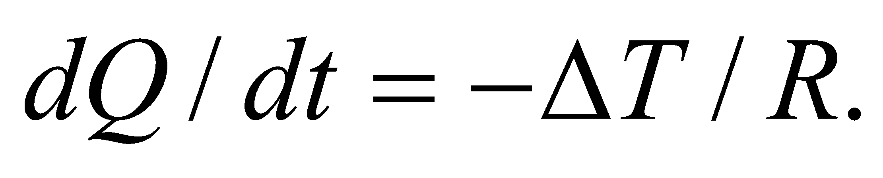 Here, 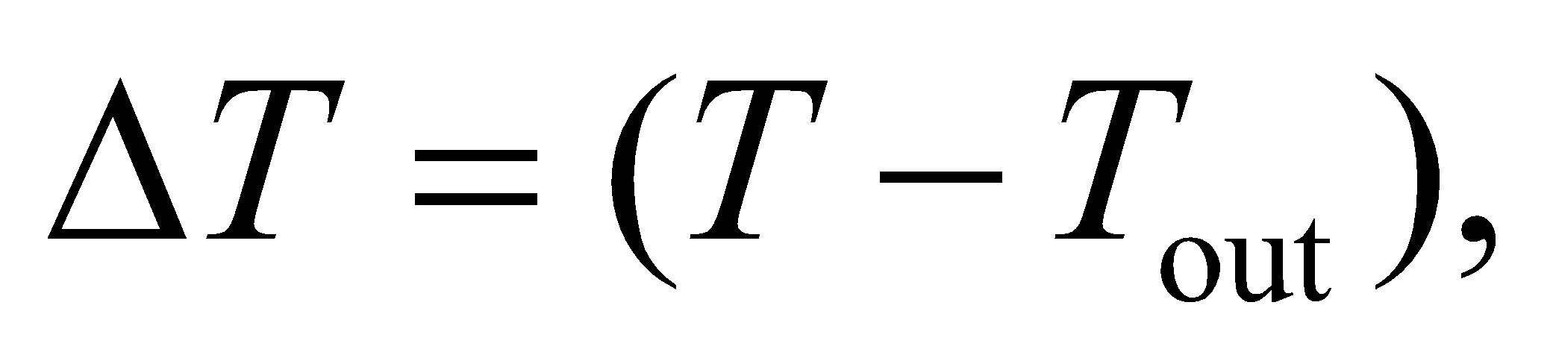where 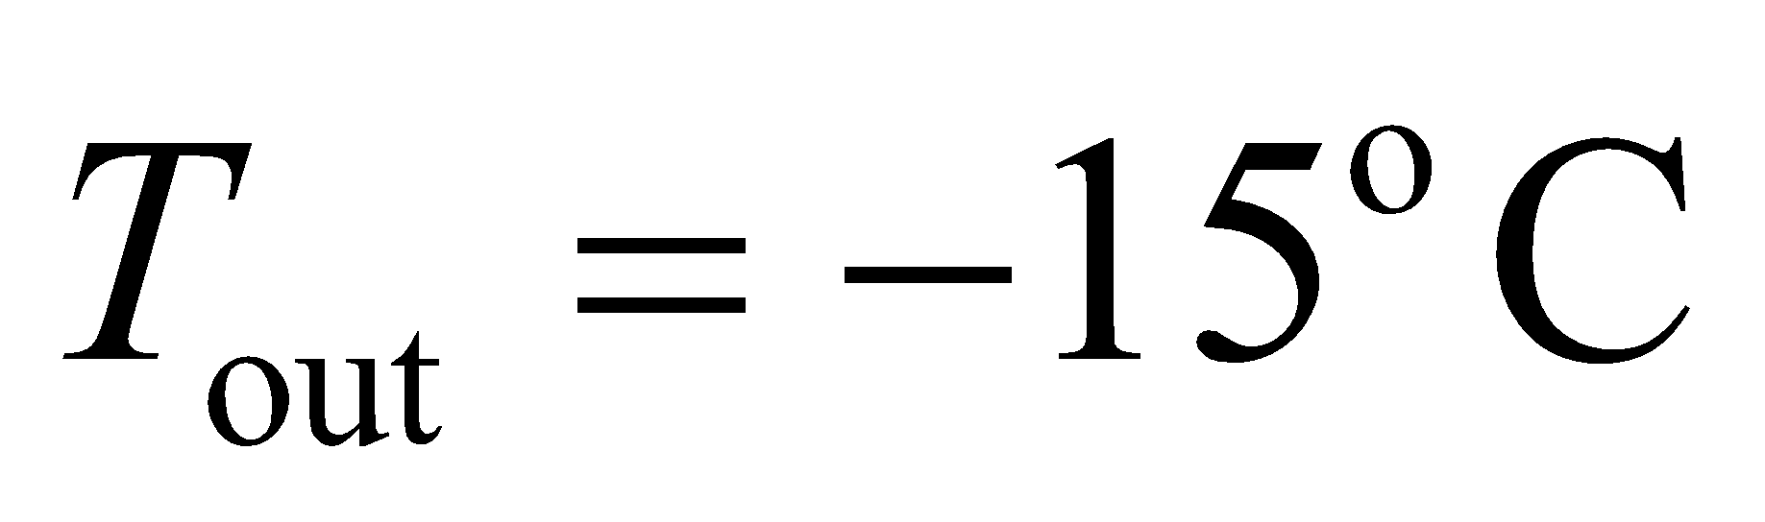 is the outdoor temperature, and *T* is the indoor temperature that is dropping due to the loss of an internal heat source. Equating the differential heat changes, 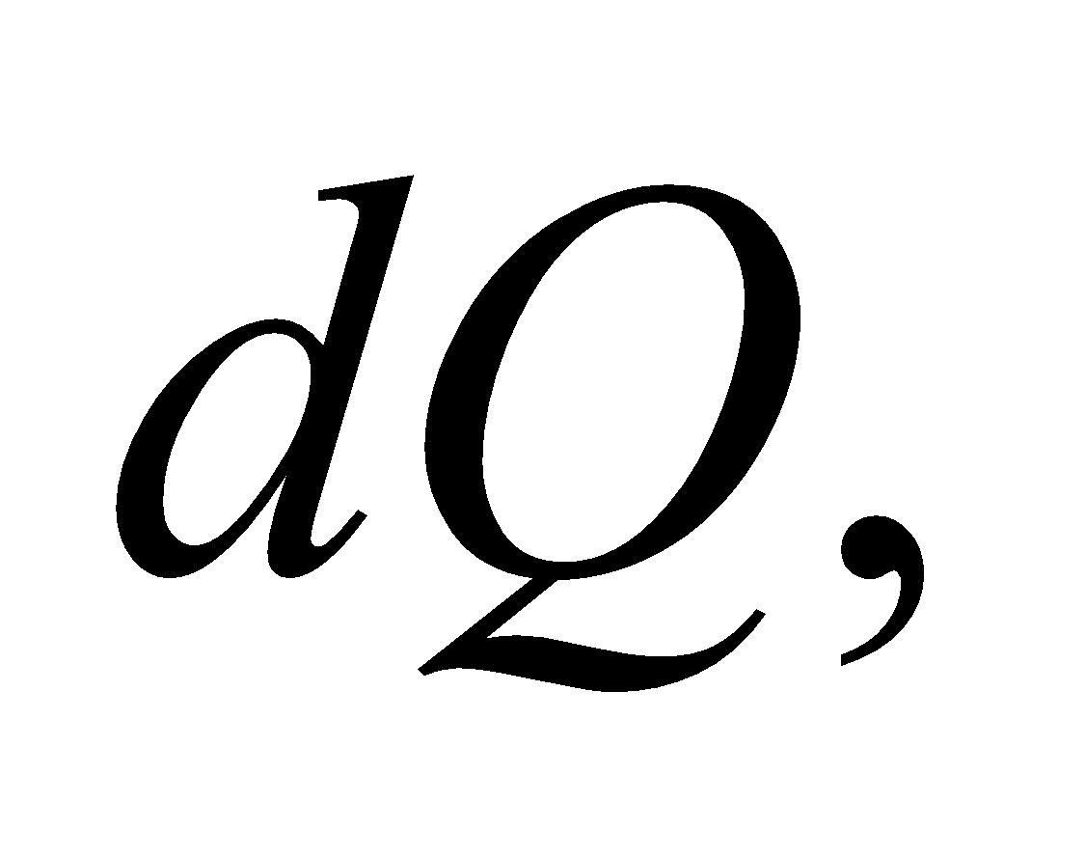in both equations we have:

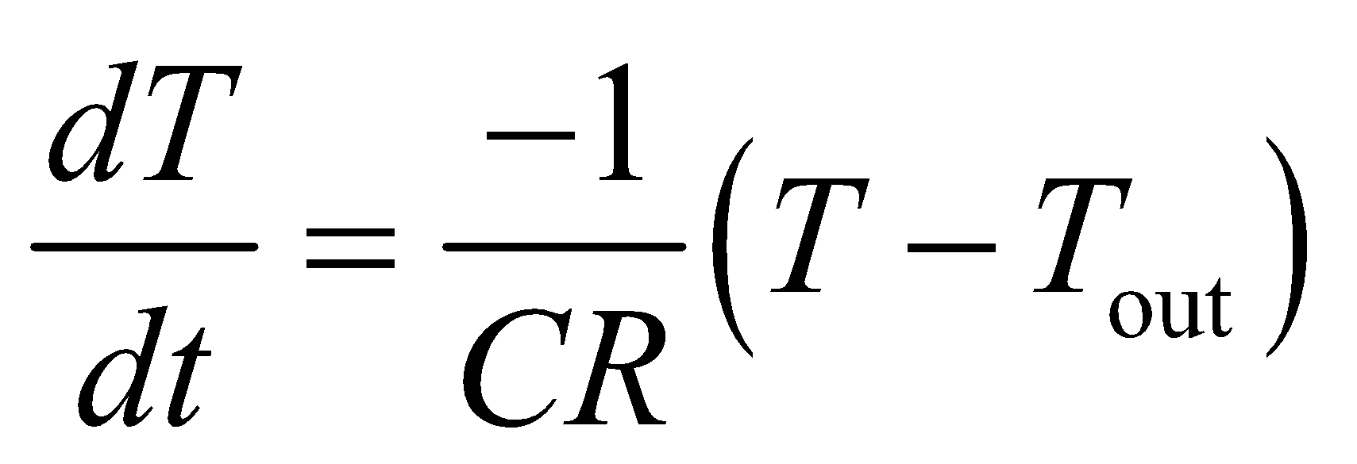

This is Newton's law of cooling. It says that the rate of temperature change of an object is proportional to the temperature difference between the object and its surroundings. We'll separate the time and the temperature and then integrate to find how long it takes for the indoor temperature to drop from 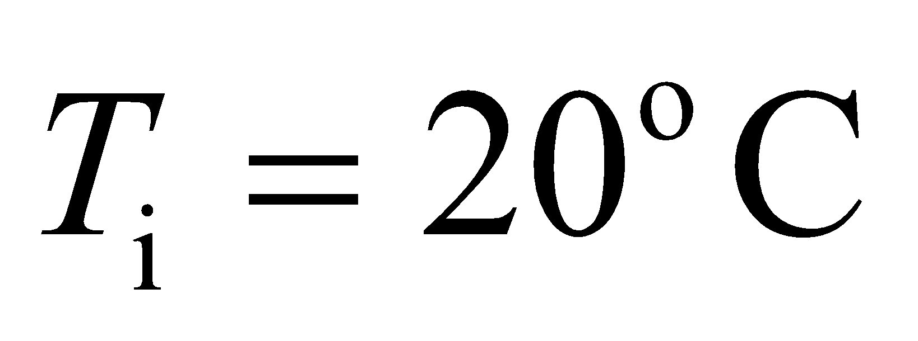to 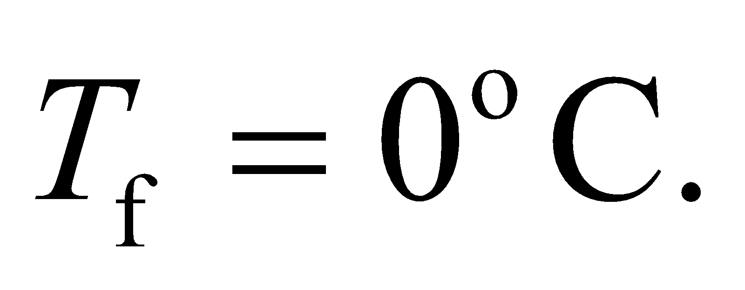

**Evaluate** Integrating the above equation gives

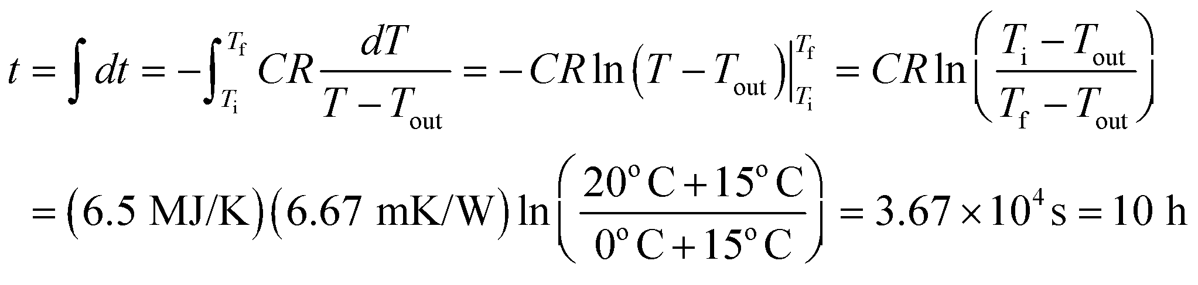

**Assess** This answer seems reasonable for the situation described.

**77. Interpret** We're asked to compute the temperature inside a greenhouse given a time-varying solar input.

**Develop** We'll assume the Sun's energy only enters through the windows 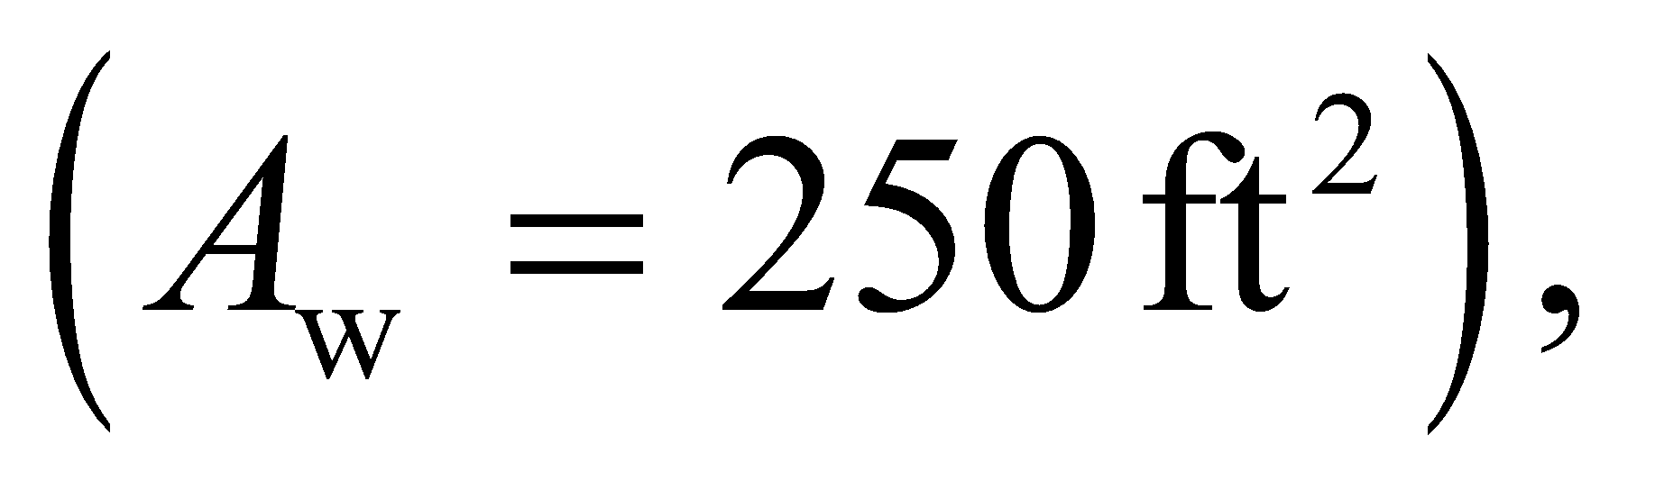 in which case the rate of heat gain from the Sun is



The rate of heat loss was computed in Example 16.7:

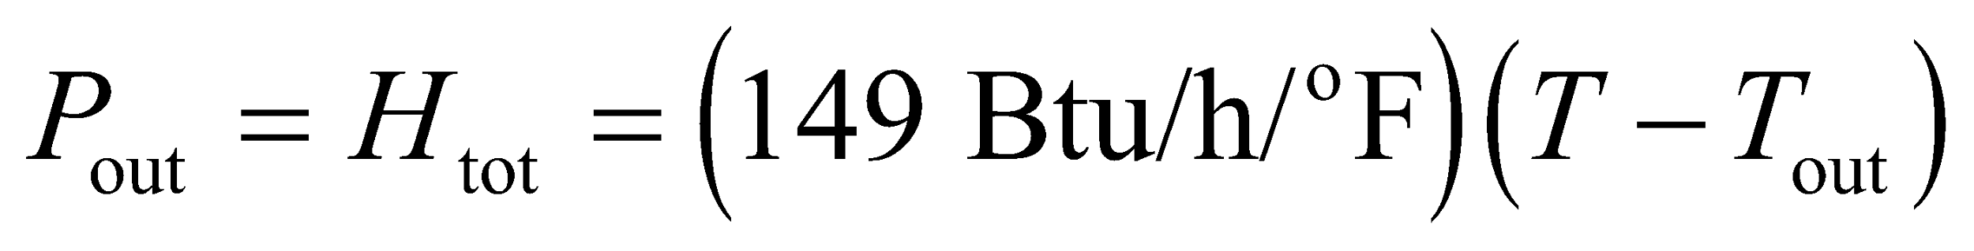

where *T* is the indoor temperature, and we assume that the outdoor temperature remains constant throughout the day: 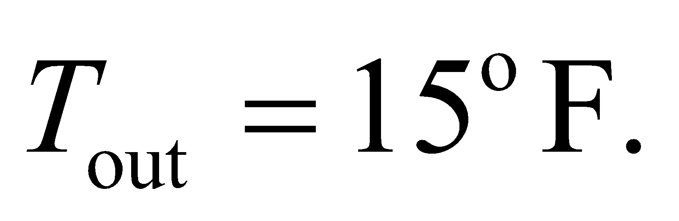 The net heat exchange will cause the indoor temperature to change according to

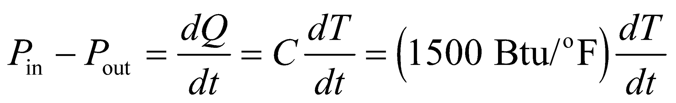

This is a linear first-order differential equation. We set 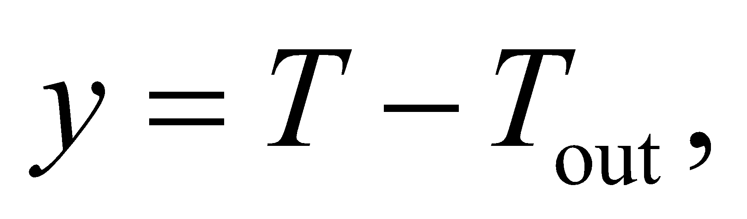such that:

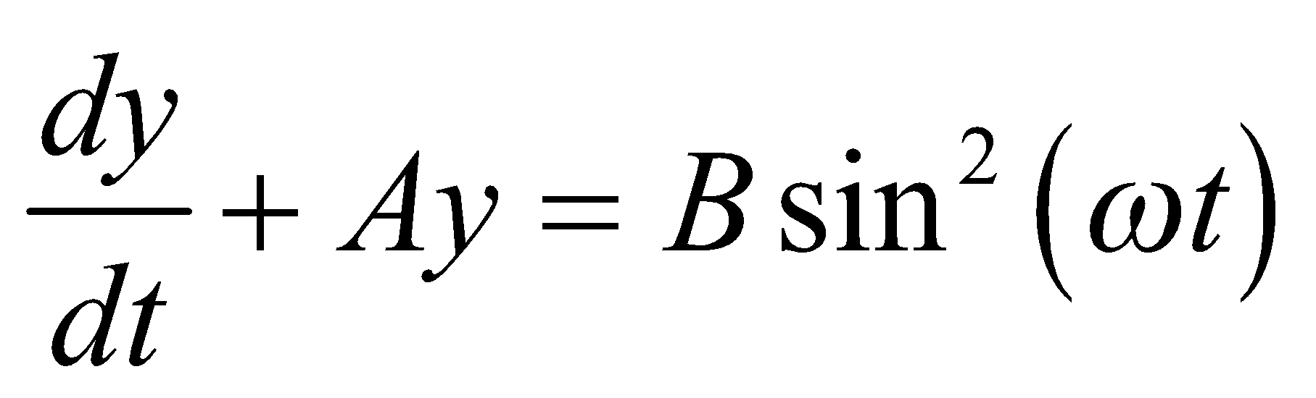

where 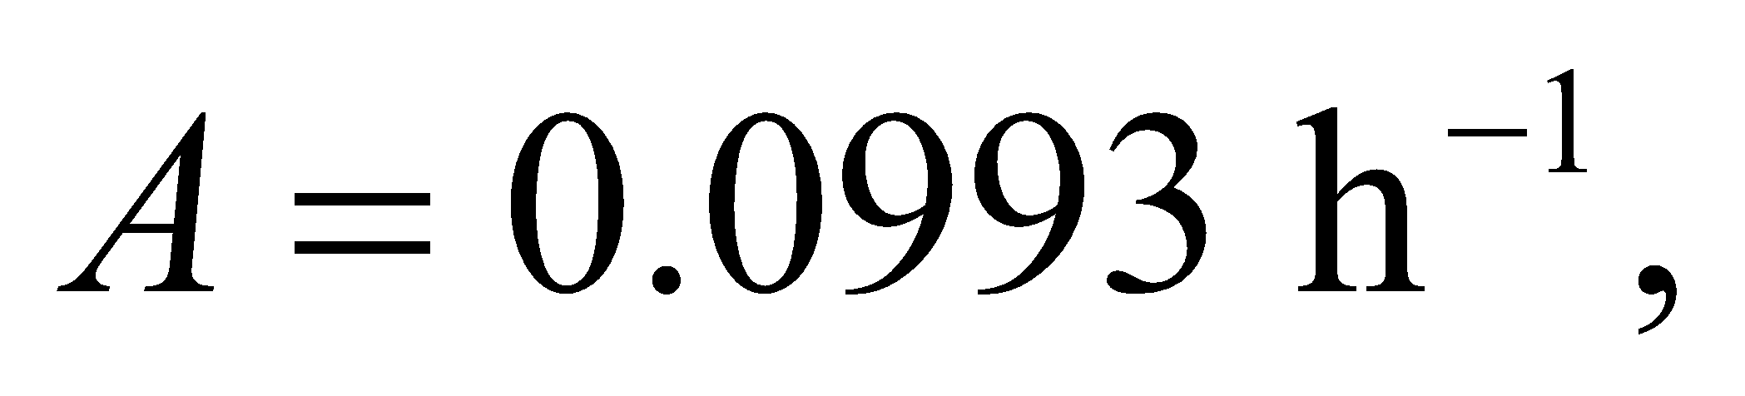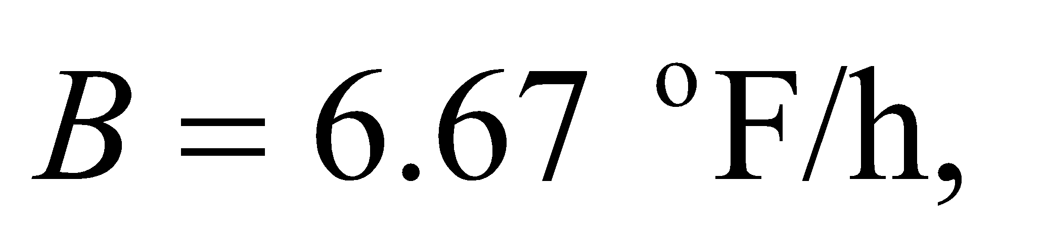and 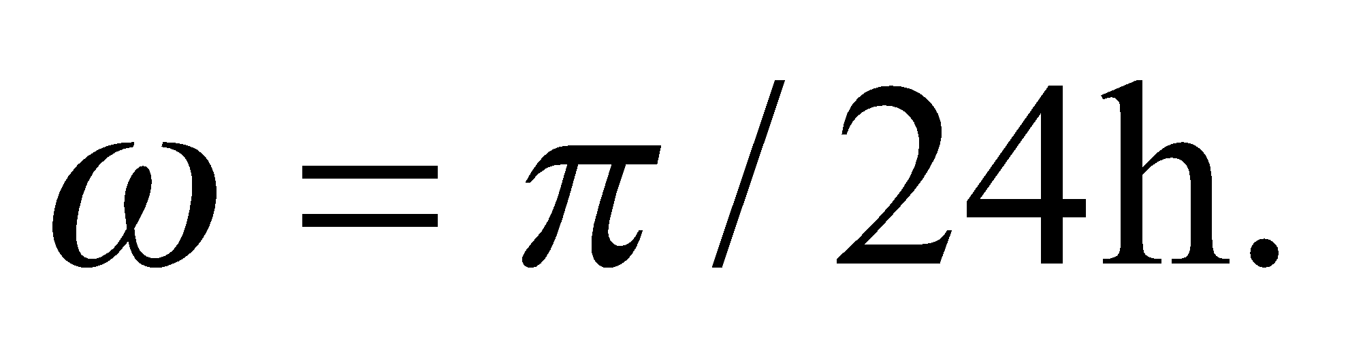

**Evaluate** One can solve the differential equation with a computer program or a calculator. We will solve it analytically. If we multiply both sides of the equation by 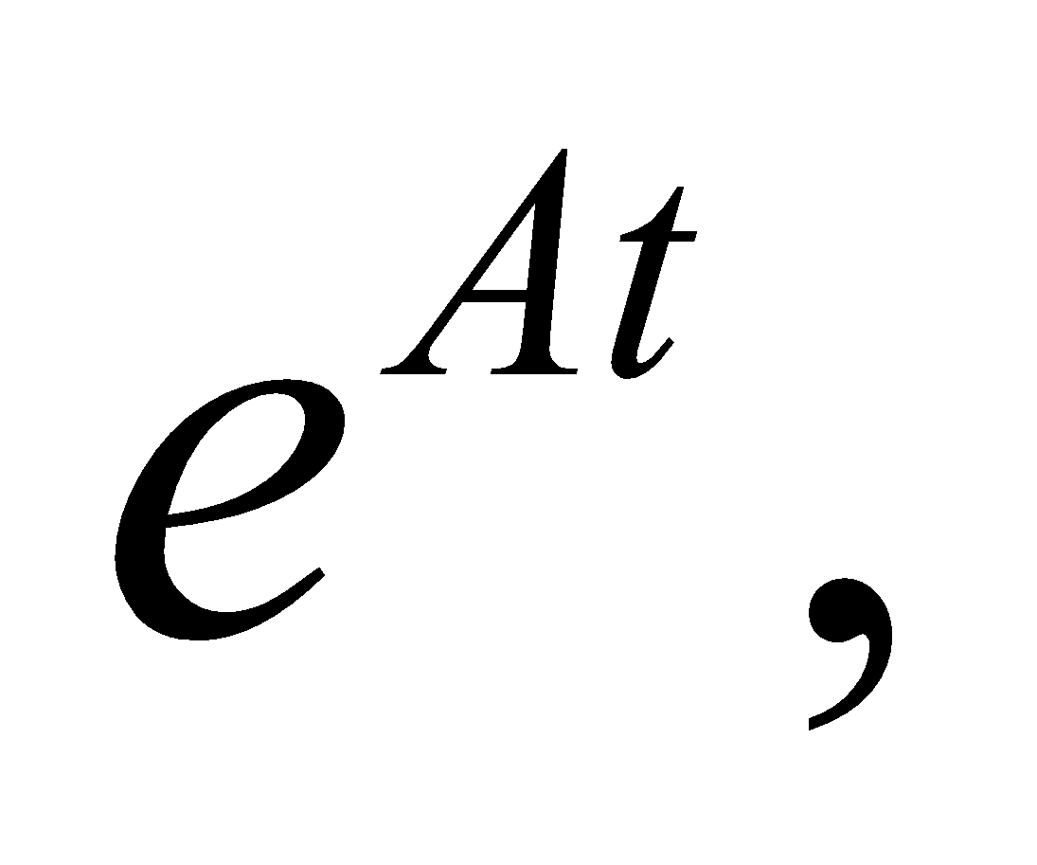then the solution for 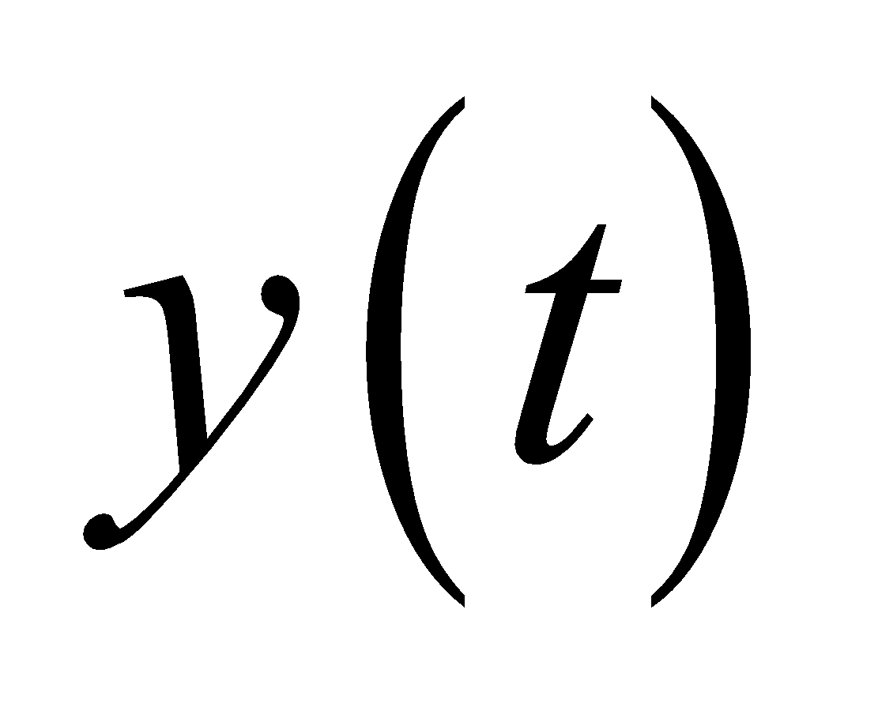 has the form

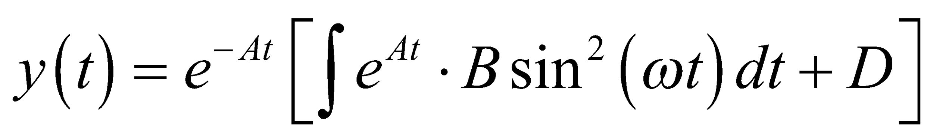

where *D* is an integration constant. One can find the integral in a table:

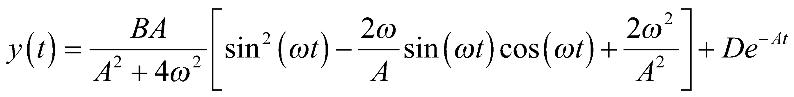

We will neglect the exponential term because it will decay away, so we are left with

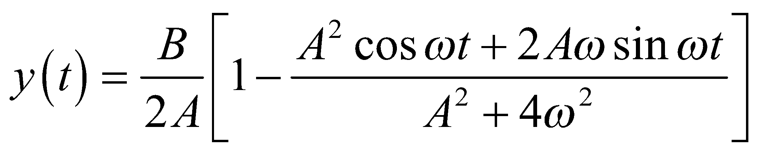

To find the maximum and minimum of 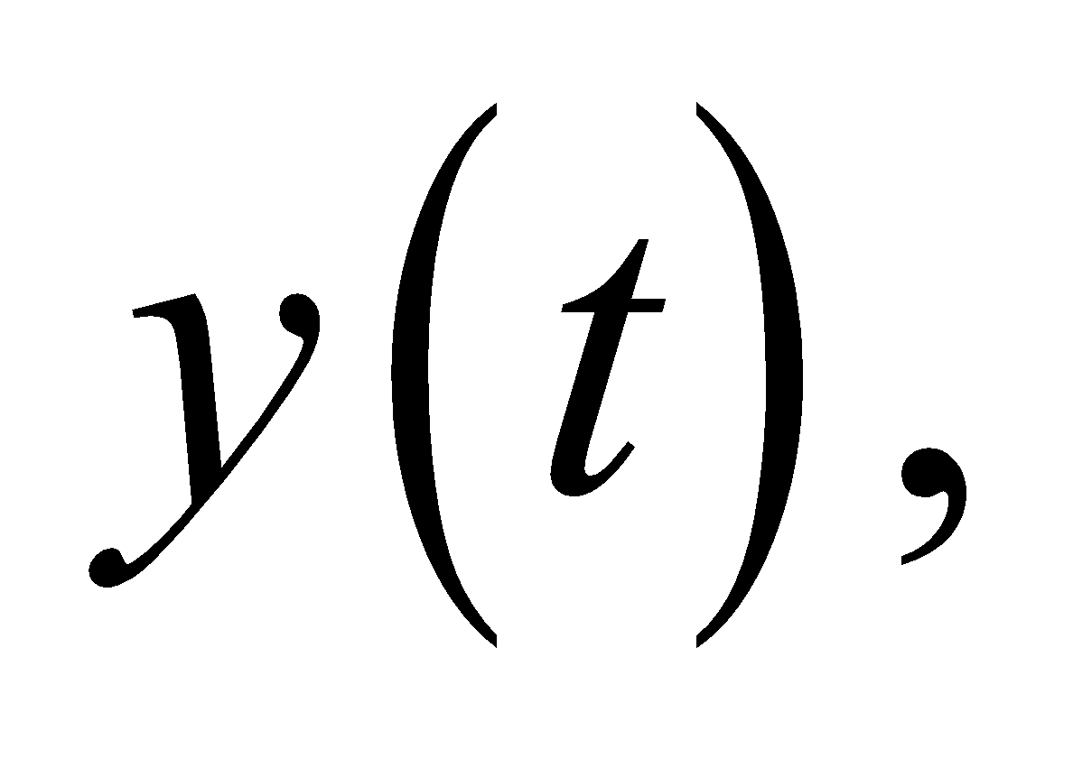we take the derivative and set it to zero. The extrema occur when

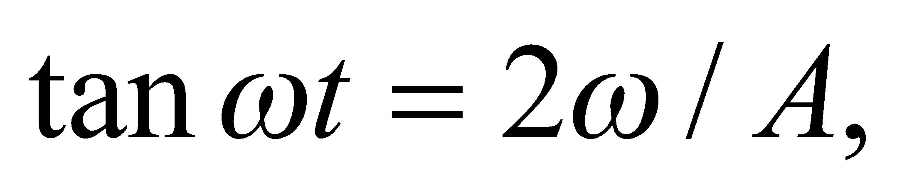 which corresponds to 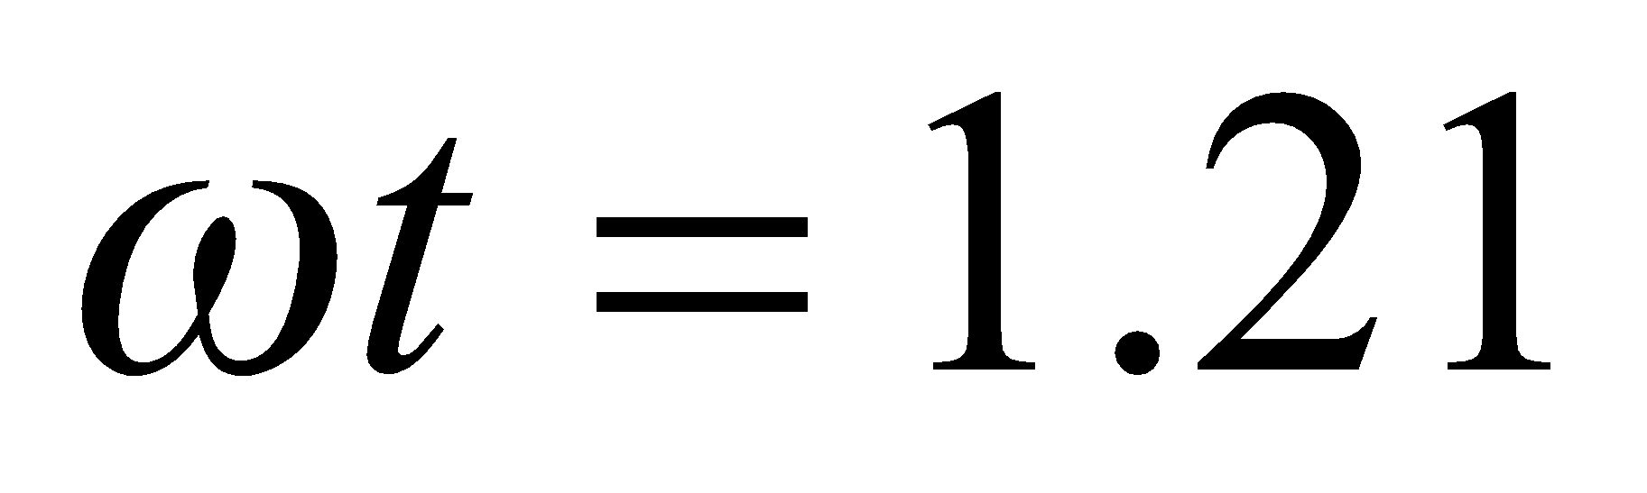 and 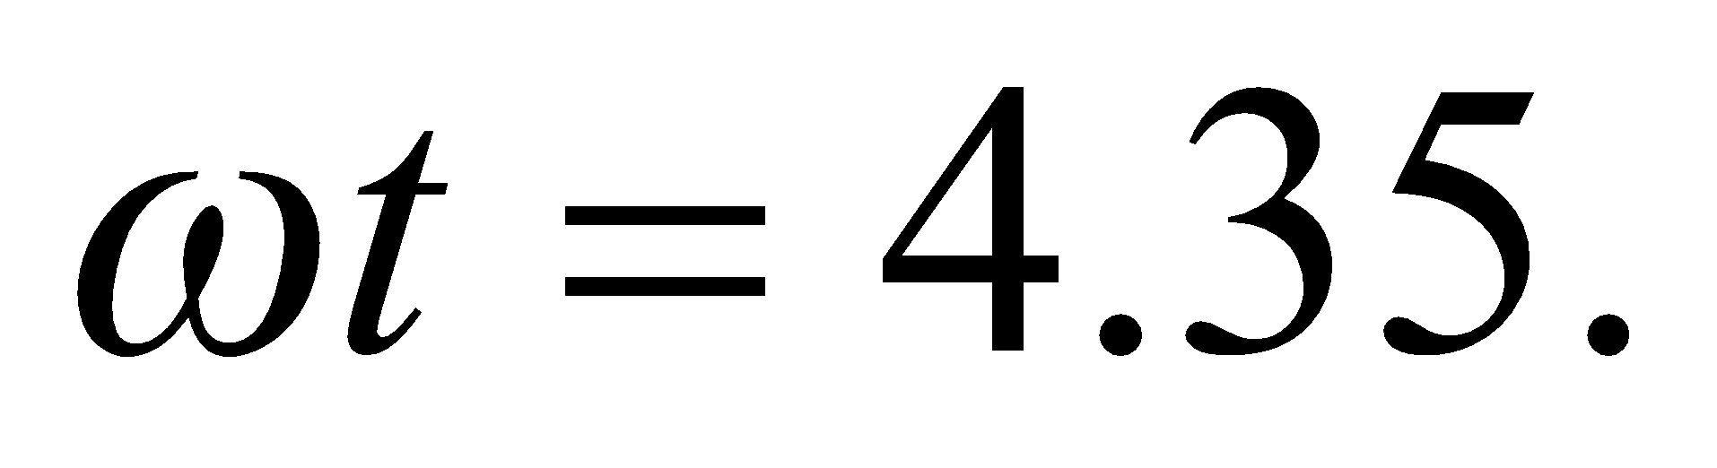 Substituting these values back into the original

equation, we find the minimum and maximum values of  are 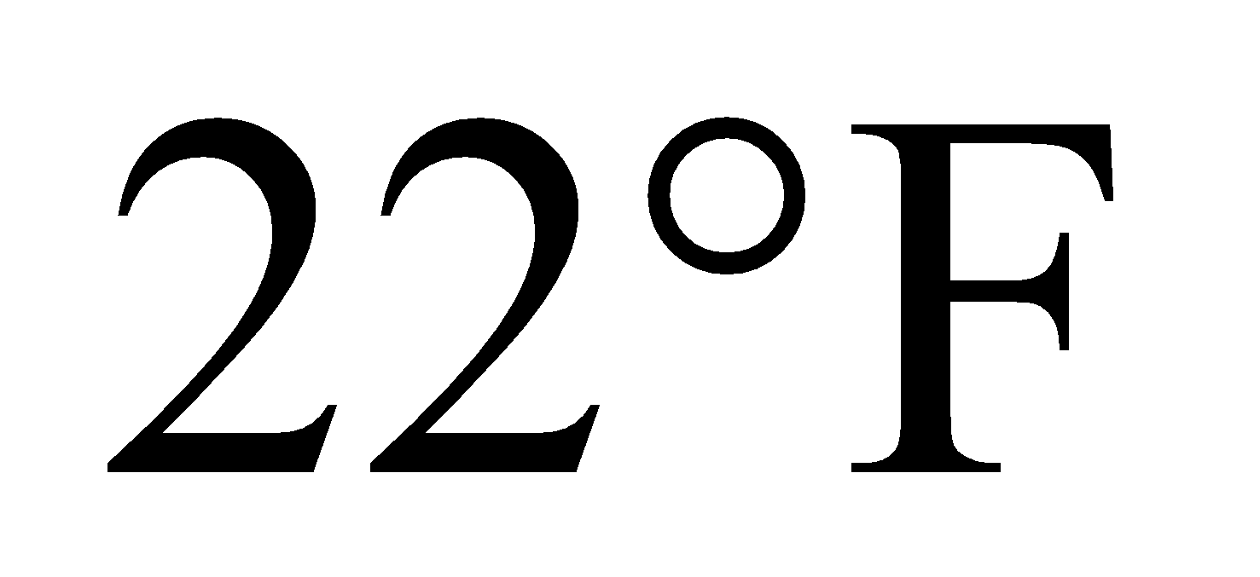 and 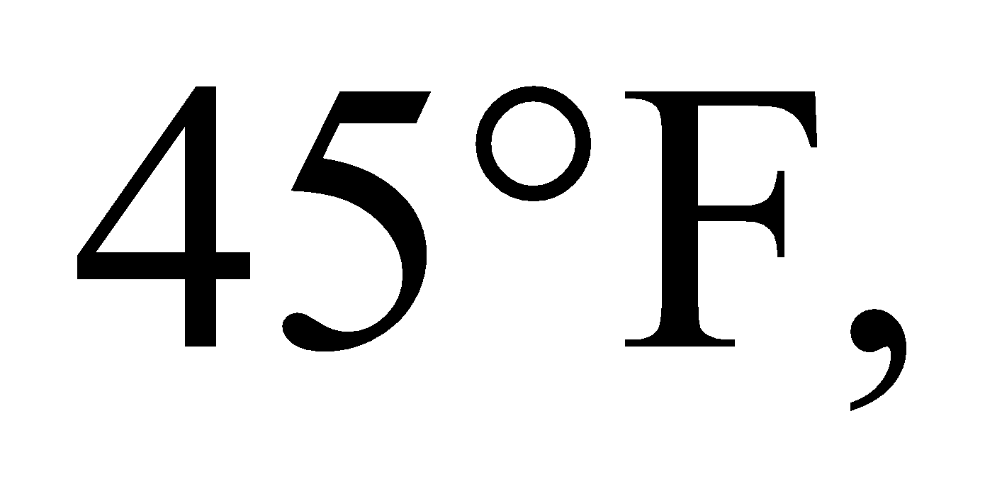 respectively. Adding these values to the outdoor temperature, the minimum and maximum indoor temperatures are 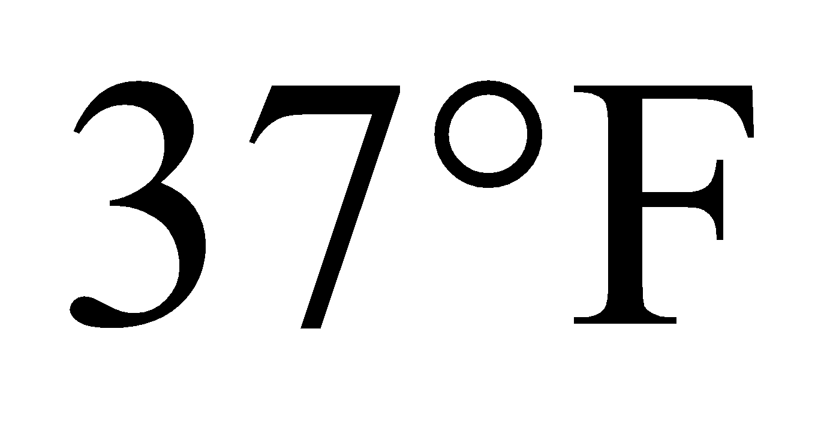 and 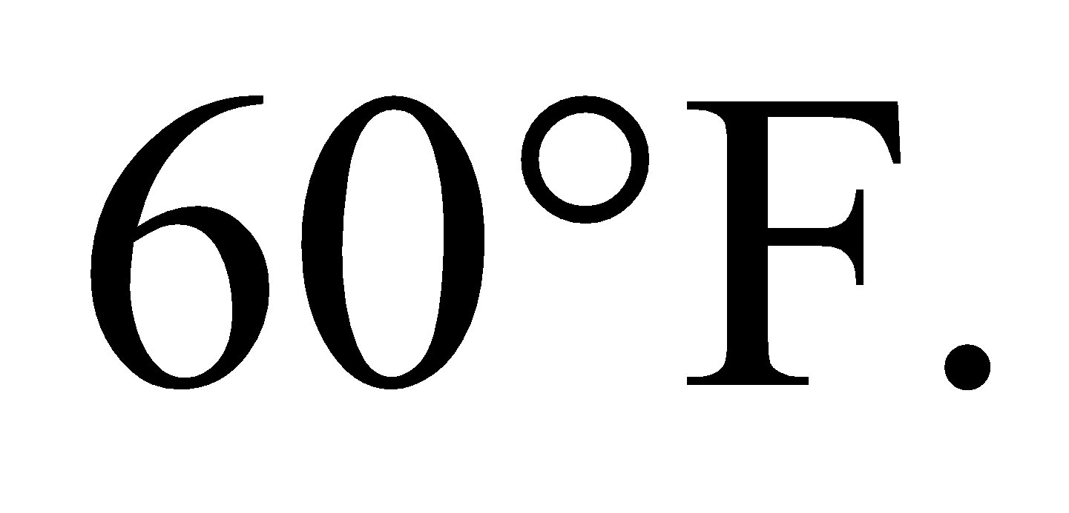

**Assess** The average temperature in the greenhouse is 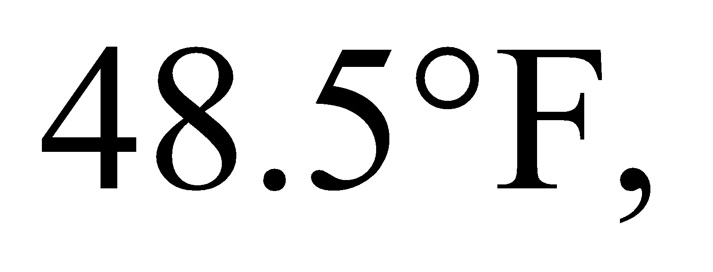 which is 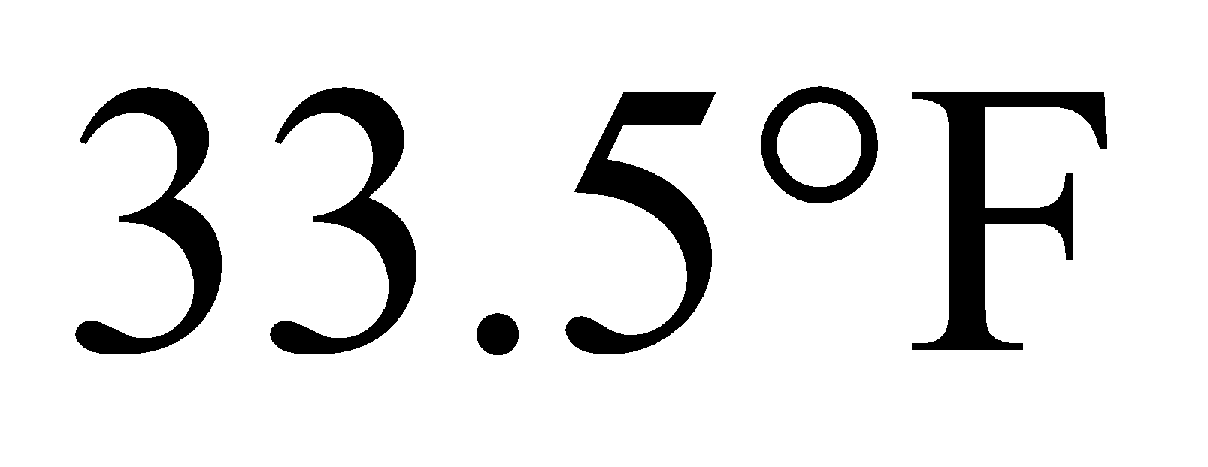above the outdoor temperature. Notice that this is exactly half the temperature difference found in Example 16.7 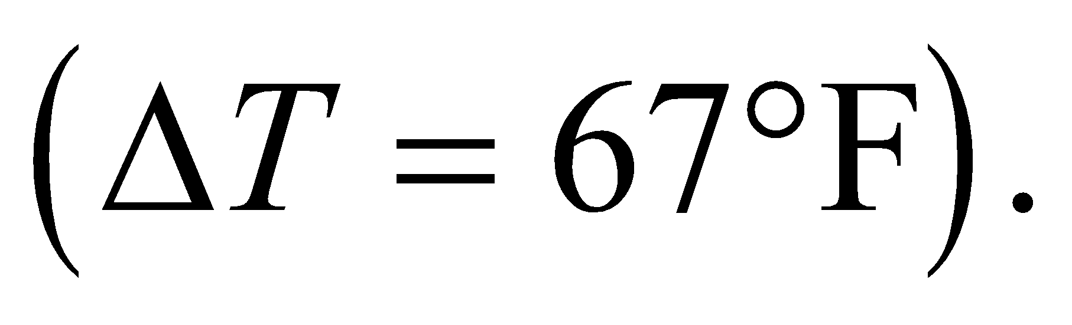 This makes sense, since the average solar input in this problem is half of what it was in Example 16.7:

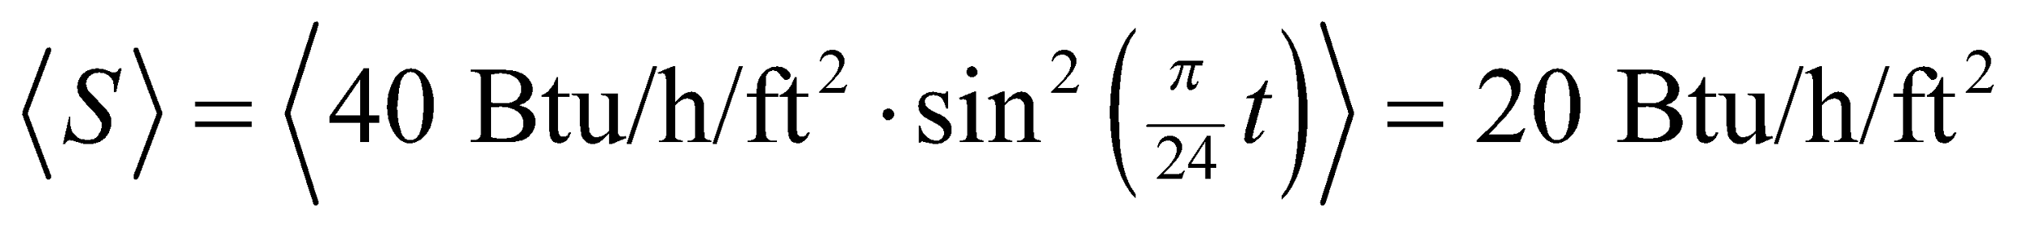

Here, we've used the fact that the average of 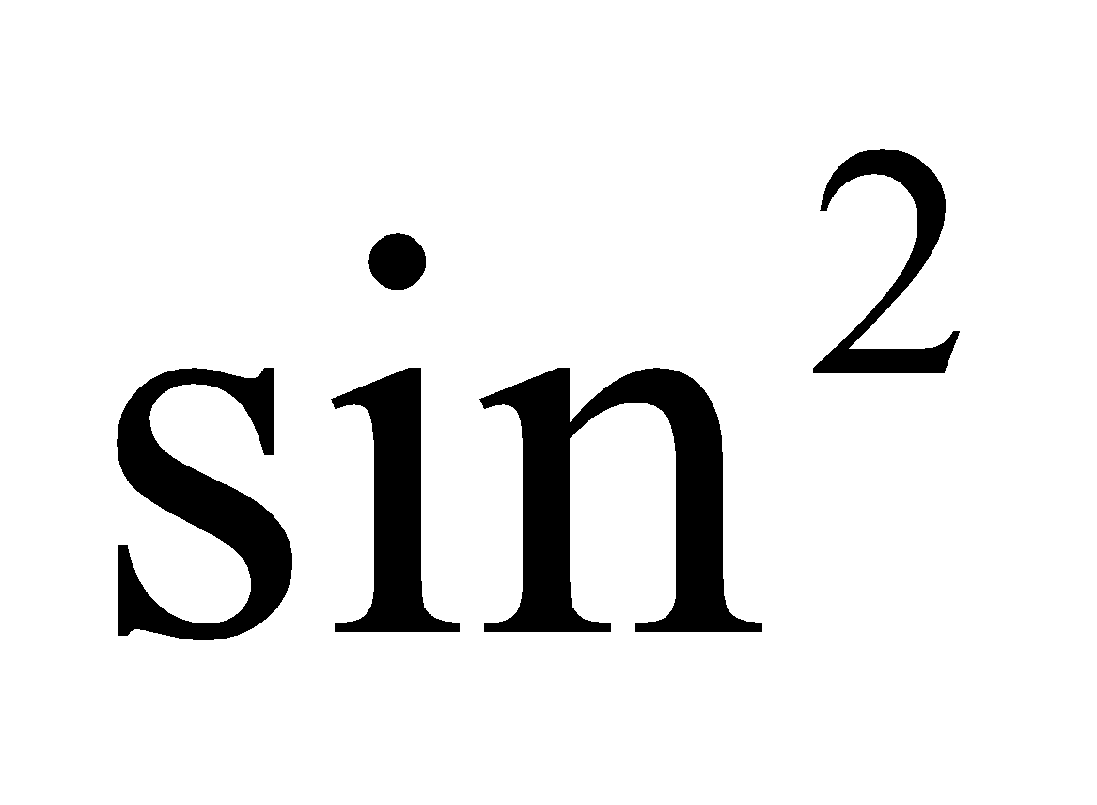 is ½.

**78. Interpret** We consider the physical properties of fiberglass insulation.

**Develop** The thermal resistance, which measures the level of insulation, is proportional to the inverse of the thermal conductivity. So a low thermal conductivity implies a high level of insulation.

**Evaluate** From Table 16.1, glass has a thermal conductivity of around 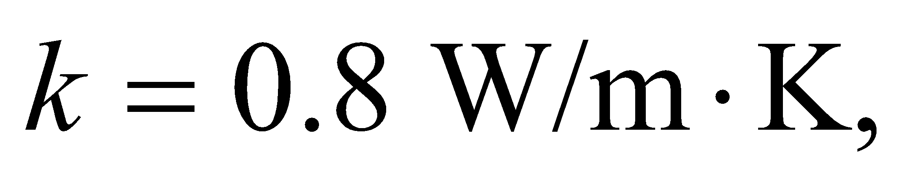whereas air trapped between the fibers has 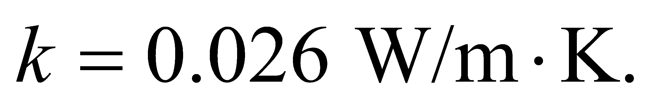So the air seems to be the more important element as far as the insulating quality is concerned.

The answer is (c).

**Assess** The logic here also applies to double pane (and even triple pane) windows. Having a thin layer of air between thin sheets of glass provides much better insulation than having a thick solid sheet of glass.

**79. Interpret** We consider the physical properties of fiberglass insulation.

**Develop** Aluminum foil has a very high thermal conductivity, 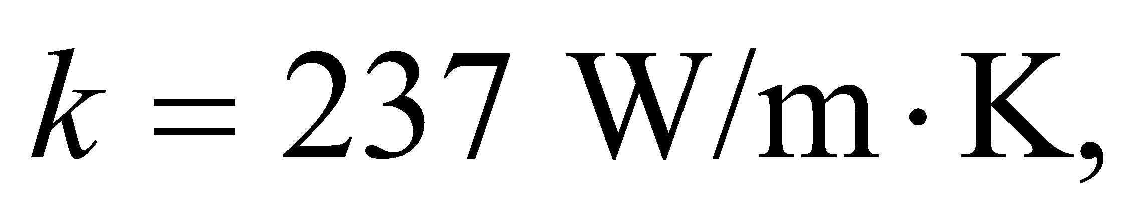so its definitely not being used to reduce heat loss by conduction. It will help prevent air from flowing through the fiberglass, but that's usually not a problem in an attic or a wall, where the air is pretty still.

**Evaluate** Aluminum is a good reflector of radiation, so it will reflect back radiation emitted from the fiberglass. This will help to reduce heat loss from radiation.

The answer is (c).

**Assess** The reflectivity is a measure of how good a material is at reflecting radiation. It is equal to 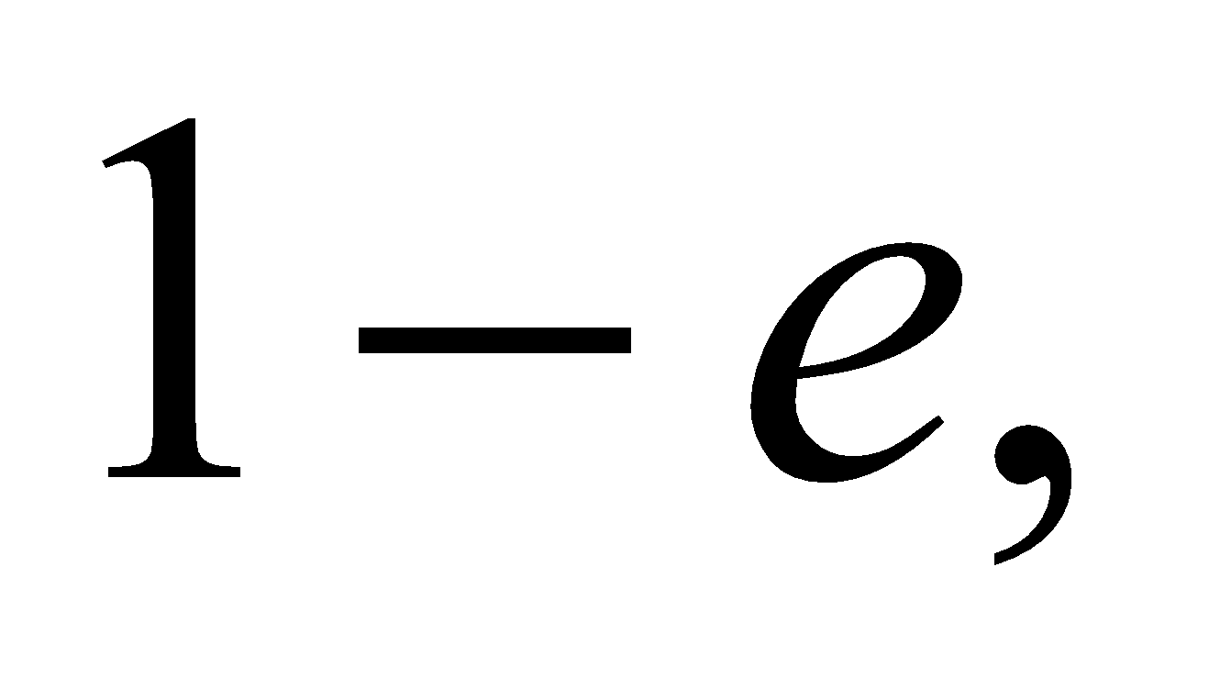 where *e* is the emissivity. Since *e* is a measure of absorption as well as emission, we can understand that a good reflector is a bad absorber. Aluminum foil has an emissivity of 0.03, which is why it is a good reflector.

**80. Interpret** We consider the physical properties of fiberglass insulation.

**Develop** We're told that 6-inch fiberglass has anof 19.

**Evaluate** As defined in Equation 16.8:  So doubling the thickness to 12 inches should double theto 38.

The answer is (a).

**Assess** For the most part, two sheets of 6-inch fiberglass should provide the same insulation (i.e. equal 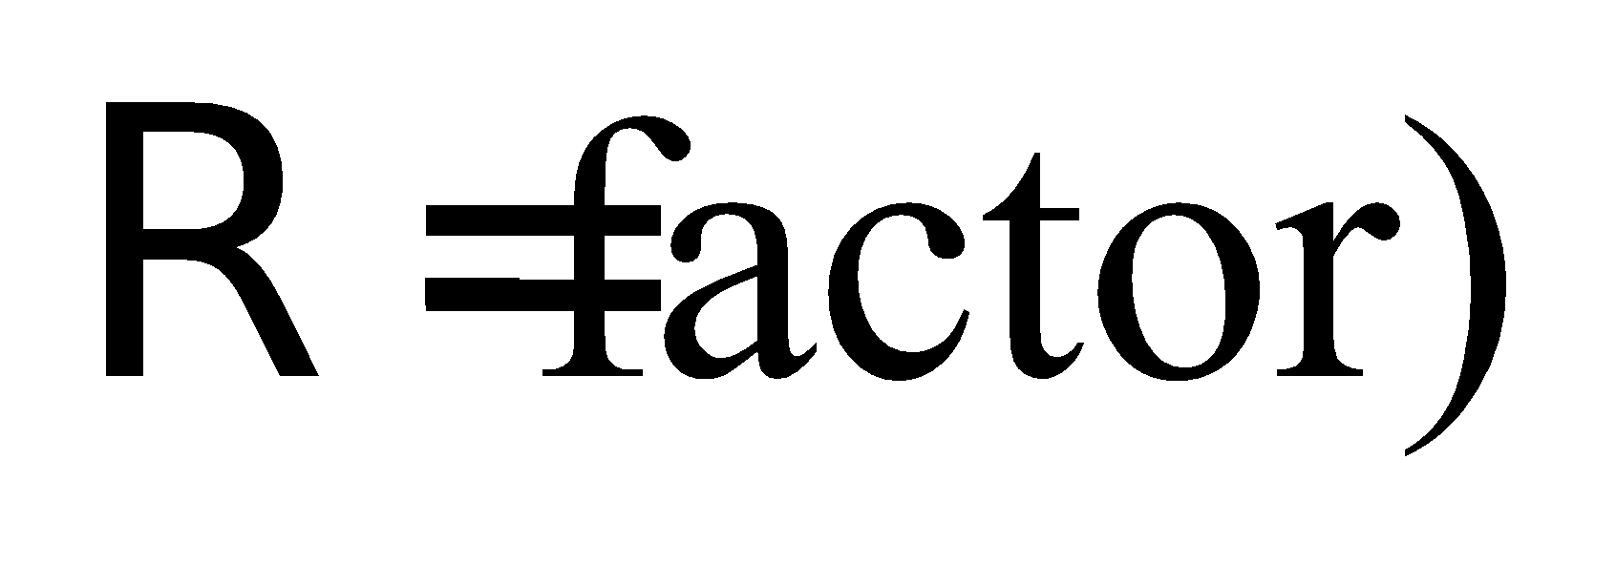as one sheet of 12-inch fiberglass.

**81. Interpret** We consider the physical properties of fiberglass insulation.

**Develop** Squeezing a fiberglass sheet will reduce the amount of air trapped between the glass fibers. By cramming two sheets into the space of one, we would essentially be replacing trapped air with glass fibers.

**Evaluate** As we argued in Problem 16.78, the trapped air is providing a large part of the insulation thanks to its low thermal conductivity. Therefore, squeezing the air out will reduce the overall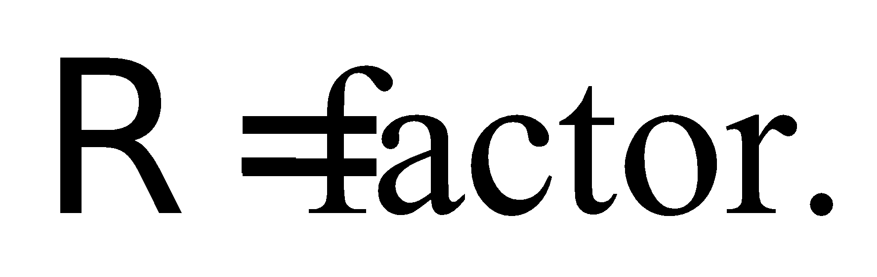

The answer is (c).

**Assess** One might imagine that the best insulation would be a layer of air, with only a thin shell to keep it in place. In fact, that's the logic behind double-pane windows. However, if the air layer is too thick, you start to have convection, which vastly reduces the insulation quality.